**Hong Kong Institute of Vocational Education (‎Tsing Yi)**

**Department of Information Technology**

**HD in Software Engineering (IT114105)**

**ITP4915M System Development Project**

**(2020/2021)**



**Prototype II and Final Report**

**Date: 2 Jul 2021**

|  |  |
| --- | --- |
| **Group No.** | 5 |

|  |  |  |
| --- | --- | --- |
| **Student** | **Contribution to the project (%)**  **(Total 100%)** | **Signature** |
| CHEUNG MAN LAI | 33 ​1⁄3 % |  |
| FUNG SHING HIN | 33 ​1⁄3 % |  |
| NG CHUN YIN | 33 ​1⁄3 % |  |

We declare that this is a group project and that no part of this submission has been copied from any other student’s work or from any other source except where due acknowledgement is made explicitly in the text, nor has any part been written for us by another person.

# Abstract

Eastern Delivery Express Limited (EDE) is one of the leading couriers in Hong Kong which provides delivery services from Hong Kong to Australia, China (Shanghai) and Japan. Currently, there are five EDE operation centers in Asia-Pacific - two in Hong Kong and one each in the aforementioned locations. EDE is planning to expand their service to Toronto, New York and London in two years’ time together with an additional Import Express service which addresses customers’ needs for regular supplies from abroad to Hong Kong.

Previously, a Requirement Specification Report has been written, acknowledging the current operation of the company by reviewing the computer system currently in use and conducting user experience interviews and specifying the requirement, both functional and non-functional, for the customized system that settles these issues and to suit EDE’s plan for expansion. It was decided that object-oriented approach shall be adapted to make possible the flexibility to improve the system in accordance with the company's plan for expansion. The proposed system shall be a web-based one that allows users, both staff members and customers, to run on any devices installed with modern browsers.

With the approval from the operation manager, a System Analysis and Design Report has subsequently been produced, attempting to outline the functional models within the object-oriented system development for the proposed system for EDE by bringing attention to the use cases and activity diagrams. More specifically, use case diagrams and their respective use case descriptions of the three major component of the proposed system, namely Company System, Staff Data Sharing Software and Staff Intranet Portal, are detailed in this report, followed by sequence diagrams and state machines diagrams which specifies the behavioral model of the proposed system, and the structural model with class diagram. Initial design of the database system as well as the Entity Relation Diagram (ERD) has also been outlined in the System Analysis and Design Report.

The final stage of this project is the production of the system itself and the implementation. This report outlines the way in which the system is built and tested. The user interface of the system has been illustrated with screenshots obtained during the testing phase. As testing is one of the most critical steps in this final stage, a detailed test plan is included in this final report where various test cases were illustrated in detail. A user guide and support plan which attempts to illustrate in what way does the system should be used and implemented is also included in this final report. It is expected that user guide could serve as a manual for the users, even if technical staff is not around.

In addition to the aforementioned elements, this report also introduces the hardware, software and network architecture required for the proposed the system. By implementing the modernization of the management system, it is expected that the company would be able to prevail over its competitors by providing all-round services that are able to address customers’ needs and fulfill their expectations. The major benefits of implementing the system, namely increased transparency, reduced workload of staff, reduced response time and transaction can be done online have also been outlined in this report. It is hoped that by specifying these elements of the system, a better picture of the system could be given to the operation manager and the managerial staff. It is hoped that the proposed system would be launched in early July upon final approval on the second prototype of the system.

# Table of Content

Abstract 1

Table of Content 2

Table of Figure 7

1. Introduction 11

1.1. Company background 11

1.2. Project background 11

1.3. Project scope 11

2. Problem Findings 12

2.1. Limited Data Sharing within EDE 12

2.2. Manual airway bill input 12

2.3. Manual shipment consolidation 12

2.4. Manual shipment checking 13

2.5. Manual Data Consolidation 13

2.6. Inconvenient Management Controls 13

2.7. Low Availability and Slow Retrieval of Information 13

2.8. Unsatisfactory Customer Experience due to manual work 14

2.9. Limited payment methods 14

3. Functional Requirements 15

3.1. Function for customer 15

*3.1.1.* *Online Self Registration* 15

*3.1.2.* *Online Shipment Tracking* 15

*3.1.3.* *Book the pickup for arrangement of shipment collection* 16

*3.1.4.* *Shipping Expenses Calculation* 16

*3.1.5.* *Shipping Records* 17

*3.1.6.* *Online Shipment Payment* 17

*3.1.7.* *EDE Airway Bills and Export Documents* 18

*3.1.8.* *Monthly Payment* 20

*3.1.9.* *Monthly Invoice* 20

*3.1.10.* *Pre-Alerting Receivers of the Shipment Information* 20

*3.1.11.* *Notification* 20

*3.1.12.* *Q&A chatbot in system for customers enquiry* 20

*3.1.13.* *Shipment reports for Customers* 21

3.2. Function for Staff 21

*3.2.1.* *Data sharing software* 21

*3.2.2.* *Intranet Portal for staff* 21

3.3. Function for system 22

*3.3.1.* *Invoice* 22

*3.3.2.* *Receiver receiving the freight* 23

*3.3.3.* *Shipment Report* 23

4. Non-Functional Requirements 24

4.1. Usability 24

4.2. Operational 24

4.3. Security 24

*4.3.1.* *Access Control* 24

*4.3.2.* *Data Privacy* 25

*4.3.3.* *Data Encryption* 25

*4.3.4.* *Account Protection* 25

4.4. Hardware 25

*4.4.1.* *“QR code” scanner* 25

*4.4.2.* *Computer* 26

4.5. Software 26

4.6. Database 26

*4.6.1.* *Edit Database Info* 26

*4.6.2.* *Modify Database Users Privileges* 26

*4.6.3.* *View the Database* 26

4.7. Supportability 26

*4.7.1.* *Adaption* 26

*4.7.2.* *Event logging* 26

4.8. Socio-cultural requirements 27

4.9. Reliability 27

*4.9.1.* *RAID* 27

*4.9.2.* *Off-site backup* 27

*4.9.3.* *Uninterruptible Power System (UPS)* 27

5. System Architecture 28

5.1. Hardware 28

5.2. Software 28

5.3. Network 29

6. Benefits 30

6.1. Increased transparency 30

6.2. Reduced the workload of the staff 30

6.3. Reduce response time 30

6.4. Transaction can be done online 31

7. Constraints and Limitations 32

7.1. System may run on different devices 32

7.2. Development environment 32

7.3. Alpha version 32

8. System Analysis and Design 33

8.1. Actor Description 33

8.2. Use Case Diagram 34

8.3. Use Case Description, Sequence Diagram and State Machine Diagram 36

*8.3.1.* *Client System* 36

8.3.1.1. Register account 36

8.3.1.2. Existing account 39

8.3.1.3. Wrong verification code 41

*8.3.1.4.* *Shipment Tracking* 44

*8.3.1.5.* *Chat with chatbot* 48

*8.3.1.6.* *Calculate shipping expense* 51

*8.3.1.7.* *Login* 53

*8.3.1.8.* *Check shipment records* 55

*8.3.1.9.* *Check shipment reports* 57

*8.3.1.10.* *Book pick up* 60

*8.3.1.11.* *Check credit limit* 63

*8.3.1.12.* *Receiving freight* 66

*8.3.1.13.* *Pay for shipment* 69

*8.3.1.14.* *E-payment* 72

*8.3.1.15.* *Credit card payment* 75

*8.3.1.16.* *Cheque payment* 78

*8.3.1.17.* *View invoice* 81

*8.3.1.18.* *Fill airway bills and export documents* 84

*8.3.1.19.* *Print airway bills* 87

*8.3.1.20.* *Help customer register* 90

*8.3.2.* *Data Sharing Software* 93

*8.3.2.1.* *Share file* 93

*8.3.2.2.* *Read file* 96

*8.3.2.3.* *Download file* 98

*8.3.2.4.* *Delete files* 101

*8.3.2.5.* *Staff Login* 104

*8.3.3.* *Intranet Portal for staff* 107

*8.3.3.1.* *Portal login* 107

*8.3.3.2.* *Retrieve simple information and status* 110

*8.3.3.3.* *Search and view shipment report and records* 113

*8.3.3.4.* *Export report and records* 116

*8.3.3.5.* *Edit reports* 119

*8.3.3.6.* *Generate reports* 122

8. Entity Relation Diagram (ERD) 125

9. Database Design 126

9.1. STAFF Table 126

9.2. ECENTRE Table (Express Centre) 127

9.3. OCENTRE Table (Operation Centre) 127

9.4. CUSTOMER Table 128

9.5. AIRWAYBILL Table 129

9.6. SHIPMENT Table 130

9.7. PICKUP Table 130

9.8. FEE Table 130

9.9. PAYMENT Table 131

9.10. INVOICE Table 131

9.11. SHIPMENTREPORT Table 131

10. User Interface Design 132

10.1. Design Overview 132

10.2. Color tone 133

10.3. The use of flat icons 134

10.4. Customer UI 135

10.5. Staff UI 137

10.6. The navigation bar and pop-up approach 139

10.7. Enhance Data Security 141

10.8. UI Design Summary 141

11. Test Plan 142

12. User Guide 168

12.1. Public Function: 168

*12.1.1.* Login 168

*12.1.2.* Pickup Booking Management 169

12.1.2.1. Edit pick up 169

*12.1.3.* Handling Import function 171

12.1.3.1. Create regular import service 172

12.1.3.2. Edit regular import service 173

12.1.3.3. Add regular import product 175

*12.1.4.* Create shipment 177

12.2. Customer: 182

*12.2.1.* Menu Program / Login 182

12.2.1.1. Account registration 182

12.2.1.2. Forgot Password 185

*12.2.2.* Express Document/ Package Express Management 187

12.2.2.1. Pickup Booking Management 187

12.2.2.2. Calculate shipping expenses 189

12.2.2.3. Generate EDE airway bills 191

*12.2.3.* Track Shipment Status 194

*12.2.4.* Bill and Payment Management 196

12.2.4.1. Generate invoice 196

12.2.4.2. Prepare monthly invoice 199

12.2.4.3. Manage payment 202

12.3. Staff: 206

*12.3.1.* Edit the pickup 206

*12.3.2.* Process Shipment 210

*12.3.3.* Advanced function 212

12.3.3.1. Searching functions (Management) 212

12.3.3.2. Searching functions (General Staff) 214

12.3.3.3. Statistical Reports (authorized users only) 216

13. Project Schedule (Gannt chart and tasks dependency) 220

Task Dependency 220

14. Conclusion 221

15. Project Log 222

16. Reference 224

# Table of Figure

Figure 1: Three-Tiered Client-Server Architecture 28

Figure 2: Proposed Network Architecture of the new system 29

[Figure 3: Client Website 34](https://vtcmca-my.sharepoint.com/personal/200427569_stu_vtc_edu_hk/Documents/ITP4915M_FinalReport_SE1C_Group5.docx#_Toc76129215)

[Figure 4: Staff data sharing software 35](https://vtcmca-my.sharepoint.com/personal/200427569_stu_vtc_edu_hk/Documents/ITP4915M_FinalReport_SE1C_Group5.docx#_Toc76129216)

Figure 5: Staff Intranet Portal 35

Figure 6: Register account (Sequence Diagram) 37

Figure 7: Register account (State Machine Diagram) 38

Figure 8: Exiting account (Sequence Diagram) 39

Figure 9: Existing account (State Machine Diagram) 40

Figure 10: Wrong verification Code (Sequence Diagram) 42

Figure 11: Wrong verification Code (State Machine Diagram) 43

Figure 12: Shipment tracking Scenario 1 (Sequence Diagram) 45

Figure 13: Shipment tracking Scenario 2 (Sequence Diagram) 46

Figure 14: Shipment tracking Scenario 3 (Sequence Diagram) 46

Figure 15: Shipment tracking (State Machine Diagram) 47

Figure 16: Chat with chatbot Scenario 1 (Sequence Diagram) 49

Figure 17: Chat with chatbot Scenario 2 (Sequence Diagram) 49

Figure 18:Chat with chatbot (State Machine Diagram) 50

Figure 19: Calculate shipment expense (Sequence Diagram) 52

Figure 20: Calculate shipment expense (State Machine Diagram) 52

Figure 21: Login Scenario 1 (Sequence Diagram) 53

Figure 22: Login Scenario 2 (Sequence Diagram) 54

Figure 23: Login (State Machine Diagram) 54

Figure 24: Check shipment record (Sequence Diagram) 55

Figure 25: Check shipment record (State Machine Diagram) 56

Figure 26: Check shipment reports (Sequence Diagram) 58

Figure 27: Check shipment reports (State Machine Diagram) 59

Figure 28: Book pick up (Sequence Diagram) 61

Figure 29: Book pick up (State Machine Diagram) 62

Figure 30: Check credit limit (Sequence Diagram) 64

Figure 31: Check credit limit (State Machine Diagram) 65

Figure 32: Receiving freight (Sequence Diagram) 67

Figure 33: Receiving freight (State Machine Diagram) 68

Figure 34: Pay for shipment (Sequence Diagram) 70

Figure 35: Pay for shipment (State Machine Diagram) 71

Figure 36: E-payment Scenario 1 (Sequence Diagram) 73

Figure 37: E-payment Scenario 2 (Sequence Diagram) 73

Figure 38: E-payment (State Machine Diagram) 74

Figure 39: Credit card payment Scenario 1 (Sequence Diagram) 76

Figure 40: Credit card payment Scenario 2 (Sequence Diagram) 76

Figure 41: Credit card payment (State Machine Diagram) 77

Figure 42: Cheque payment (Sequence Diagram) 79

Figure 43: Cheque Payment (State Machine Diagram) 80

Figure 44: View invoice (Sequence Diagram) 82

Figure 45: View invoice (State Machine Diagram) 83

Figure 46: Fill airway bills and export documents (Sequence Diagram) 85

Figure 47: Fill airway bills and export documents (State Machine Diagram) 86

Figure 48: Print airway bills (Sequence Diagram) 88

Figure 49: Print airway bills (State Machine Diagram) 89

Figure 50: Help customer register (Sequence Diagram) 91

Figure 51: Help customer register (State Machine Diagram) 92

Figure 52: Share file (Sequence Diagram) 94

Figure 53: Share file (State Machine Diagram) 95

Figure 54: Read file (Sequence Diagram) 97

Figure 55: Download file (Sequence Diagram) 99

Figure 56: Download file (State Machine Diagram) 100

Figure 57: Delete Files (Sequence Diagram) 102

Figure 58: Delete Files (State Machine Diagram) 103

Figure 59: Staff Login (Sequence Diagram) 105

Figure 60: Staff Login (State Machine Diagram) 106

Figure 61: Portal login (Sequence Diagram) 108

Figure 62: Portal login (State Machine Diagram) 109

Figure 63: Retrieve simple information and status (Sequence Diagram) 111

Figure 64: Retrieve simple information and status (State Machine Diagram) 112

Figure 65: Search and view shipment report and records (Sequence Diagram) 114

Figure 66: Search and view shipment report and records (State Machine Diagram) 115

Figure 67: Export report and records (Sequence Diagram) 117

Figure 68: Export shipment report and records (State Machine Diagram) 118

Figure 69: Edit reports (Sequence Diagram) 120

Figure 70: Edit reports (State Machine Diagram) 121

Figure 71: Generate reports (Sequence Diagram) 123

Figure 72: Export report (State Machine Diagram) 124

[Figure 73: ERD of the proposed system 125](https://vtcmca-my.sharepoint.com/personal/200427569_stu_vtc_edu_hk/Documents/ITP4915M_FinalReport_SE1C_Group5.docx#_Toc76129285)

Figure 74: Rebranded Company Logo 132

Figure 75: Login UI with Large Company Logo 132

Figure 76: Staff Dashboard (Light color tone) 133

Figure 77: Customer Dashboard (Dark color tone) 133

Figure 78: Flat icons (Navigation Bar) 134

Figure 79: Flat icons (Function1) 134

Figure 80: Flat icons (Function2) 134

Figure 81: Customer Dashboard 135

Figure 82: Screenshot for Customer UI 1 136

Figure 83: Screenshot for Customer UI 2 136

Figure 84: Screenshot for Customer UI 3 136

Figure 85: Screenshot for Staff UI 1 137

Figure 86: Screenshot for Staff UI 2 138

Figure 87: Screenshot for Staff UI 3 138

Figure 88: Navigation Bar (Staff UI) 139

Figure 89: Customer UI 139

[Figure 90: Pop-up approach 140](https://vtcmca-my.sharepoint.com/personal/200427569_stu_vtc_edu_hk/Documents/ITP4915M_FinalReport_SE1C_Group5.docx#_Toc76129302)

Figure 91: Restricted access of certain UI 141

Figure 92: Create Shipment 177

Figure 93: Select document type 177

Figure 94: Shipment form 178

Figure 95: Click "Next" and follow the instruction shown on screen 179

Figure 96: Illustrating how to go back from pages 180

Figure 97: Submitting the form 181

Figure 98: Shipment Created 181

Figure 99: Incorrect input alert 182

Figure 100: Login UI (Account Registration) 182

Figure 101: Registration form 183

Figure 102: Email format mismatch message 184

Figure 103: Username missing message 184

Figure 104: Name missing message 184

Figure 105: Phone format mismatch message 184

Figure 106: Username taken message 184

Figure 107: Address missing message 184

Figure 108: Registration process starts message 184

Figure 109: Registration process finishes message 184

Figure 110: Login UI (Forgot Password) 185

Figure 111: Reset password form 185

Figure 112: Reset password in progress 186

Figure 113: Reset password finish 186

Figure 114: Enter username alert Figure 115: Password not identical alert 186

Figure 116: Enter password alert Figure 117: E-mail field empty alert 186

Figure 118: Create New Order 187

Figure 119: New Pickup Order form 187

Figure 120: Adding new order alert 188

Figure 121: Finished adding new order alert 188

Figure 122: Pickup address required alert 188

Figure 123: Service Type required alert 188

Figure 124: Calculate Shipment Expenses 189

Figure 125: Expense Calculation Form 189

Figure 126: Expense Calculation Form (continued) 190

Figure 127: Expense Calculation Form (error) 190

Figure 128: Generate EDE airway bills 191

Figure 129: Airway Bill selector 191

Figure 130: Airway bill selector (continued) 191

Figure 131: Airway bill selector (continued) 192

Figure 132: Airway bill selector (continued) 192

Figure 133: Airway bill viewer 192

Figure 134: Generate bill in BMP or PDF format 193

Figure 135: Generate successful message 193

Figure 136: Printer prompt dialogue 193

Figure 137: Process Shipment 194

Figure 138: Process Shipment form 194

Figure 139: Search for airway bill 195

Figure 140: Shipment status 195

Figure 141: Select invoice 196

Figure 142: Select invoice (continued) 197

Figure 143: Select invoice (continued) 197

Figure 144: View invoice 198

Figure 145: Save or Print invoice for record if necessary 199

Figure 146: Save successful message 199

Figure 147: Monthly Invoice 200

Figure 148: Monthly invoice form 200

Figure 149: Monthly invoice form (filter function) 201

Figure 150: Filtered monthly invoice 201

Figure 151: Additional save and print function (similar to previous section) 202

Figure 152: Manage payment 202

Figure 153: Choose monthly or individual payment 203

Figure 154: Choose monthly or individual payment (continued) 203

Figure 155: Pay button 203

Figure 156: Payment method 204

Figure 157: e-payment 204

Figure 158: Credit card payment 205

Figure 159: Payment in progress message 205

Figure 160: Payment successful message 206

Figure 161: Edit pickup 206

Figure 162: Airway bill selector 207

Figure 163: Airway bill selector (continued) 207

Figure 164: Edit Shipment 208

Figure 165: Edit Shipment (continued) 209

Figure 166: Update completed message 209

Figure 167: Search for airway bill (staff) 210

Figure 168: Shipment status update (staff) 211

Figure 169: Shipment updated, and alert sent message 211

Figure 170: E-mail sent to receiver 212

Figure 171: Search Functions (Management) 212

Figure 172: Search Staff Directory 213

Figure 173: Search Staff Directory (continued) 213

Figure 174: Search Functions (General Staff) 214

Figure 175: Search Airway bill 215

Figure 176: Quick search airway bill 215

Figure 177: Statistic and Report 216

Figure 178: Statistic and Report (continued) 216

Figure 179: Refine statistic criteria 217

Figure 180: Create chart 217

Figure 181: Create Chart (continued) 218

Figure 182: Change to Pie Chart 218

Figure 183: Addition functions (print as PDF) 219

# Introduction

# Company background

Hong Kong-based Eastern Delivery Express Limited (EDE) is one of the leading couriers in the region which provides delivery services from Hong Kong to Australia, China (Shanghai) and Japan. Currently, there are five EDE operation centers in Asia-Pacific – two in Hong Kong and one each in the aforementioned locations. In Hong Kong, there are altogether 15 Express Centers situated in major business districts. The Company now employs approximately 200 staff and has 30 vehicles for daily courier services. EDE is determined in entertaining all customers with fast, reliable and door-to door delivery services. The management believed that speed of delivery, cost saving, and just-in-time logistics management are the key to success.

# Project background

At the moment, the Company is capable of processing up to 2000 transactions for both Express Document Envelope and Express Freight daily. EDE is planning to expand their service to Toronto, New York and London in two years’ time together with an additional Import Express service which addresses customers’ needs for regular supplies from abroad to Hong Kong. It is learnt that the current operation of EDE requires a tremendous amount of manual work that could lead to high workload, low efficient and possibly human mistakes. All this would ultimately lead to unsatisfactory standards for customers. It is expected that the new system that addresses all these issues would be launched in early July and the budget is around HKD 550,000 for hardware purchasing, staff training and software development.

# Project scope

This project attempts to develop a modernized management system based on Windows Form Application that addresses the existing issues confronted by EDE. These issues were identified by analyzing the current operation of the company, reviewing the computer system currently in used and conducting user experience interviews. The customized system shall subsequently be deployed to settle these issues as well as to suit EDE’s plan for expansion. By implementing the modernization of the management system, it is expected that the company would be able to prevail over its competitors by providing all-round services that are able to address customers’ needs and fulfill their expectations. Object oriented approach shall be adopted in developing the system to enable easy expansion of the system and addition of new functions to meet customers' needs given that the company has a plan to undergo large scale expansion. As the system is built with Windows form application, it is expected that users are required to use Desktop computer with Microsoft Windows installed to run the management system.

# Problem Findings

# Limited Data Sharing within EDE

2.1.1 It is reported that the computer system currently in operation consists of standalone PCs that are not interconnected, with the use of electronic spreadsheets. Any tasks or data associated with these computers stay inside them and are not accessible from anywhere else. As a result, data sharing requests between different centers must be manually processed (e.g., via E-mails) and in turn data cannot be readily shared.

2.1.2 By setting up a Wide Area Network (WAN) which connects the five operation centers, and all express centers, it is expected that the modernized system could relay data to clients and staff members of different ranks and positions from various locations around the world. This allows EDE to effectively carry out its daily function regardless of location.

2.1.3 It is acknowledged that one of the reasons that standalone PCs are still in use at EDE is security and damage control. The modernized system to be implemented shall deploy high quality security measures (e.g., implementation of Virtual Private Network (VPN) system, Two-Factor Authentication (2-FA)) and regular backups that would strike a balance between functionality, efficiency, security and usability.

# Manual airway bill input

2.2.1 It is suggested that with the existing system all airway bill information is inputted by Express Centre Clerk. If there is any desired information missing in the form, the clerk is required to contact the customer and ask for the missing information. It is time consuming for these documents checking.

2.2.2 The new system shall allow customers to fill a form online with mandatory fields that are required for airway bills. The system shall be able to remind customers which information is missing and ask them to refill the missing field. It is expected that this could reduce the workload of the clerk and minimize manual mistakes (e.g., poor handwriting).

# Manual shipment consolidation

2.3.1 It is suggested that Operation Centre staff are responsible for the consolidation of shipment packages based on their destination area manually at the moment.

2.3.2 With the current system, shipment reports and pre-alerting reminders to overseas Operation Centre are also manually prepared by Centre staff.

2.3.3 The proposed system shall automatically generate shipment reports and reminders with the implementation of a database that is interconnected with all Centers, locals or overseas.

# Manual shipment checking

2.4.1 It is reported that shipment checking service is only available by calling the 24-hour customer service hotline or the account executive at the moment.

2.4.2 All shipment records are situated at the Headquarters with the existing system and thus information is not readily available to staff at operation centers and express centers (i.e., outside of the Headquarters).

2.4.3 The proposed system consists of a central database server that allows staff members with appropriate privileges to obtain such information regardless of their locations.

# Manual Data Consolidation

2.5.1 It is reported that express information from various Centers has to be manually consolidated each month for recording purposes. For instance, the Accounting Department is responsible for reconciling the receipts signed by receivers as well as preparing invoices for individual customers.

2.5.2 Due to the complexity and vast amount of volume, this creates a lot of manual work for the Accounting Department to keep track of the payment status of the account customer.

2.5.3 With the database server within the WAN of the proposed system, users with appropriate privilege shall be able to generate consolidated data by just one click.

# Inconvenient Management Controls

2.6.1 Managerial staff reported that management controls option is limited and the reports for analysis are not readily available with the existing system.

2.6.2 By setting up a WAN that is interconnected, users are able to retrieve information from the servers and databases easily.

2.6.3 Appropriate access rights shall be assigned to designated users and the level of information to be retrieved shall be in accordance with the privilege of individual users.

2.6.4 Users shall be able to process the information by providing necessary attributes for the computerized system to automatically generate meaningful data in the form of reports.

# Low Availability and Slow Retrieval of Information

2.7.1 The Customer Service Department reported that the current computer system is unable to provide up-to-date information in a fast and efficient manner, which leads to complaints filed by customers.

2.7.2 The modernized system shall provide a user-friendly interface for staff members to retrieve meaningful data such as reports readily and easily from the server.

2.7.3 It is expected that the new system would also provide a chat bot that could provide customers with necessary information related to their shipment as well as general information.

# Unsatisfactory Customer Experience due to manual work

2.8.1 It is reported that with the old system customers have to drop-off shipments at operation center or express center unless they owned an EDE Delivery Express account which could only be registered by calling EDE staff via the 24-hour Customer Service hotline or account executive.

2.8.2 The 24-hour customer service hotline is also currently responsible for answering customers' enquiries regarding shipping tracking.

2.8.3 The modernized system should provide a user-friendly interface that provides self-service to the customers, including but not limited to: account registration, pickup arrangement and shipping tracking.

2.8.4 It is reported that with the existing system customers must obtain blank airway from EDE operation and express centers which leads to inconvenience to customers.

2.8.5 The new system shall allow users to generate electronic airway bills by filling an online from. The completed form shall be printed by a responsible staff and attached to the appropriate shipment accordingly.

2.8.6 To enhance user experience, the new system shall also provide the following self-service: shipping expenses calculation, shipping tracking and monthly shipping records checking.

# Limited payment methods

2.9.1 It is reported that customers could only pay the shipping service by cash or credit card in person with the existing system, unless the customer owns an EDE delivery Express account which allows customers to settle bill payment monthly by cheque.

2.9.2 The new system shall allow customers to settle bill payment online via modern e-payment methods such as credit card and FPS.

2.9.3 Cheque payment shall be available to ordinary customers as well by asking them to deposit the cheque and upload the receipt obtained from ATM machines or tellers.

# Functional Requirements

Traditionally, the functional requirements deal with what system is expected to provide, how particular inputs should the system react upon and how should the system behave different situations (Thakurta, 2012, p. 574). The following outlines the functional requirements of the proposed system.

# Function for customer

# *Online Self Registration*

The system enables customers to perform self-registration via the self-service portal. To sign up for an EDE Delivery Express account, the customer should provide their information by filling the secure register form on the official site of EDE. If the phone number that user provided matches an existing account, system will show a link to the login page to remind user that they can login with an existing account. Before the registration is finished, the system needs to verify customers' phone number by sending a SMS message that includes a randomly generated verification code to the customer's phone number. The customer is required to enter the code to the form in order to verify. If the verification is failed, a “verification failed'' message will be prompted and ask the customer to check their input. When necessary, customers could ask for new codes for up to 3 times. Upon successful registration, the information inputted shall be encrypted and sent to EDE's database to be implemented with the proposed system. As a result, the account shall be created and activated, and the customer could then use EDE's service. If a customer would like to register in person, they could approach any of our centers and the staff would be ready to provide assistance. Responsible staff at the counter would help them to finish the register process with the computer at the counter.

Customer is required to input the following attributes when creating a account:

* customer name
* address
* contact phone number
* password

# *Online Shipment Tracking*

With the new system, customers would be able to track their shipment through EDE's system software by visiting the shipment tracking page by providing a valid shipment number and customer’s phone number. The system shall first check if the shipment number exists or not. If the shipment number does not exist, the system returns a “Shipment number does not exist” message. The customer could close the message and re-enter the shipment number or leave the system. If the shipment number exists, the system shall check the phone number supplied. If the phone number does not match with the system record, the system shall return an “Identity mismatch” message. If the customer's identity is successfully verified, the system shall show the details about the shipment, including but not limited to current location of the shipment with a map, and estimated delivery date, etc.

Customer is required to input the following attributes to track the shipment:

* shipment number
* customer’s phone number

# *Book the pickup for arrangement of shipment collection*

Customers could arrange shipment collection online on the customer system. A pickup order needs to be made two hours in advance and there will be a cut-off time each day. To make a pickup order, the customers are required to login their account first via EDE's system, navigate to the booking page and click the “book a pickup” button.

If the customer pays the shipment bills monthly (i.e., with EDE Delivery Express account), there will be an additional step for them. The system will first check their credit limit, if the status is not good, a “Please contact our customer service hotline” message with the phone number of the center hotline will show up.

For customer with good status and other customers, the customer proceeds to the next page and needs to enter the pick-up time the customer wants, the quantity and the shipment type that need to be picked up. The pick-up order shall be directed to the nearest express center in accordance with the information supplied by the customer.

The pick-up service fee will be added to the shipment bill.

The following attributes are required to book a pickup:

* pick up quantity
* pick up time
* shipment type

# *Shipping Expenses Calculation*

The new system allows users to input necessary data such as weight and return appropriate shipping expenses accordingly on the customer system. Document envelopes express and freight express have their own charges respectively. The maximum weight and dimension of EDE Express Document Envelope would be 3 kg and 25cm(L) x 35cm(W) respectively. If the document envelope’s weight and/or length and/or width exceeds the limit, shipment will be delivered through Express Freight. The calculation does not include taxes.

Expenses are calculated as below:

According to appendix D supplied with the case study:

EDE EXPRESS DOCUMENT ENVELOPE Global Charges

|  |  |
| --- | --- |
| WEIGHT  Kg | Countries  AUSTRALIA JAPAN China SHANGHAI |
| 0.5 kg | HK$158 |
| Over 0.5kg  Add HK$/0.5kg | HK$150 |

Charges for EDE EXPRESS FREIGHT

|  |  |  |  |
| --- | --- | --- | --- |
| WEIGHT  Kg | Countries  HK$ per kg | | |
| AUSTRALIA | JAPAN | China SHANGHAI |
| 3-15  16-29  30-44  45-69  70-99  100-499  500-999 | 75  70  65  62  61  58  58 | 75  70  65  62  61  58  58 | 45  40  37  35  33  32  32 |
|
|
|

The attributes that need to be inputted to the system in order to calculate the shipping expenses:

* express type
* weight
* countries

# *Shipping Records*

Customers would be able to check their monthly shipment records via the proposed system. To check the records, customers should login to the system and go to the monthly shipment records page. Users are required to specify the time period that they would like to check, e.g., February 2021, then the system will return the shipment records.

The attributes that need to be inputted to the system in order to calculate the shipping expenses:

* month
* year

# *Online Shipment Payment*

Customer needs to pay for the delivery service and shipment shall be confirmed upon confirmation of the payment status. Customer could pay the fee by cash, credit card (VISA, MASTER, UNION PAY), cheque or e-cheque or e-pay (Faster Payment System (FPS)/ Apple Pay/ Google Pay/ “WECHAT PAY”/ “ALIPAY”/ “ALIPAY HK” / “PAYME” / Octopus/ Octopus Wallet (formerly known as “O! EPAY”) via the new system.

* To settle the bills, users should go to EDE's system and login. By navigating to the account information page, they could then choose the “My shipment” tab. After specifying the desirable shipment, such as a particular shipment or monthly shipment, they could then click the pay button which would redirect them to the payment page where they are required to choose the payment method, then they would be redirected to an external payment gateway.
* If the customer would like to settle the bill by credit card, they are required to first indicate which type of the credit card is. They shall then be redirected to that credit card’s external payment gateway, then they need to fill in the card information in the credit card payment form and click “Send”. Customers shall be asked if the credit card information (e.g., card number, name and expiry date) shall be encrypted and saved for future order. Appropriate measures shall be implemented to encrypt this information and the CVV code shall not be saved to the database.
* If the customer would like to settle the bill by other electronic payment methods, they could click "pay by e-pay". A list of e-pay methods shall be prompted for the customer to choose from. After the customer chooses one of the methods, the customer needs to proceed further according to the instruction shown on screen (e.g., depending on the chosen type of e-pay, a corresponding QR code or payment code shall be shown on screen). This information shall be supplied by the external gateway.
* If the customer chooses to use cheque/e-cheque to settle the payment, there would be an upload button, they should upload the receipt of the cheque payment then send it. However, due to the limit imposed by banks, payment via cheque/e-cheque would be verified by responsible staff next business day by noon.

A notification shall be sent to customers and an invoice shall be automatically generated in the database after the payment is completed, customers shall be able to find it on the EDE's system in the account information page and choose the “Invoice” tab.

The attributes that need to be inputted to the system in order to pay the payment with credit card:

* credit card type
* credit card number
* expiry date
* CVV code

# *EDE Airway Bills and Export Documents*

If customers would like to use EDE's service to deliver a shipment, they have to prepare an EDE airway bill for every document or freight. With the new system, customers could fill airway bills online instead of taking blank airway bills from our operation or express centers. If customers would like to fill airway bills online, they would first need to login their account on the system. They should then navigate to the fill airway bills page, and there will be a form for the customer to fill in and there will be a button for customer to upload export documents. After the customer submits the form, the form shall be saved in the database and could refer with later. Also, customers could click the print button if they would like to print out the airway bills. If a customer wants to drop-off shipments at an operation center or express center, they can go to the counter and ask staff for assistance. Staff will help them to complete and print the airway bills with the counter computer.

Attributes that must be input for all shipment:

* From (Sender)
  + Account no.
  + sender's name
  + sender's reference (first twelve characters will be shown on invoice) (optional)
  + company name
  + address
  + postcode (optional)
  + phone/fax/telex (specify one)
* To receiver
  + company name
  + delivery address (No delivery to a po box)
  + post code
  + country
  + contact person
  + phone/fax/telex (specify one)
  + shipment no.
* shipment details (Not all payment and service options are available in all countries)
  + services (choose one)
    - document
    - package express (all declarable)
    - express document
    - domestic
    - world mail (airmail/printed master (specify one))
    - other service (specify)
  + Full description of contents
* Size and weight
  + no. of pieces
* Sender's authorization and signature
  + date

There are no additional attributes that must be input for the document envelope.

Additional attributes that must input if the shipment is a Freight:

* Shipment details
  + package express shipments only (attach the original and two copies of a Proforma or commercial invoice) (optional)
    - declared value (give currency)
    - harmonized commodity code (if applies)
* Destination duties/taxes (if left blank receiver pays duties/taxes) (choose one)
  + receiver
  + sender
  + other (specify destination approved account number)
* Size and weight
  + weight
  + dimensions (L*W*H in cm)

# *Monthly Payment*

If customers own an EDE Delivery Express account, there would be a consolidated bill to be sent to every account that made the transaction. If there are unpaid bills, the system will send a request to the customers notifying them that there are outstanding balances.

# *Monthly Invoice*

If customers own an EDE Delivery Express account, a consolidated monthly invoice shall automatically be generated by the system after the end of the month which contains information such as delivery costs and details for customers to verify and pay the payment. To check the monthly invoice, customers have to login the customer system, and login their account. After visitng the ‘My account’ page, there shall be a tab called ‘Invoice’, inside this tab, choose the ‘Monthly Invoice’ tab, the page should show all the monthly invoice in ascending order. Also, customer can see other invoices, customer can enter dates or months to show related invoice by day and month.

# *Pre-Alerting Receivers of the Shipment Information*

Once the delivery of shipment commences, the new system shall send a SMS message of notification to inform receivers that the shipment is starting to deliver.

The following attributes are required when a Pre-Alerting message is being created:

* sender’s details
* shipment reference
* shipment number
* receiver’s details
* description of shipment
* weight of shipment
* flight number
* dates of delivery from the source and to the destination
* times of delivery from the source and to the destination

# *Notification*

A message containing status update shall also be sent to the receiver upon every departure from/arrival at major facilities such as airports.

# *Q&A chatbot in system for customers enquiry*

There would be a chat bot on the system which would float at the bottom right corner on every page of the system. It would first appear as a small button with an icon, showing a message prompt of ‘Need Help?’. After the user clicks on it, a chat box should show up, asking the user what assistance they would like to provide with. There shall be a few common Q&A’s buttons about the issue that is commonly faced by customers on that page for the user to choose from. If they click on one of the buttons, the chat box will show the corresponding Q&A for the to the user.

Users are also allowed to manually type in the questions that they would like to raise. If the user attempts to type a sentence to ask questions, the chat bot will auto detect some keywords of the input and recommend some related Q&A for the user. For instance, users could type ‘my shipment’ to the chat box to ask about their shipment, then the chat bot provides customers with necessary information related to their shipment as well as general information. There would be a button ‘The Q&A can’t solve your problems?’ in the bottom of the Q&A buttons. If a user clicks on it, they are allowed to chat with customer service assistants during office hours. Otherwise, it shall prompt EDE's office hour, and show the email address of the customer service department to the user.

# *Shipment reports for Customers*

Customers could check their shipment report. To do so, they have to login to the customer system and click on the ‘My account’ tab. There shall be a ‘Reports’ tab on the page. Reports could be generated in the form of daily, weekly, monthly and yearly reports. These reports will be auto updated on the page at every end of a day, week, month and year. These reports are automatically generated by the system.

# Function for Staff

# *Data sharing software*

There would be software for staff to share their files document. They can open the software, and login to their account that was assigned by the company. Then there should be an input bar, for staff to enter one or more receiver staff ids to select the receiver, then there would be a box for staff to drag in file(s) that they want to share. After the file(s) was sent, the files will be saved in the company server. Also, there would be a tab for viewing file(s) that is sent by other staff, staff can view files in the software, also they can select the file(s) they want to download and click download or delete the files that are not useful anymore, then the file(s) would be downloaded from the server or be deleted in the server. Also, the servers are connected to all centers in every country.

The following attribute are required when sending file(s) to other staff:

* staffID

# *Intranet Portal for staff*

There would be a portal for staff only. To use any function of the system, all staff have to login first. Functionality and privileges shall be in accordance with the rank of the staff member concern:

* If staff logged a normal staff account, the staff could retrieve simple information and status of the shipment for simple enquiry for customers.
* If staff logged an accounting account, they would be able to search and view shipment reports or records. Responsible staff at the account department would be able to export those files as excel files.
* If staff logged a management account, they are allowed to generate reports. To generate reports, staff must enter a range of months and countries are optional. Also, they could edit reports, but staff need to edit reports as a new copy and there shall be edit records logged on the server.

The following attribute are required when checking simple shipment information /status:

* shipment no.

The following attribute are required when searching reports:

* report no.

The following attributes are required to generate a shipment report:

* country
* year and month

or

* a lot of shipment no.

# Function for system

# *Invoice*

After settling the payment, an invoice shall automatically be generated and sent to the customer. An invoice contains delivery costs and details.

The following attributes are needed when an invoice is being created:

* Shipper
  + Company Name
  + Airway bill number
  + address
  + contact name
  + phone/Fax number
* Ship to
  + Company Name:
  + number of pieces
  + address
  + town/area code
  + total weight
  + state/country
  + contact name
  + phone/fax no
* Shipment details
  + full description of goods
  + harmonized code
  + number of items
  + unit value
  + total value
  + total invoice value
* information
  + reason for export
  + origin
  + name
  + name of company/firm

# *Receiver receiving the freight*

After the shipment is delivered, the receiver needs to sign a receipt for the shipment.

Courier staff shall give the receiver an android device that was supplied by the company for e-signature. Once the receiver signs the receipt, courier staff should click the “shipment complete” button to finish the shipment. A copy of the receipt shall be saved to the database. Receivers could view and download the receipt by logging in to our system, and the receipt could be found in the account information page and choose the “receipt” tab. Also, the General Ledger of the Company shall get an e-copy of the receipt. The corresponding shipment record in the Shipment File will be updated accordingly.

# *Shipment Report*

A daily, weekly, monthly and yearly shipment report will automatically be generated by the system at the end of a day, a week, a month and a week. The report shall be sent to the related Managers for analysis automatically. Furthermore, the system also will automatically sync the data with the branch, and these reports are stored in the database. Customers could also view their own daily, weekly, monthly and yearly reports as well. The content of the report shall refer to the transaction data in the database.

# Non-Functional Requirements

According to Chung and do Prado Leite, the concept of quality is fundamental to software engineering, and functional and non-functional requirements must both be taken into consideration in the development of a quality software system (2009, p. 363). The following shall outline the non-functional requirements of the proposed system.

# Usability

Since the system turns to a computerized one, the system must provide a user-friendly interface to enhance usability. For customers, there would be a web-based application which allows them to schedule a pickup. When the user inserts data to the system, the system shall ask the customer if they would like to store the data securely on our database. When the user orders next time, the system will prompt a message to ask the customers if the user data shall be filled in automatically. Therefore, they do not need to fill in the information again. Furthermore, the system will not only provide English interface but will also have a Chinese and the Japanese interface for different users to entertain customers from these regions where operation Centers are in operation.

# Operational

The system will provide a 24-7 service. As a result, EDE could minimize manpower required for the 24-hour Customer services hotline and thus could reduce operational costs.

The customer could also schedule next day pickup order within the non-business hours. The new customer services will have a live chat for the user and there will have a FAQ and the live tracking system for the user before the user calls the customer service. Therefore, the user could check the packet status anytime and without the staff help. The company can minimize the manpower required.

# Security

# *Access Control*

Each staff member shall be provided a personal account to manage and log their records and tasks. New staff members shall be assigned a Portal UID (User Identification, i.e., account name) and an associated Portal PIN (Personal Identification Number, i.e., password) which is randomly generated by the system. A password change message will be prompted when a user attempts their first login, and they are required to create a password at their own choice. Different users have different kinds of permission in the system. The system allows the following permission.

* The Managing Director can read the data
* The Managing Director can generate the report for analysis
* The accounting clerk can read the data
* The accounting clerk can edit the data
* The Customer service Officer can read the customer data
* The Customer service Officer can read and edit the shipping data
* The Customer can place the order
* The Customer can read the Shipping data

As a security measure, staff members are not permitted to access the system out of office without proper identification. For instance, if a staff member would like to work from home, a valid VPN connection is required with the use of 2-factor authentication (2FA). The enhanced security of the use of 2FA is supported by evidence-based research (Mahmood et al., 2020, p. 16). A SMS message with a one-time code shall be sent to the user's mobile phone upon request, which allows them to login the database remotely. If VPN connection is not established or a wrong code is supplied when attempting to login the database, access shall be denied by default.

# *Data Privacy*

As a responsible company, EDE values the privacy of our customers and does not collect excessive and unnecessary information from users. A link to the company's privacy statement shall be shown on EDE's system, stating that the company is committed to meeting internationally recognized standards of personal data privacy protection, in compliance with the requirements of the Personal Data (Privacy) Ordinance (Laws Compilation and Publication Unit, 2013). All the data stored in the database shall be protected by security measures implemented by hardware and software. For instance, there shall be a firewall protecting the data from being hacked and all the client data shall not be leaked to the internet. Unable to protect customers' data would result in user dissatisfaction as well as possible legal consequence as in the 2018 case of Cathay Pacific (BBC, 2018).

# *Data Encryption*

In order to enhance data security, basic information stored on EDE's server shall be encrypted with Advanced Encryption Standard (e.g., 256-bit data encryption). According to a research conducted by Boateng et al., organizations are recommended to implement AES to protect the data of its clients when seeking to do a secure business transaction (2017, p. 93). Apart from basic information, customers could opt to send encrypted credit card information (e.g., card number, name, expiry date) to our database for enhanced usability. The CVV code shall not in any way be sent to EDE's database. Staff members do not have access to all of the credit card information. Customers are the only eligible users to edit and read credit card information.

# *Account Protection*

User's password and 2-FA verification are required to edit a user's profile to ensure that information will not be disclosed and edited by other personnel. As a result, the customer account can be protected more safely.

# Hardware

# *“QR code” scanner*

QR code scanners shall be installed at the counters of all Express Centers. Portable scanners would also be provided to courier staff. The portable device is a customized android device that uses a closed system connected to the database to ensure information security. When the staff place the order, the system will generate a QR code on the invoice. When the customer sends the packet, the staff will stick the QR code on the packet. The QR code will save the receiver information and the destination. When the staff use the QR code scanner to scan the QR code, all the packet information will be stored in the database. So, it can reduce the time for the customer to enter the data. The device also acts as an input device for a client's e-signature upon receiving the shipment.

# *Computer*

All the computers shall be situated in a WAN that is interconnected among the Operation Centers and Express Centers. There will be a central server situated in the WAN, together with other servers. The data of the packet shall be sent to the server so all the staff can read the full status of the packet. Information between Hong Kong and all operation centers will be connected. Firewall shall be installed on all the computers and staff members are not allowed to install any software to the computer without permission from respective Head of Department as well as the IT Department. Installation of any additional software shall be handled by IT staff.

# Software

The company already has the visual studio and the MySQL license. Therefore, the company does not need to buy the software license anymore.

# Database

# *Edit Database Info*

Database creators can edit the database properties for example the name description and the size of the database.

# *Modify Database Users Privileges*

Enables the database creator to add or modify the database users for this database. Database users are granted full permission on the database.

# *View the Database*

The database creator shall be able to view all the details of the database except sensitive information which are encrypted. The creator shall not be able to directly view these data.

# Supportability

# *Adaption*

There will be a bug submission box for the user. If the customer is facing the bugs while they are using the system. They can use the box to submit the situation to the IT department. The IT department will check the bug report every day to make sure that the system will run properly. After the bug is fixed the IT department will send email to the customers when the bugs are tackled.

# *Event logging*

The system will have Event logging for the debugging and monitoring of the system. Logging system is one of the most convenient way to debug the program. When the system is not functioning properly, the programmer could check the logging system and check where the bug is and find out the bug immediately. As a result, bug fix could be easier.

# Socio-cultural requirements

To project a positive corporate image and to be socially responsible, the web application to be implemented shall be designed in accordance with the Web Content Accessibility Guidelines (WCAG). As a result, it not only facilitates everyone including disability groups, but also helps facilitate business development and building an inclusive society. The next round of Web Accessibility Recognition Scheme (WARS) organized by the Hong Kong Internet Registration Corporation Limited (HKIRC) shall be sought.

# Reliability

# *RAID*

In order to avoid any hard disk failure, the server to be implemented with the new system shall make use of RAID 5 to store the data in order to strive for a balance between security and speed. RAID 5 is the most suitable way to store data as it could take care both of the speed and space for the storage. If one of the hard disks is down, there will be another hard disk to recover the data immediately. It is believed that by implementing RAID 5, the data of the company could be protected and could make the system more reliable.

# *Off-site backup*

In order to protect the data stored at the database (e.g., customer information), there shall be an off-site full back up every month. With regular backup, user data could be protected and restored, even if there is hardware failure.

There shall also be differential backups for the system. Differential backup shall perform every night with rotated logging in order to make sure the data could be saved safely. Even if the system is broken or the data was lost while the system is operating, the technician could recover the system as soon as possible. The system would operate again within a short period. Therefore, the differential backup can protect the data and make sure the data will not be lost even if the system is broken. If the system is down, there is also a backup to make sure the system can operate as usual.

# *Uninterruptible Power System (UPS)*

In order to provide a prefect user experience for users and maintain a stable system for the user, the system shall have Uninterruptible Power System (UPS) to make sure the system will operate stalely. If the power supply is suddenly downed. The UPS can provide 60 minutes powers for the system to make sure the system will be more stable.

# System Architecture

A Three-Tiered Client-Server Architecture shall be employed in the new system of EDE, as illustrated in Figure 1. By separating the processing that occurs, there shall be a better balance to the load on different servers. It is proposed that there will be one Application Server processing the application logic and one Database Server to store customers data and other information. Most application logic and data shall be hosted by the server. The Client, on the other hand, integrates with the presentation layer and accesses the server for application-specific tasks and processing.

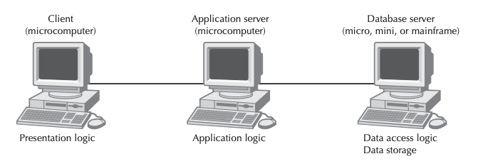

Figure : Three-Tiered Client-Server Architecture

# Hardware

Currently, there are five computers in the head office of the EDE, and they are primarily used for E-mail correspondence and shipment status checking. For the Customer Service Office situated in the Operation Centres, there shall be five computers for the clerk to check up-to-date information for customers. Every Express Center will also have a computer to update the status of the shipment.

The minimum computer specification shall be Intel® Core™ i3 and 8GB DDR4 RAM. Existing hardware shall act as terminals to be used. Two new servers shall be purchased, with one for handling system logic and the other one shall serve the database server. As security measure, there shall be differential backup after each day and a 4TB HDD shall be purchased to server this purpose.

Additional hardware in other branches may be considered upon request and shall be added on a later date if deemed necessary.

QR code scanners and label printers are to be purchased for scanning the unique QR code for updating shipping status. A unique QR code label shall be printed on each shipment package. Staff responsible shall scan the QR Code when the packet arrives at the Operation Center.

# Software

The operating system that is currently in operation at EDE Microsoft Windows. To avoid data conversion and incompatibility issue, the new system shall also be compatible with MS Windows. It is proposed that the minimum system requirements shall be Windows 10 to avoid security issues, given that the lifecycle of Windows 7 has already been officially ended by Microsoft. Existing computers in the headquarters and the Operation Centres shall be used to install the proposed modernized software. As Windows 7 is currently used on some existing terminals, all of them will be upgraded to Windows 10 to meet the system requirements.

For system security, a high standard Firewall shall be employed to enhance the security of the new system. The purpose of installing Firewall is that it is necessary to protect the system against malware threats that exist on the internet or other connected network. In addition to the aforementioned firewall, every computer in the office will also have an anti-virus software installed in order to project the computer from threats such as Trojan Horse. Data security is the and it is a responsibility to make sure that the system could run safe.

The budget of the software is around HK$ 2,000 for the Microsoft Windows licenses and 500 for the Firewall software, account for a total budget estimated of HK$ 40,000.

# Network

Internet connection is a necessity to the new system. All the computers shall be operated in connection and thus not stand-alone after implementing the modernized system. It is reported that the stand-alone PCs currently in operation lead to time consuming activities such as updating data on every computer and data is not synchronized throughout the company. It is hoped that by implementing the new system, data synchronization could be made possible by connect every computer within the network. The Server and the database shall be installed in the headquarters of EDE, and each of the branches will have to connect to the system, which forms a WAN within the facilities of the company. With such efforts, all the facilities, including but not limited to the operation centers and express centers, are able to check the latest status of the shipment and the record of the shipment. In order to protect all the customers personal data such as the address, phone number and the bank account, firewalls shall be installed as forementioned. The server will only allow the users with a valid token to access the server.

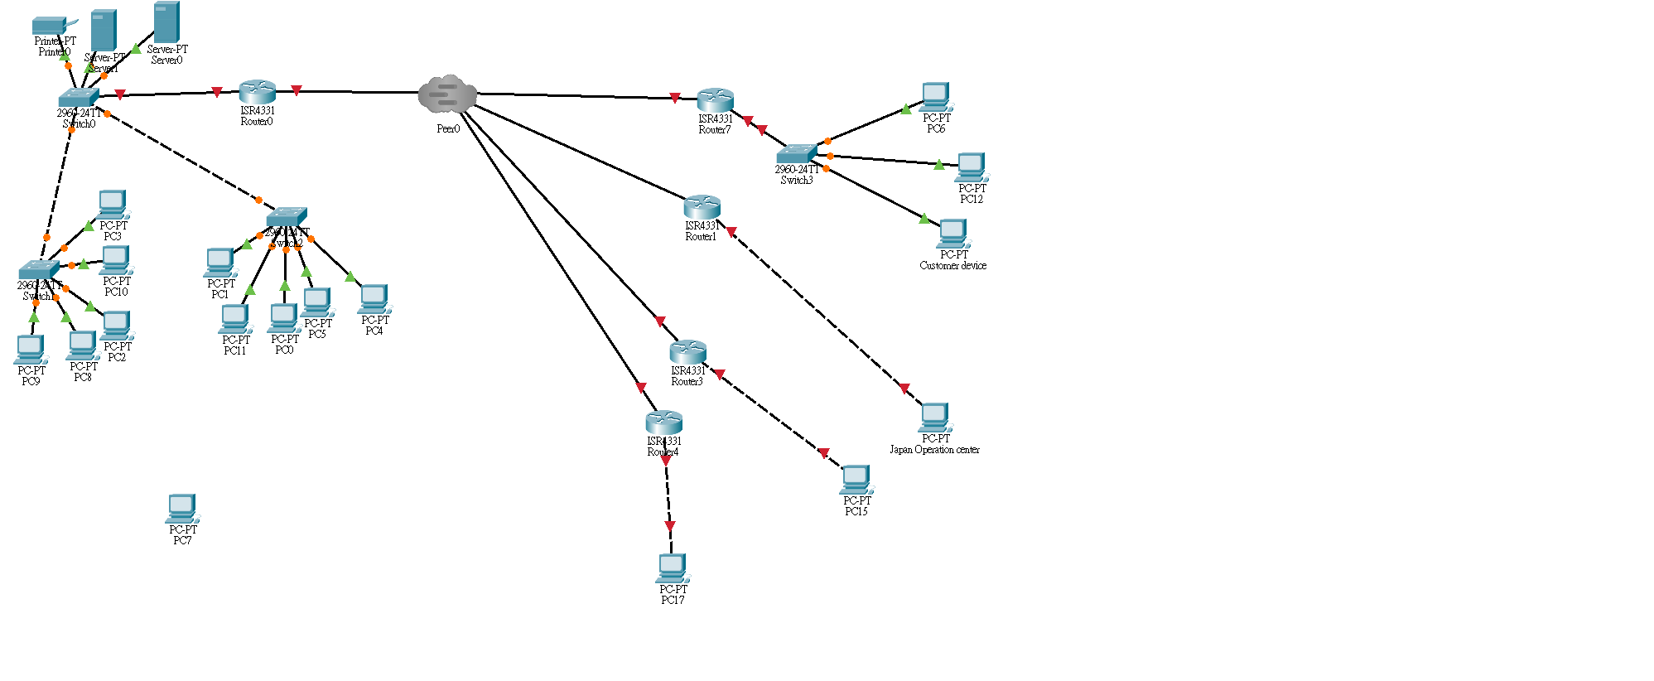

Figure : Proposed Network Architecture of the new system

# Benefits

It is believed that there shall be four major benefits to EDE, as outlined below, after the system is modernized, namely: Increased transparency, reduced workload of staff, reduced response time and Online transactions.

# Increased transparency

With the help of the modernized system, data updates from different Operation Centers, Express Centers and the headquarters shall be reflected at all centers immediately. The Managing Director could monitor the data retrieved form the system and this could be done in real time. As a result, the managing director could propose new strategy in accordance with the real time information retrieved from the system.

Furthermore, thanks to the live tracking system, users are now able to inquiry where the packet is. As a result, customers no longer required to call the customer service hotline every time when he/she would like to check the current location of the packet. If the customer has more than one packet in transit, the system shall be able to check more than one packet at the same time. This could save customers’ time from checking the packets as they do not need to spend more time to check the packet status for the packet one by one.

# Reduced the workload of the staff

After implementing the system, some tasks that requires manual labor due to the existing workflow could be done by the system automatically. For instance, the Accounting Clerk no longer requires inputting the express information from every Center after each month as the new system are capable to record and automatically update and synchronized latest. The accounting clerk does not need to consolidate the data for record-keeping as well.

Similarly, the system could also reduce the workload of the clerks at the headquarters. With the existing workflow, clerks are responsible for sending message manually to alert customer that the packets almost arrive. The new system could improve this situation because the system shall automatically send the SMS to customers to let the customers know that the packets is arrived. As a result, the system could reduce the workload of the employees of EDE, and it is hoped that human resources could be better allocated.

# Reduce response time

Some preliminary inquiries, including but not limited to packet status and time of arrival, asked by customers shall be answered by the platform 24-7. Currently, such work is handled by the customer service team, and they are required respond to the email during 24hrs per day under the existing system. An automated system of the new system shall show basic information and let the customers get their answers in real-time and it does not need extra manpower to handle it.

# Transaction can be done online

Some activities shall now be able to perform online: Registering a new customer account, placing a new order, and paying bill. Currently, customer needs to register new account in person at Operation Centers or Express Centers. Staff at the centers are responsible to perform such operations, but these could be shifted online with the new system. As a result, guest could create a new account and settle bill payment regardless of place and time. This could bring convenience to both staff members and customers.

# Constraints and Limitations

There are some constraints and limitations in designing the system which the team must carefully consider during the design phase for the fact that it might affect further development.

# System may run on different devices

It is acknowledged that the system may not be only run on a computer. For instance, smartphones are now so convenient that clients may use their devices to connect to our system. Issues such as this must be considered during the design phase. As a result, the proposed system shall not be only designed for computer users, but also other devices. The UI of the system, therefore, shall suit both staff and client users. Responsive layout shall be employed when designing the UI and thus different layout shall be created for users of different devices. Also, version of Operating System, browsers on difference devices should also be considered.

# Development environment

As there are enough Visual Studio licenses at EDE for the development team to develop system with C#, the system should be written with C# programming language. It is unfortunate that the team does not have much prior experience in using C# to develop a system, the development team may face some obstacles during the development stage. Also, if there are new updates to the language, the development team should become familiar and adapt with it soon, since if there is a new update means there might be something outdated.

# Alpha version

As there are only a few samples provided for the development team to develop the system, the development team may need to make up data to test the system. Therefore, the development team could only provide an alpha version of the system since the system is using make up data to test with. Also, there might be some unexpected situations that did not show on the samples that were given to the team and thus cannot be solved in the alpha version alone. As a result, the outcome of the system might not suit the company's needs in full. In order to improve the system, it takes time to let the system run and get real life data, then with the real-life data, the development team shall be able to improve the alpha version and provide a beta version of the system.

# System Analysis and Design

# Actor Description

|  |  |  |
| --- | --- | --- |
| **Actor Name** | **Superclass** | **Description** |
| Guest |  | A guest is a person that visits our system without logging in their account. Guests can use some basic functions that are not required to login an EDE account. Guests can register an EDE account. |
| Customer | Guest | A customer is a person that uses our system with a registered account. Customers can place delivery orders and book for pickup or other functions that are required to login to an EDE account. |
| Staff |  | A staff is a person that works in our company and uses our system to work. Staff can help guests to register an EDE account. Staff have basic permission in the system. They can see the basic information of a shipment report. |
| Accounting | staff | An accounting staff is a person that works in our company and uses our system to work. Accounting staff have a higher permission than normal staff. Accounting staff can view shipment report detailly and export them. |
| Manager | staff | A manager is a staff that manages other staff. They will have more permission than the accounting staff. Manager can generate and edit reports. |
| Clerk |  | A clerk is a staff that handles delivery that is placed by a customer. |
| Counter Staff |  | A Counter Staff is a staff that works in the counter and interacts with customers face to face. A counter staff and help guest to create an EDE account. And give basic shipment information to customer. |
| Payment Gateway |  | An external entity, which handles the e-payment transaction. |

# Use Case Diagram

There shall be three use case diagrams outlying the components of the proposed EDE Delivery System, namely: Client System (Figure. 3), Staff Data Sharing Software (Figure.4), and Staff Intranet Portal (Figure. 5).

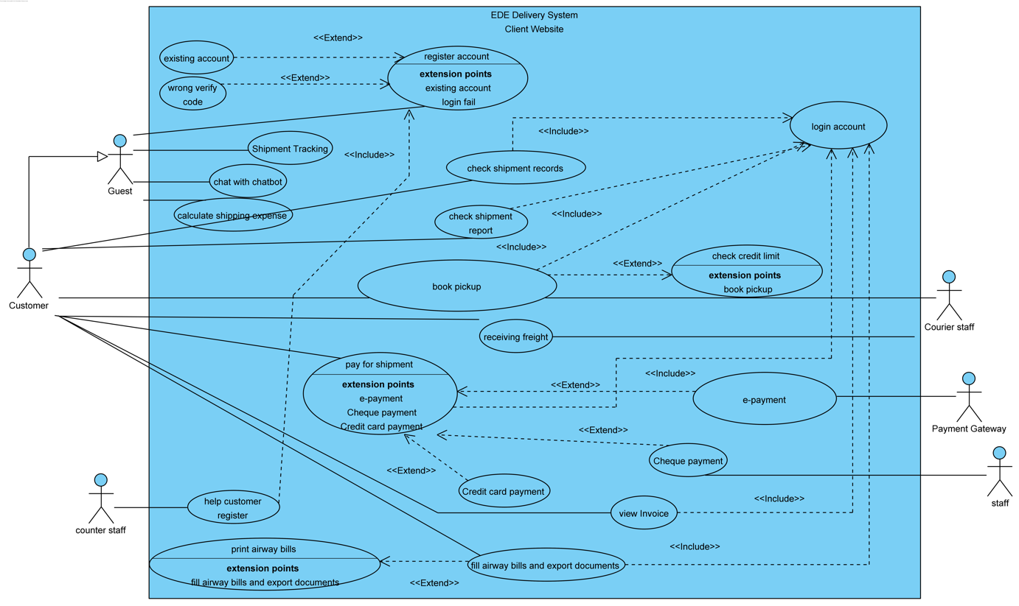

Figure : Client Website

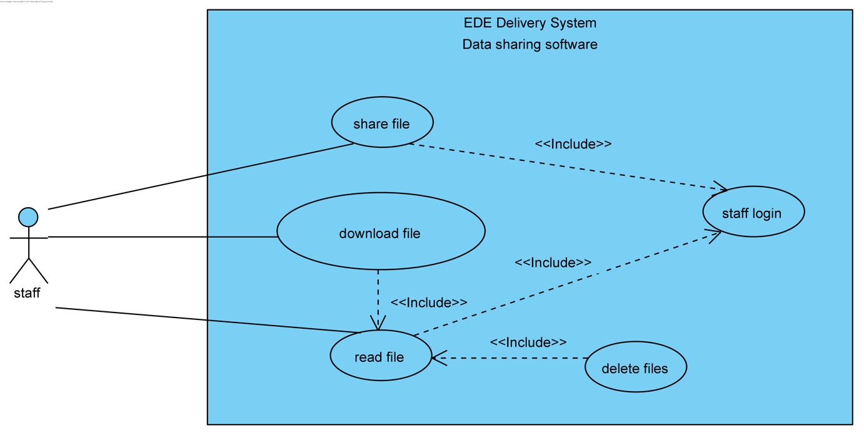

Figure : Staff data sharing software

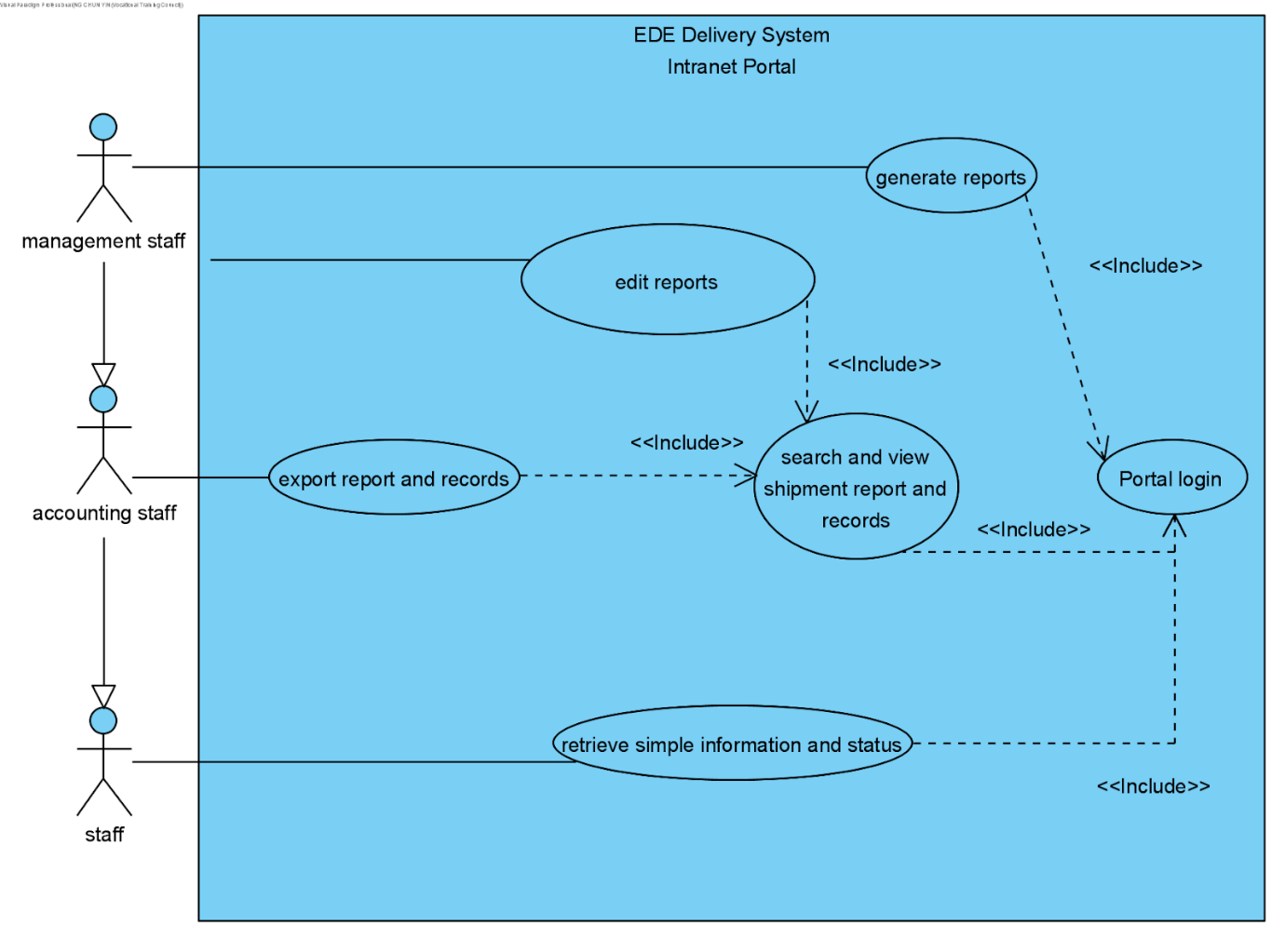

Figure : Staff Intranet Portal

# Use Case Description, Sequence Diagram and State Machine Diagram

# *Client System*

# Register account

|  |  |
| --- | --- |
| **Use case name** | Register account |
| **Use case ID** | UC-001 |
| **Super use case** |  |
| **Actor(s)** | Guest |
| **Brief description** | A guest can register an EDE account |
| **Preconditions** | A guest without an EDE account |
| **Post-conditions** | A guest become a customer with an EDE account |
| **Flow of events** | 1. Go to the register page of the system  2. Fill in their name, home address, phone number, password in a form and submit it  3. A SMS message with a verification code will send to the phone number the guest provided  4. Guest enter the code on the system to verify.  5. The system creates the account. |
| **Alternative flows and exceptions** | If a guest input wrong verification code, extend (wrong verification code)  If the phone number provided by guest is match an existing account, extend (Existing account) |
| **Priority** |  |
| **Non-behavioral requirements** |  |
| **Assumptions** |  |
| **Issues** |  |
| **Source** |  |

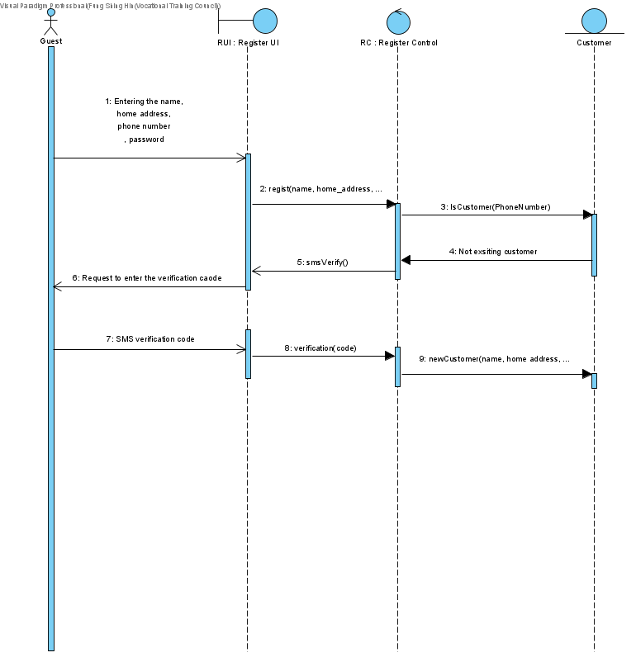

Figure : Register account (Sequence Diagram)

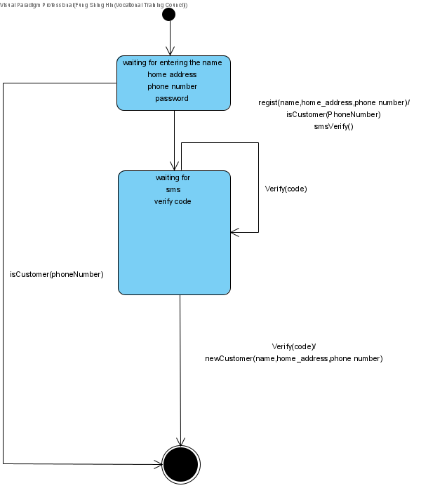

Figure : Register account (State Machine Diagram)

# Existing account

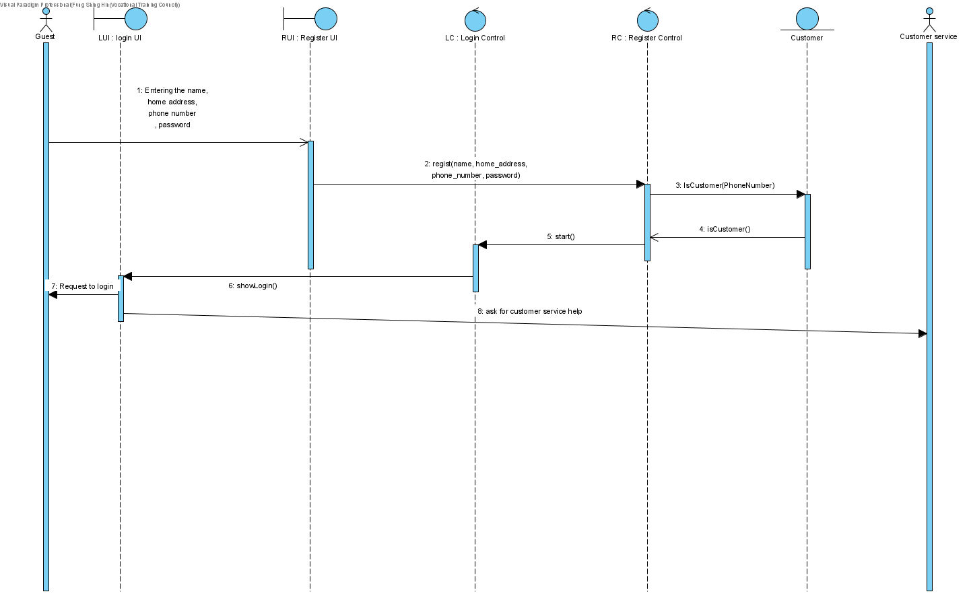

|  |  |
| --- | --- |
| **Use case name** | Existing account |
| **Use case ID** | UC-002 |
| **Super use case** |  |
| **Actor(s)** | Guest |
| **Brief description** | A guest wants to register an EDE account with phone number that match an existing EDE account |
| **Preconditions** | Guest registering account |
| **Post-conditions** | Register fails |
| **Flow of events** | 1. System display a message to the guest to ask he to login, since there is an existing account. Also, system will show a message to ask guest to contact customer service if guest don’t remember they have registered an EDE account before. |
| **Alternative flows and exceptions** |  |
| **Priority** |  |
| **Non-behavioral requirements** |  |
| **Assumptions** |  |
| **Issues** |  |
| **Source** |  |

Figure : Exiting account (Sequence Diagram)



Figure : Existing account (State Machine Diagram)

# Wrong verification code

|  |  |
| --- | --- |
| **Use case name** | Wrong verification code |
| **Use case ID** | UC-003 |
| **Super use case** |  |
| **Actor(s)** | Guest |
| **Brief description** | A guest can register an EDE account |
| **Preconditions** | Guest registering account |
| **Post-conditions** | Register fails |
| **Flow of events** | 1. System send new verification code  2. guest enter verification code  3. System check verification code  4. Register successful |
| **Alternative flows and exceptions** | Step 1-3 can be repeated until guest enter a right verification code or verification code had been sent to guest three time in total  If a guest input wrong verification code for three time, the verification will fail |
| **Priority** |  |
| **Non-behavioral requirements** |  |
| **Assumptions** |  |
| **Issues** |  |
| **Source** |  |

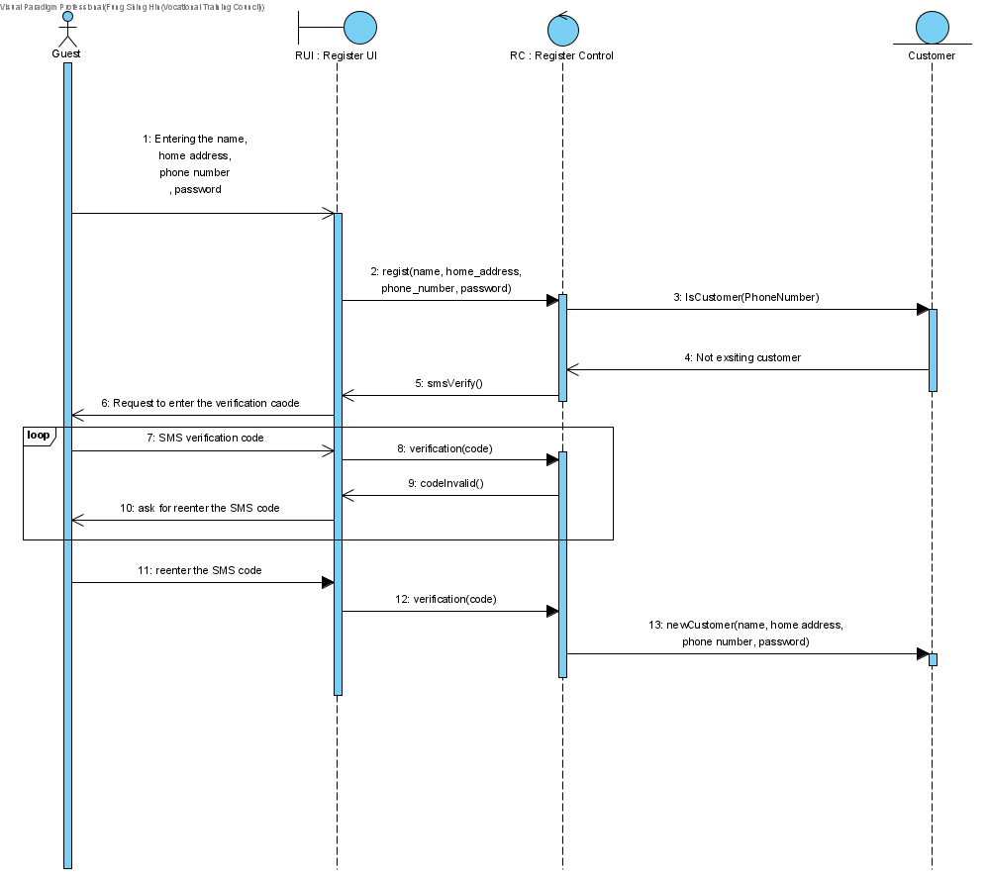

Figure : Wrong verification Code (Sequence Diagram)



Figure : Wrong verification Code (State Machine Diagram)

# *Shipment Tracking*

|  |  |
| --- | --- |
| **Use case name** | Shipment Tracking |
| **Use case ID** | UC-004 |
| **Super use case** |  |
| **Actor(s)** | Guest |
| **Brief description** | A guest can check shipment status and information online |
| **Preconditions** | shipment status and information not shown |
| **Post-conditions** | shipment status and information shown |
| **Flow of events** | 1. The guest visit the register page  2. The guest enter shipment number and the phone number of the shipment sender. System checks if the shipment number is existing or not. And system check is the phone number inputted match the shipment number or not  5. System show the shipment status and information |
| **Alternative flows and exceptions** | The guest enters shipment number shipment number that does not exist. The system shows an error message.    The phone number inputted does not match shipment number. The system will show an error message. |
| **Priority** |  |
| **Non-behavioral requirements** |  |
| **Assumptions** |  |
| **Issues** |  |
| **Source** |  |

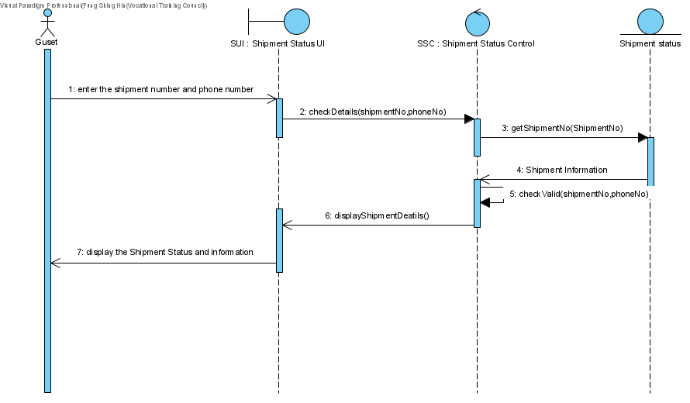

Figure : Shipment tracking Scenario 1 (Sequence Diagram)

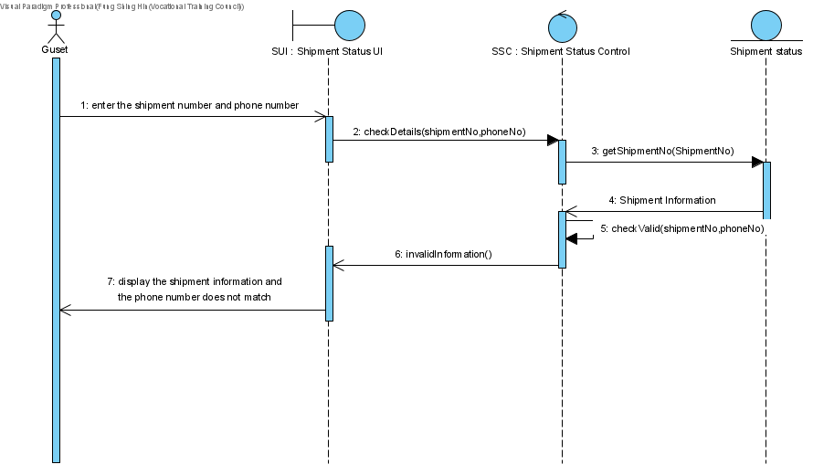

Figure : Shipment tracking Scenario 2 (Sequence Diagram)

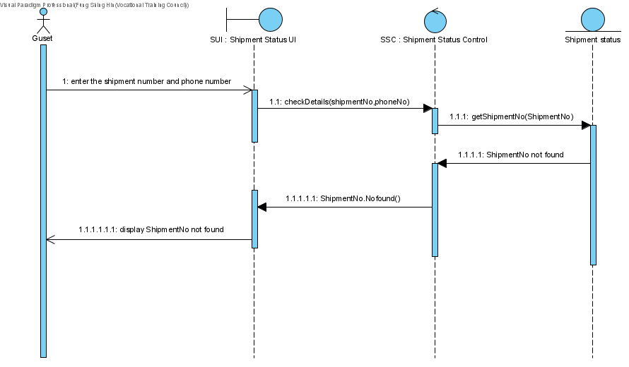

Figure : Shipment tracking Scenario 3 (Sequence Diagram)

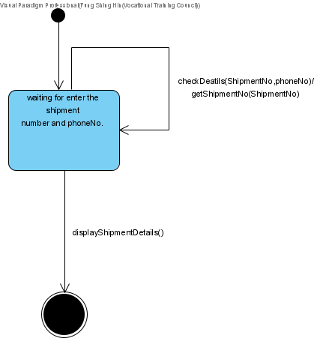

Figure : Shipment tracking (State Machine Diagram)

# *Chat with chatbot*

|  |  |
| --- | --- |
| **Use case name** | chat with chatbot |
| **Use case ID** | UC-005 |
| **Super use case** |  |
| **Actor(s)** | Guest |
| **Brief description** | A guest can talk with chatbot to get information |
| **Preconditions** | Guest visiting our system |
| **Post-conditions** | Guest gets information from the chatbot |
| **Flow of events** | 1. Guest click into the bot section of the system  2. Guest input message or click existing Q&A  3. Chatbot show related information |
| **Alternative flows and exceptions** | Steps 2-3 can be repeated until the customer stops using the chatbot.    If there are questions that the chatbot cannot answer, the system will contact staff to help with. |
| **Priority** |  |
| **Non-behavioral requirements** |  |
| **Assumptions** |  |
| **Issues** |  |
| **Source** |  |

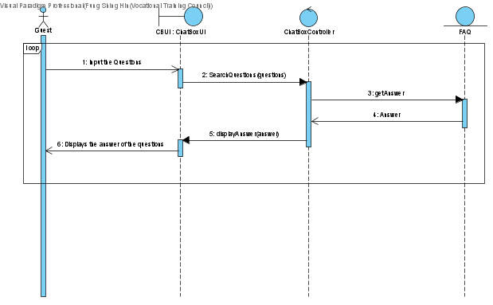

Figure : Chat with chatbot Scenario 1 (Sequence Diagram)

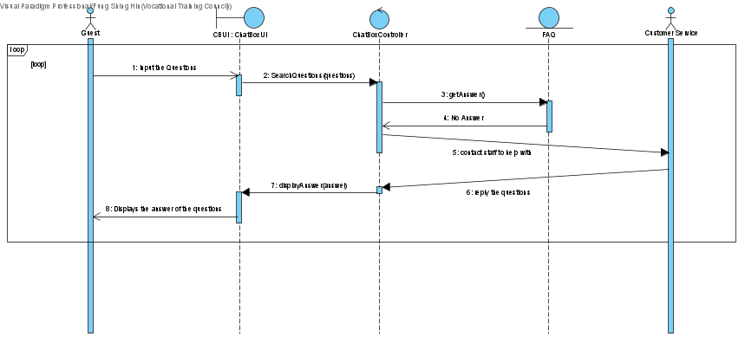

Figure : Chat with chatbot Scenario 2 (Sequence Diagram)

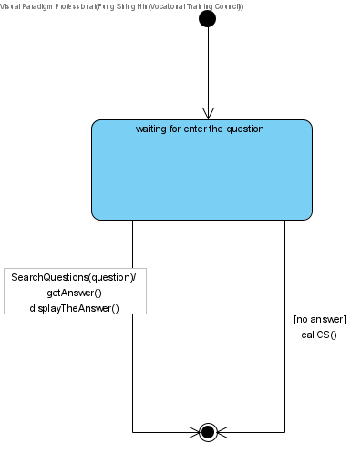

Figure :Chat with chatbot (State Machine Diagram)

# *Calculate shipping expense*

|  |  |
| --- | --- |
| **Use case name** | Calculate shipping expense |
| **Use case ID** | UC-006 |
| **Super use case** |  |
| **Actor(s)** | Guest |
| **Brief description** | Guest can enter basic shipment information to calculate shipping expense |
| **Preconditions** |  |
| **Post-conditions** |  |
| **Flow of events** | 1. The guest visit the Shipping Expenses Calculation page  2. The guest enter express type, weight and countries of the shipment  3. The system process those data and calculate the shipment expense and show to the guest |
| **Alternative flows and exceptions** | Guest did not enter all data that are needed, the system will ask customer to enter the information again. |
| **Priority** |  |
| **Non-behavioral requirements** |  |
| **Assumptions** |  |
| **Issues** |  |
| **Source** |  |

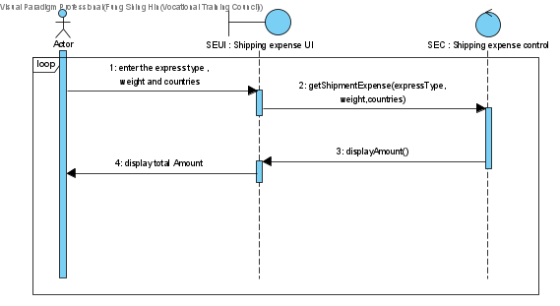

Figure : Calculate shipment expense (Sequence Diagram)

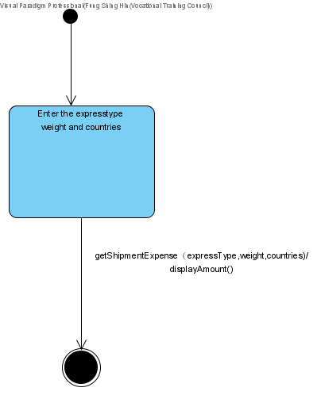

Figure : Calculate shipment expense (State Machine Diagram)

# *Login*

|  |  |
| --- | --- |
| **Use case name** | login |
| **Use case ID** | UC-007 |
| **Super use case** | Guest |
| **Actor(s)** | Customer |
| **Brief description** | The customer logins the system. |
| **Preconditions** | Customer not logged in in the system |
| **Post-conditions** | Customer logged in with their account. |
| **Flow of events** | 1. Enter phone number and password.  2. System check data that customer inputted  3. System print an output successful message |
| **Alternative flows and exceptions** | Customer enters a wrong password |
| **Priority** |  |
| **Non-behavioral requirements** |  |
| **Assumptions** |  |
| **Issues** |  |
| **Source** |  |

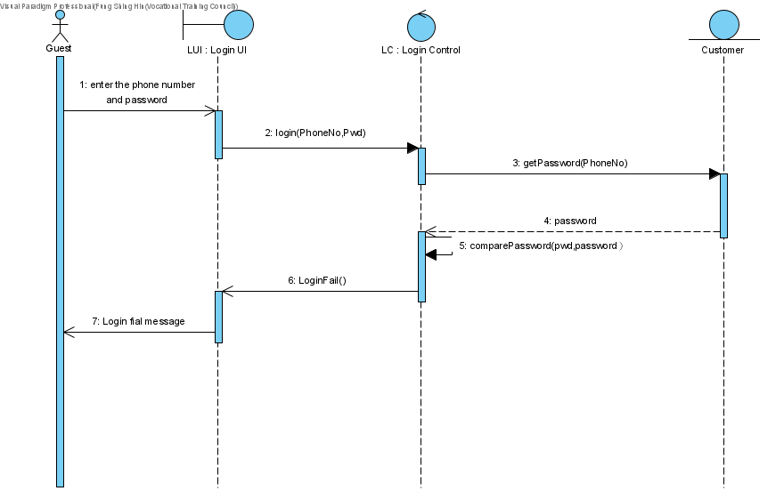

Figure : Login Scenario 1 (Sequence Diagram)



Figure : Login Scenario 2 (Sequence Diagram)

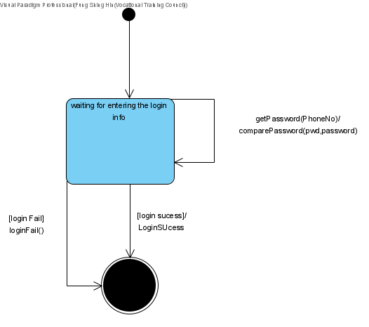

Figure : Login (State Machine Diagram)

# *Check shipment records*

|  |  |
| --- | --- |
| **Use case name** | Check shipment records |
| **Use case ID** | UC-008 |
| **Super use case** | Guest |
| **Actor(s)** | Customer |
| **Brief description** | The customer check shipment records, to know the details of the shipment. |
| **Preconditions** | Customer not logged in in the system |
| **Post-conditions** | Customer gets shipment records |
| **Flow of events** | 1. include (login).  2. Customer enter month year  3. System show related shipment records |
| **Alternative flows and exceptions** |  |
| **Priority** |  |
| **Non-behavioral requirements** |  |
| **Assumptions** |  |
| **Issues** |  |
| **Source** |  |

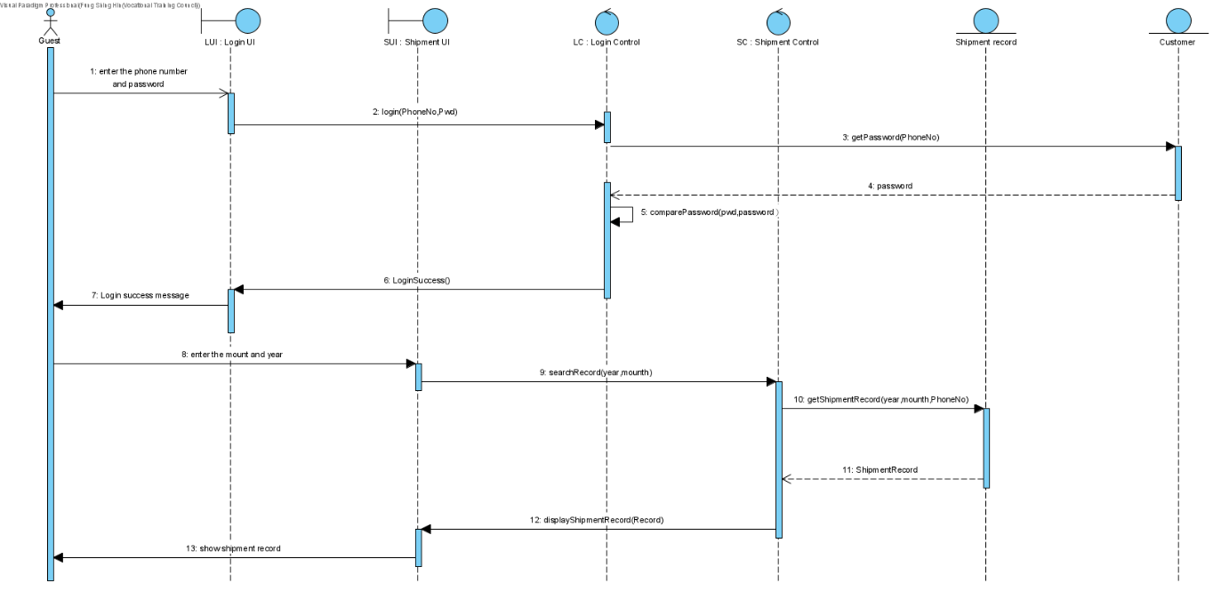

Figure : Check shipment record (Sequence Diagram)

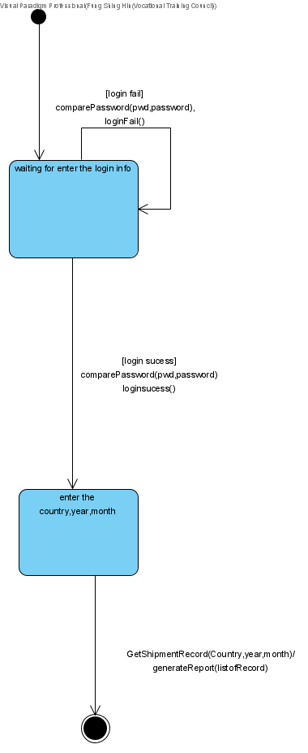

Figure : Check shipment record (State Machine Diagram)

# *Check shipment reports*

|  |  |
| --- | --- |
| **Use case name** | Check shipment reports |
| **Use case ID** | UC-009 |
| **Super use case** | Guest |
| **Actor(s)** | Customer |
| **Brief description** | The customer checks shipment reports, to know the shipment status with reports. |
| **Preconditions** | Customer not logged in in the system |
| **Post-conditions** | Customer gets shipment reports |
| **Flow of events** | 1. include (login).  2. Click into the account tab and choose report tab  3. Customer choose to view daily or weekly or monthly or yearly reports  4. System shows related report |
| **Alternative flows and exceptions** |  |
| **Priority** |  |
| **Non-behavioral requirements** |  |
| **Assumptions** |  |
| **Issues** |  |
| **Source** |  |

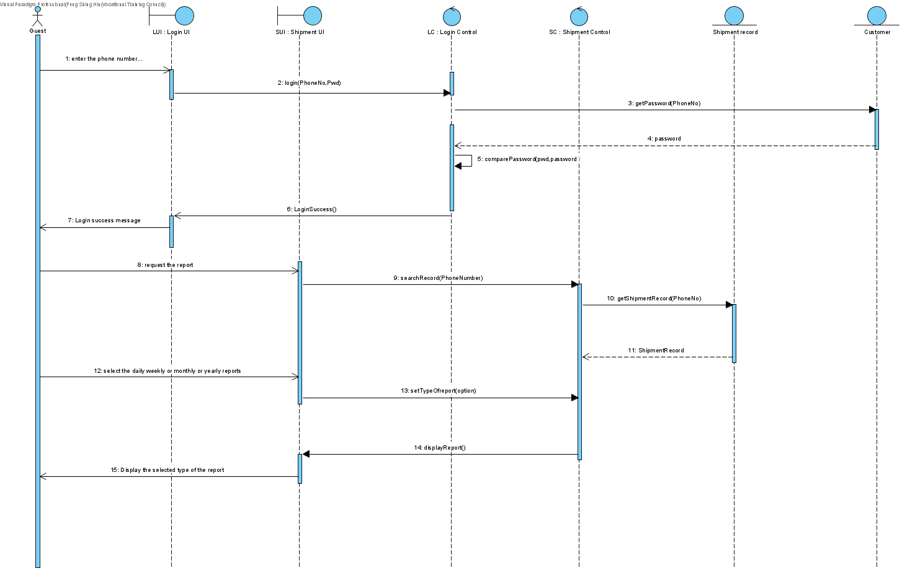

Figure : Check shipment reports (Sequence Diagram)

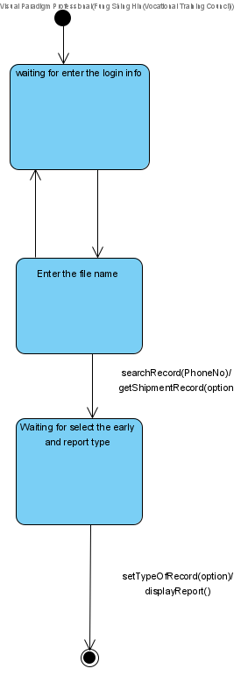

Figure : Check shipment reports (State Machine Diagram)

# *Book pick up*

|  |  |
| --- | --- |
| **Use case name** | book pick up |
| **Use case ID** | UC-0010 |
| **Super use case** | Guest |
| **Actor(s)** | Customer |
| **Brief description** | The customer Book the pickup for arrangement of shipment collection |
| **Preconditions** | Customer not logged in the system |
| **Post-conditions** | Customer have booked for shipment pickup |
| **Flow of events** | 1. include (login).  2. Customer enter the pick-up time, shipment quantity and the shipment type  3. System direct pickup order to nearest express center  4. System will add the pickup fee to the shipment bill |
| **Alternative flows and exceptions** | Customer pays the shipment bills monthly. extend (check credit limit) |
| **Priority** |  |
| **Non-behavioral requirements** |  |
| **Assumptions** |  |
| **Issues** |  |
| **Source** |  |

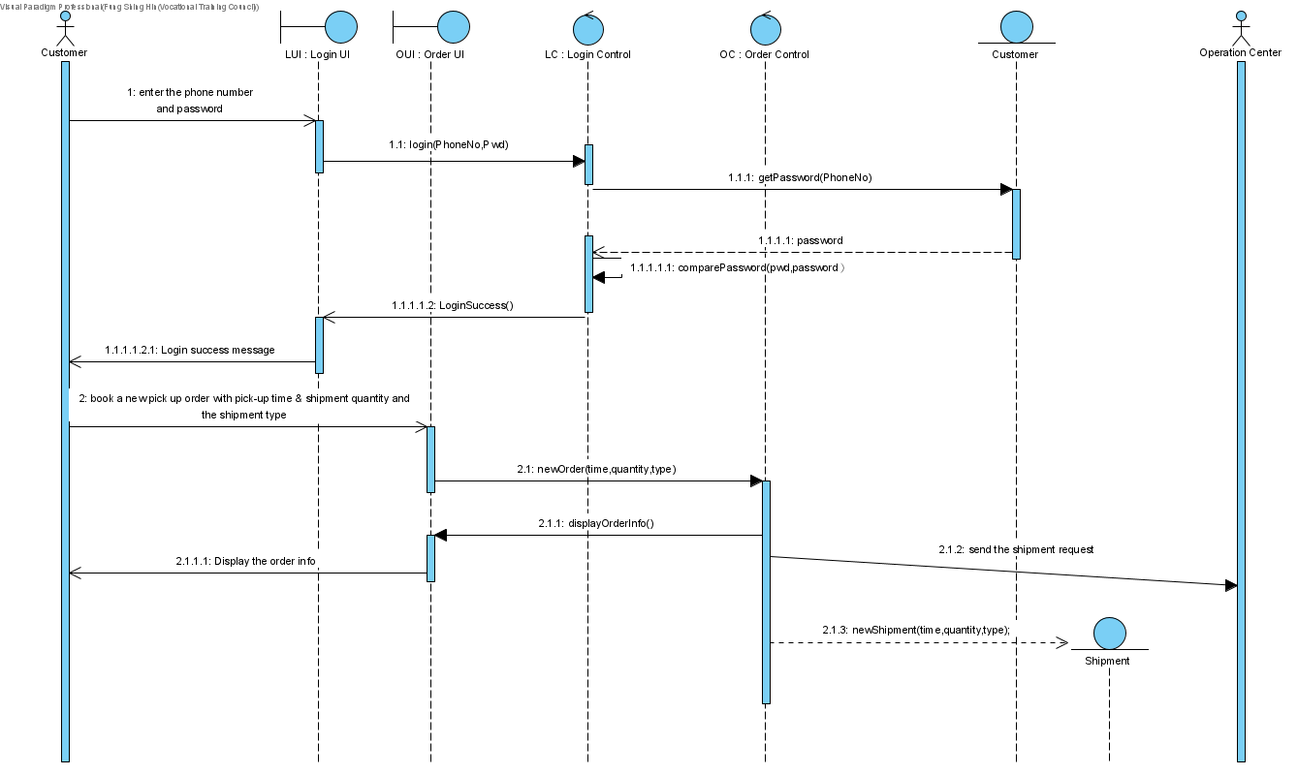

Figure : Book pick up (Sequence Diagram)

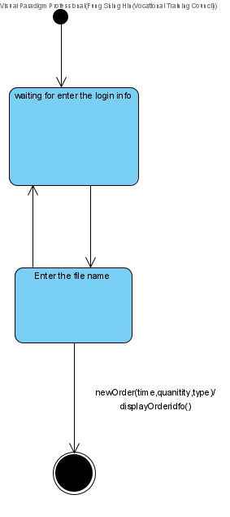

Figure : Book pick up (State Machine Diagram)

# *Check credit limit*

|  |  |
| --- | --- |
| **Use case name** | check credit limit |
| **Use case ID** | UC-011 |
| **Super use case** | Guest |
| **Actor(s)** | Customer |
| **Brief description** | Customer pays the shipment bills monthly. System checks their credit limit. |
| **Preconditions** | Customer not logged in the system |
| **Post-conditions** | Customer have booked for shipment pickup |
| **Flow of events** | 1. System will check their credit limit.  2. System knows customers have good credit limits; customers proceed to pick up bookings. |
| **Alternative flows and exceptions** | If the credit limit is not good, the system will show a message to the customer to call the hotline for help. |
| **Priority** |  |
| **Non-behavioral requirements** |  |
| **Assumptions** |  |
| **Issues** |  |
| **Source** |  |

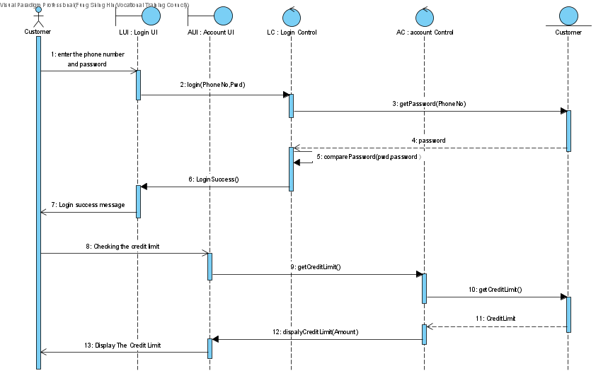

Figure : Check credit limit (Sequence Diagram)

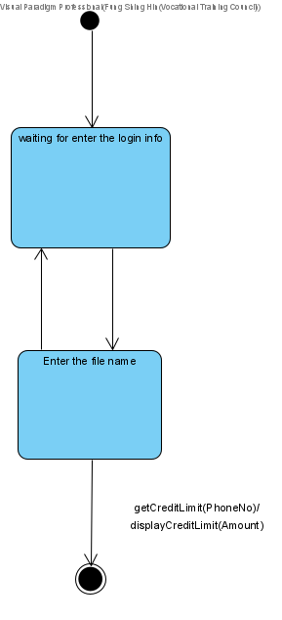

Figure : Check credit limit (State Machine Diagram)

# *Receiving freight*

|  |  |
| --- | --- |
| **Use case name** | receiving freight |
| **Use case ID** | UC-012 |
| **Super use case** | Guest |
| **Actor(s)** | Customer |
| **Secondary Actor** | Clerk |
| **Brief description** | Customer |
| **Preconditions** | Shipment not complete |
| **Post-conditions** | Shipment complete |
| **Flow of events** | 1. Customer sign in the tablet  2. Courier Staff click complete button in the tablet  3. System create a receipt and saved in the database  4. Receipt are also sent to the General Ledger |
| **Alternative flows and exceptions** |  |
| **Priority** |  |
| **Non-behavioral requirements** |  |
| **Assumptions** |  |
| **Issues** |  |
| **Source** |  |

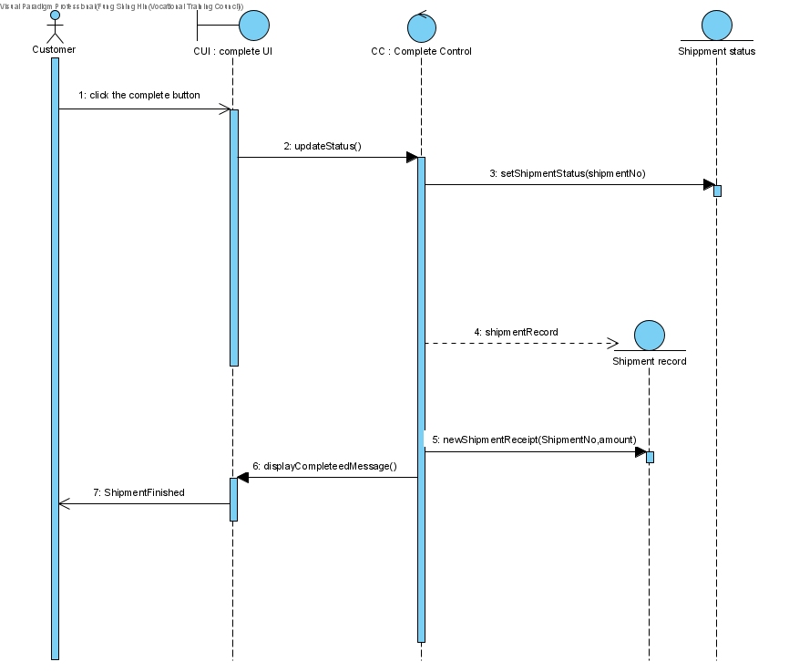

Figure : Receiving freight (Sequence Diagram)

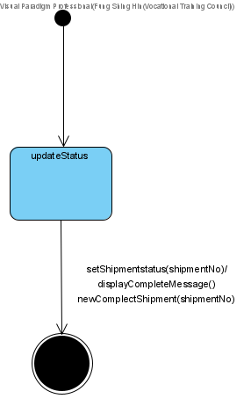

Figure : Receiving freight (State Machine Diagram)

# *Pay for shipment*

|  |  |
| --- | --- |
| **Use case name** | pay for shipment |
| **Use case ID** | UC-013 |
| **Super use case** | Guest |
| **Actor(s)** | Customer |
| **Secondary Actor** |  |
| **Brief description** | Customer can pay for the shipment bill |
| **Preconditions** | Shipment has not been paid |
| **Post-conditions** | Shipment has been paid |
|  | 1. include(login)  2. Customer select shipment or monthly shipment in the “My shipment” tab of the account information page  3. Customer click the pay button  4. System redirect the system to the payment page  5. Customer choose the payment method  6. extend(e-payment)/  extend (Credit card payment)/  extend (Cheque payment)  7. System shows payment successful message and generate invoice in the database. |
| **Alternative flows and exceptions** | If customer pays with e-payment, extend (e-payment)  If customer pays with credit card, extend (Credit card payment)  If customer pays with cheque, extend (Cheque payment)  If customer payment fails, system show a message to ask for customer to pay again. |
| **Priority** |  |
| **Non-behavioral requirements** |  |
| **Assumptions** |  |
| **Issues** |  |
| **Source** |  |

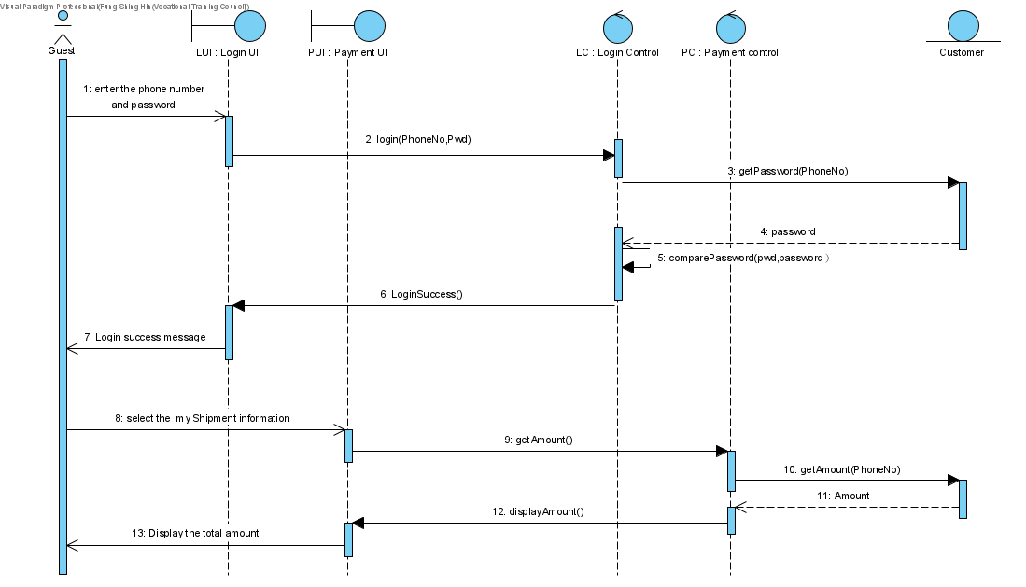

Figure : Pay for shipment (Sequence Diagram)

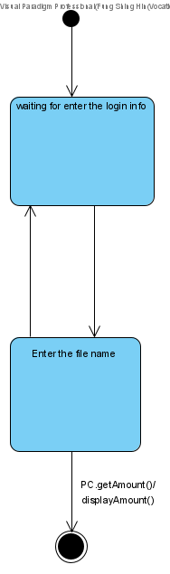

Figure : Pay for shipment (State Machine Diagram)

# *E-payment*

|  |  |
| --- | --- |
| **Use case name** | e-payment |
| **Use case ID** | UC-014 |
| **Super use case** | Guest |
| **Actor(s)** | Customer |
| **Secondary Actor** | Payment Gateway |
| **Brief description** | Customer can choose to pay their shipment with e-payment, if use this method to pay, an external Payment Gateway will help to finish the payment |
| **Preconditions** | Shipment not complete |
| **Post-conditions** | Shipment complete |
| **Flow of events** | 1. Customer choose which e-payment method they want to pay with  2. System show related instruction on screen  3. Customer follow instruction to enter or scan a corresponding QR code or payment code with his phone e-payment app |
| **Alternative flows and exceptions** |  |
| **Priority** |  |
| **Non-behavioral requirements** |  |
| **Assumptions** |  |
| **Issues** |  |
| **Source** |  |

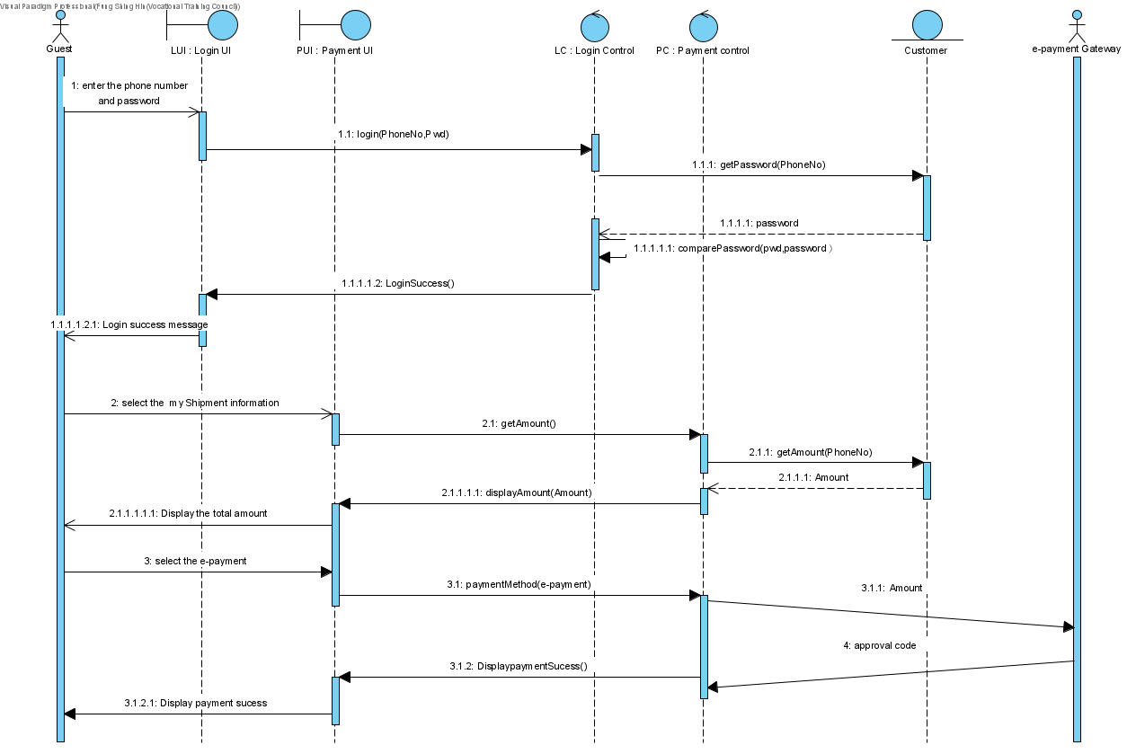

Figure : E-payment Scenario 1 (Sequence Diagram)

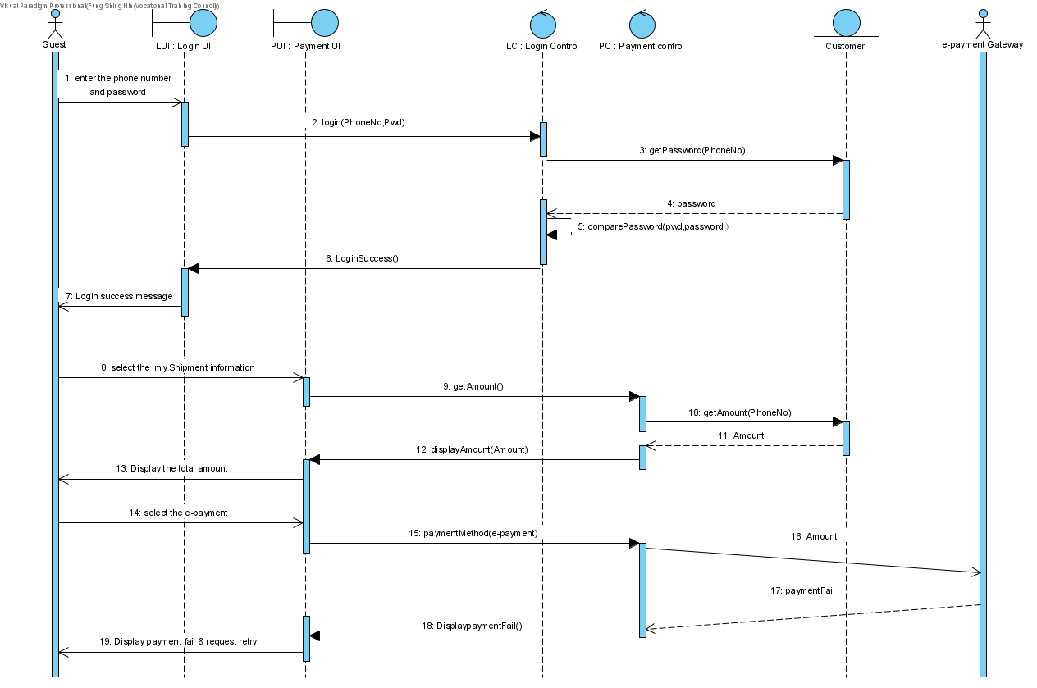

Figure : E-payment Scenario 2 (Sequence Diagram)

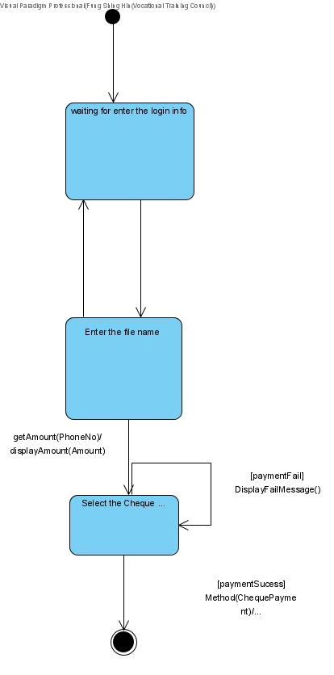

Figure : E-payment (State Machine Diagram)

# *Credit card payment*

|  |  |
| --- | --- |
| **Use case name** | Credit card payment |
| **Use case ID** | UC-015 |
| **Super use case** | Guest |
| **Actor(s)** | Customer |
| **Secondary Actor** | Payment Gateway |
| **Brief description** | Customer can choose to pay their shipment with e-payment, if use this method to pay, an external Payment Gateway will help to finish the payment |
| **Preconditions** | Shipment not complete |
| **Post-conditions** | Shipment complete |
| **Flow of events** | 1. System redirect customer to credit card’s external payment gateway  2. Customer fill in the card information and send it |
| **Alternative flows and exceptions** |  |
| **Priority** |  |
| **Non-behavioral requirements** |  |
| **Assumptions** |  |
| **Issues** |  |
| **Source** |  |

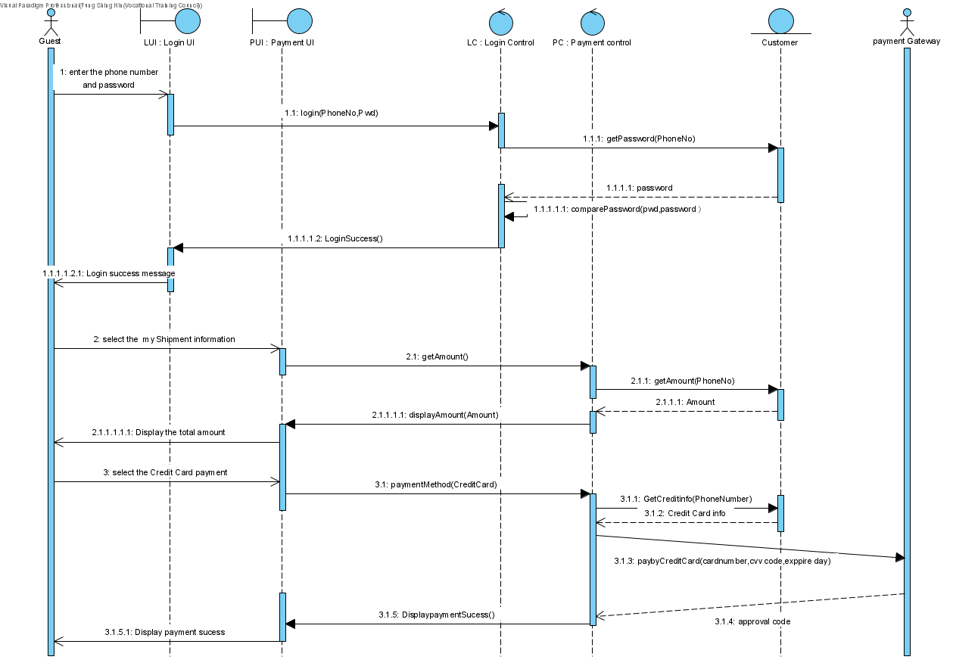

Figure : Credit card payment Scenario 1 (Sequence Diagram)

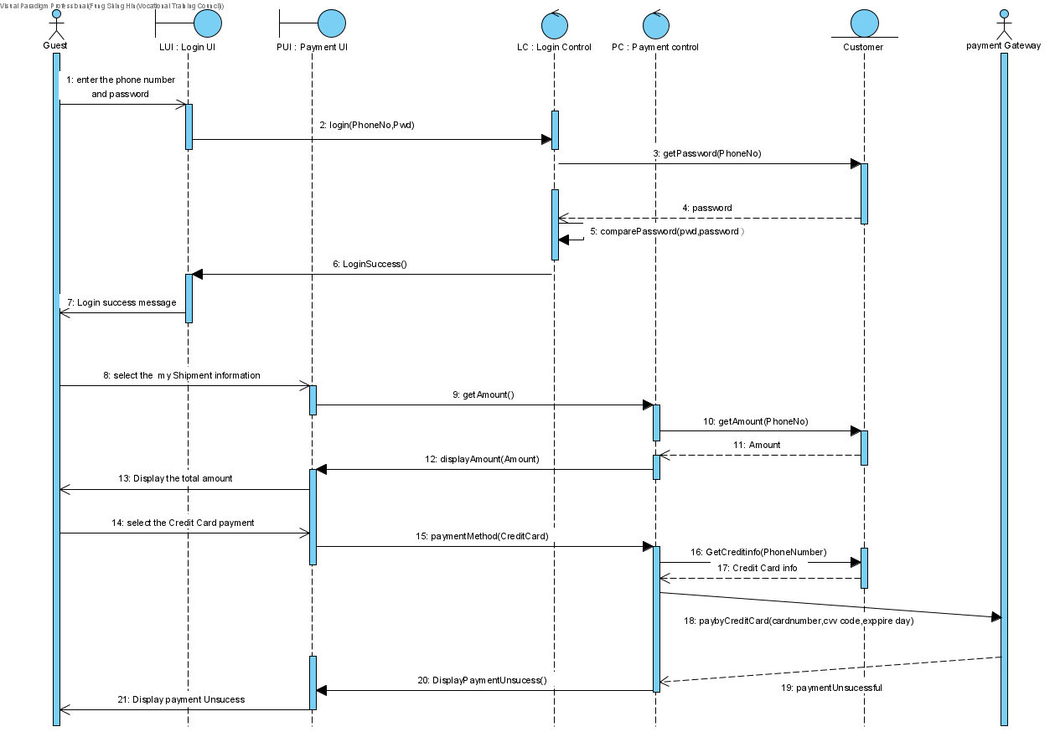

Figure : Credit card payment Scenario 2 (Sequence Diagram)

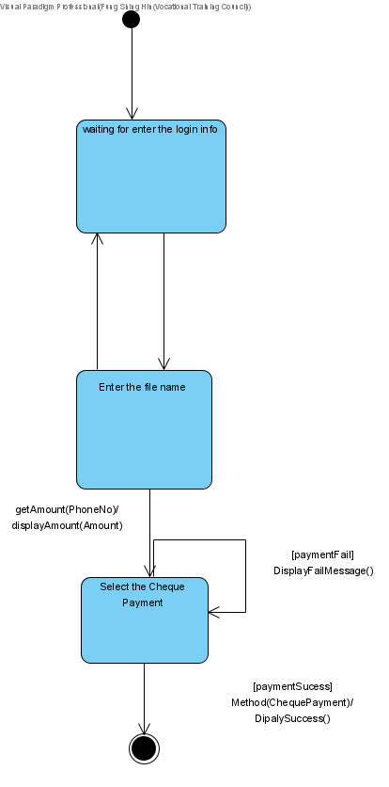

Figure : Credit card payment (State Machine Diagram)

# *Cheque payment*

|  |  |
| --- | --- |
| **Use case name** | Cheque payment |
| **Use case ID** | UC-016 |
| **Super use case** | Guest |
| **Actor(s)** | Customer |
| **Secondary Actor** | Staff |
| **Brief description** | Customer can choose to pay their shipment with e-payment, if use this method to pay, an external Payment Gateway will help to finish the payment |
| **Preconditions** | Shipment not complete |
| **Post-conditions** | Shipment complete |
| **Flow of events** | 1. Customer clicks the upload button to upload the receipt of the cheque payment  2. System send the receipt to staff for verification |
| **Alternative flows and exceptions** |  |
| **Priority** |  |
| **Non-behavioral requirements** |  |
| **Assumptions** |  |
| **Issues** |  |
| **Source** |  |

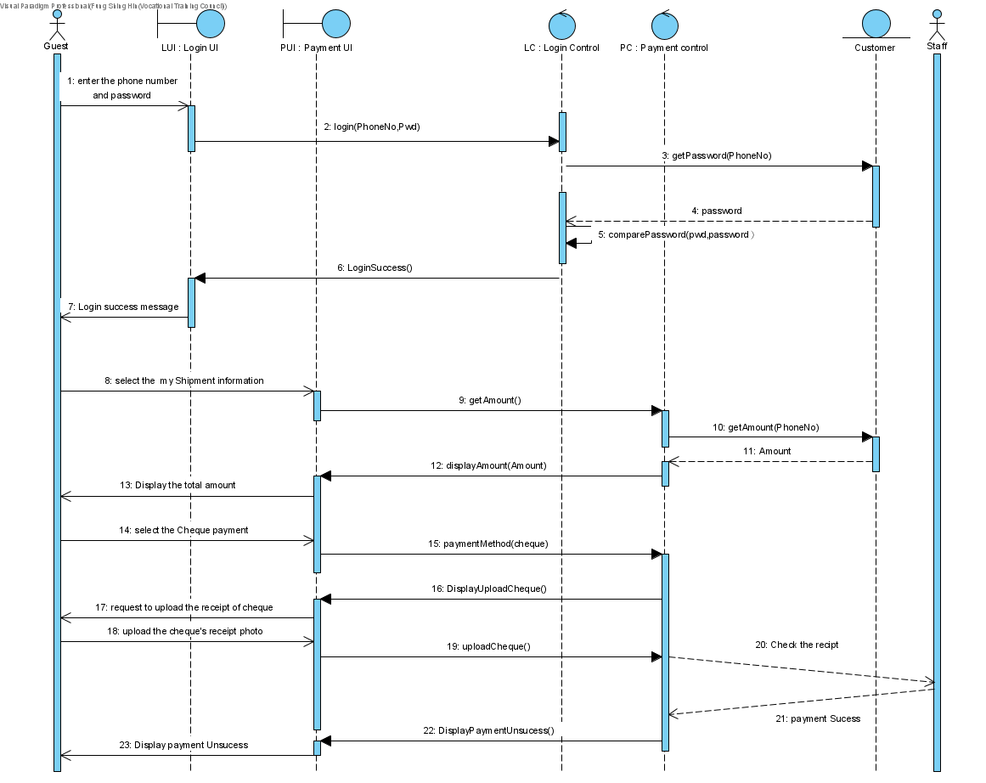

Figure : Cheque payment (Sequence Diagram)

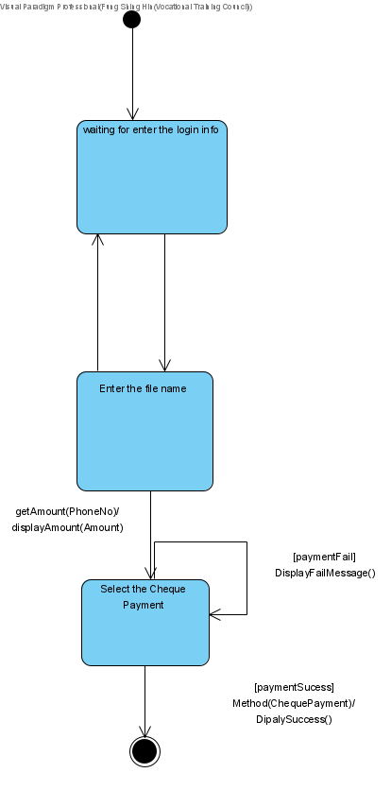

Figure : Cheque Payment (State Machine Diagram)

# *View invoice*

|  |  |
| --- | --- |
| **Use case name** | view invoice |
| **Use case ID** | UC-017 |
| **Super use case** | Guest |
| **Actor(s)** | Customer |
| **Secondary Actor** |  |
| **Brief description** | Customer can login account to view invoice of completed shipment |
| **Preconditions** |  |
| **Post-conditions** |  |
| **Flow of events** | 1. include(login)  2. Customer visit “My account” page of the system  3. Customer click the “Invoice” tab  4. Customer enters the month and year of invoice customer want to see  5. System show related invoice of the customer |
| **Alternative flows and exceptions** |  |
| **Priority** |  |
| **Non-behavioral requirements** |  |
| **Assumptions** |  |
| **Issues** |  |
| **Source** |  |

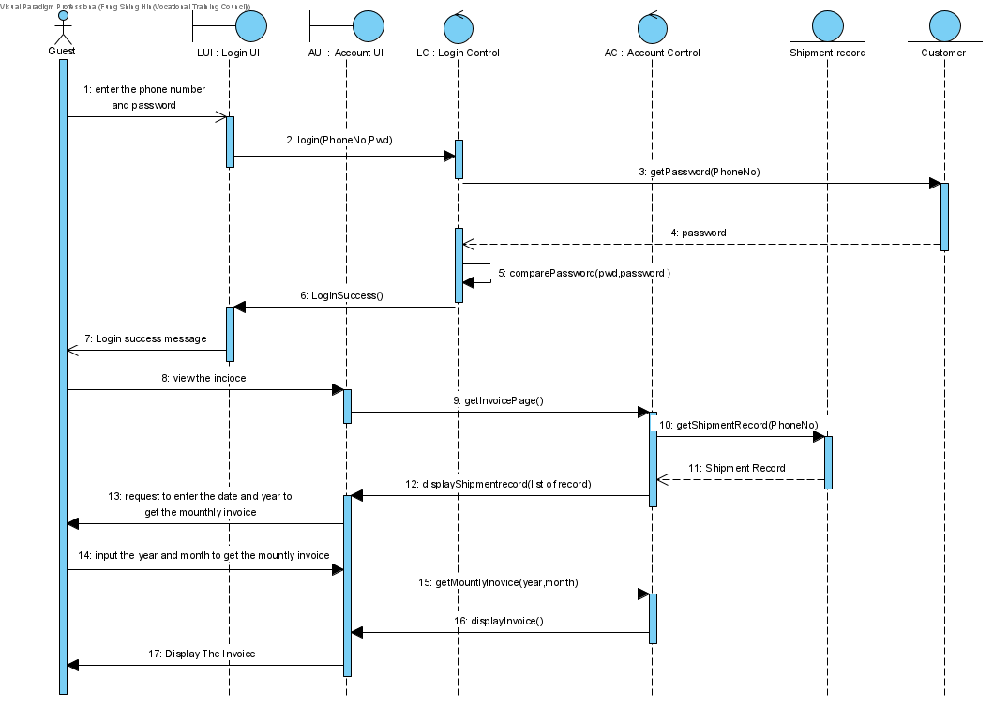

Figure : View invoice (Sequence Diagram)

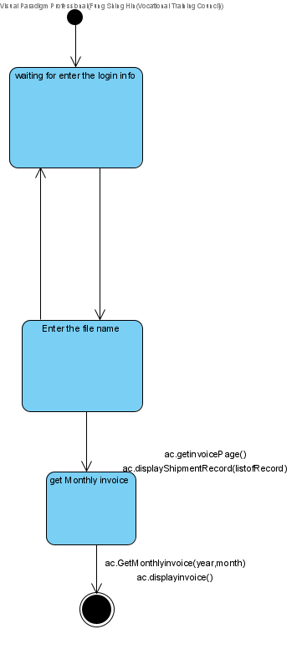

Figure : View invoice (State Machine Diagram)

# *Fill airway bills and export documents*

|  |  |
| --- | --- |
| **Use case name** | fill airway bills and export documents |
| **Use case ID** | UC-018 |
| **Super use case** | Guest |
| **Actor(s)** | Customer |
| **Secondary Actor** |  |
| **Brief description** | Customer can fill airway bills and export documents, so that they don’t have to fill those documents in the EDE center |
| **Preconditions** | airway bills and export documents not in database |
| **Post-conditions** | airway bills and export documents saved in database |
| **Flow of events** | 1. include(login)  2. Customer navigate to the fill airway bills page  3. customer filled the airway bills form and upload export documents  3. System save the form in database |
| **Alternative flows and exceptions** |  |
| **Priority** |  |
| **Non-behavioral requirements** |  |
| **Assumptions** |  |
| **Issues** |  |
| **Source** |  |

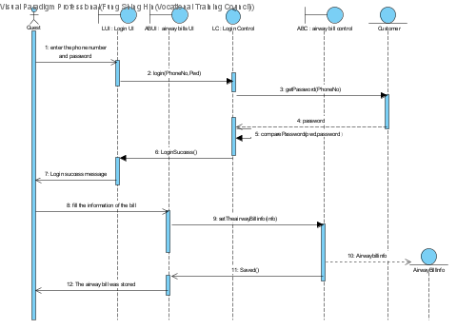

Figure : Fill airway bills and export documents (Sequence Diagram)

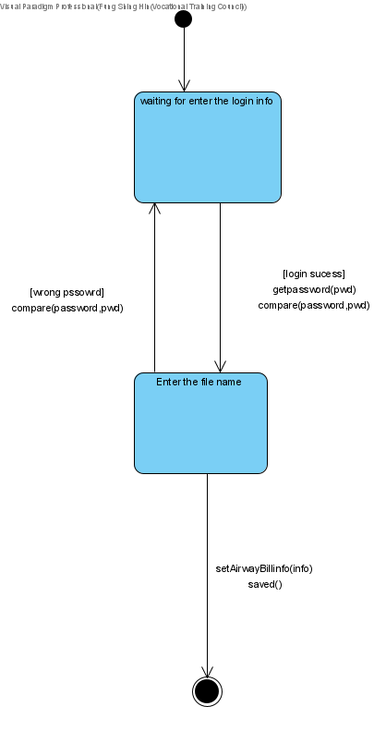

Figure : Fill airway bills and export documents (State Machine Diagram)

# *Print airway bills*

|  |  |
| --- | --- |
| **Use case name** | print airway bills |
| **Use case ID** | UC-019 |
| **Super use case** |  |
| **Actor(s)** | Customer |
| **Secondary Actor** |  |
| **Brief description** | after submitted airway bills customer can choose to print out the airway bills |
| **Preconditions** | Customer submitted the form |
| **Post-conditions** | Airway bills are printed |
| **Flow of events** | 1. include (fill airway bills and export documents)  2. Customer click print button  3. System inform the computer to send printing request to printer |
| **Alternative flows and exceptions** |  |
| **Priority** |  |
| **Non-behavioral requirements** |  |
| **Assumptions** |  |
| **Issues** |  |
| **Source** |  |

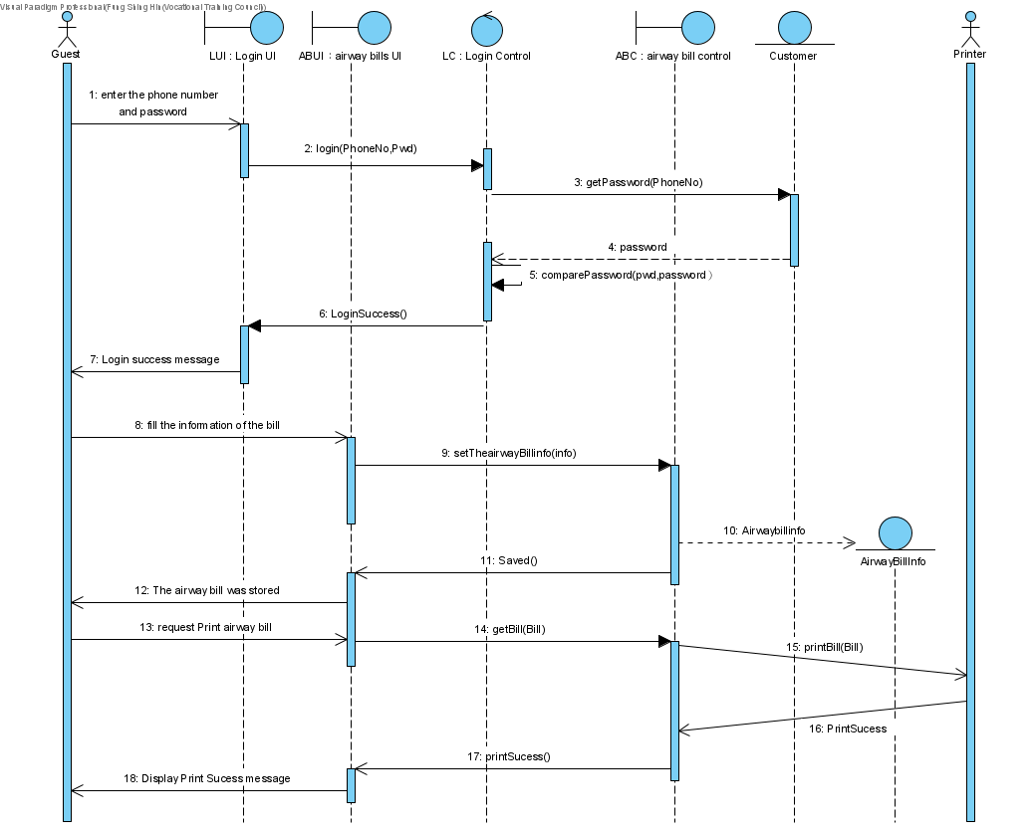

Figure : Print airway bills (Sequence Diagram)

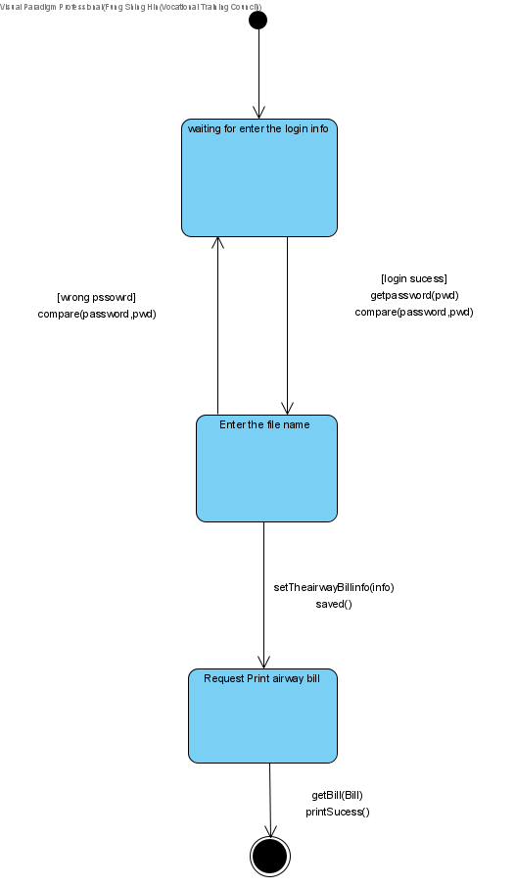

Figure : Print airway bills (State Machine Diagram)

# *Help customer register*

|  |  |
| --- | --- |
| **Use case name** | Help customer register |
| **Use case ID** | UC-020 |
| **Super use case** |  |
| **Actor(s)** | Counter Staff |
| **Secondary Actor** |  |
| **Brief description** | If customers go to the EDE center to create an EDE account, counter staff can provide help. |
| **Preconditions** | Guest without an EDE account |
| **Post-conditions** | Guest become customer with an EDE account |
| **Flow of events** | 1. include (register account) |
| **Alternative flows and exceptions** |  |
| **Priority** |  |
| **Non-behavioral requirements** |  |
| **Assumptions** |  |
| **Issues** |  |
| **Source** |  |

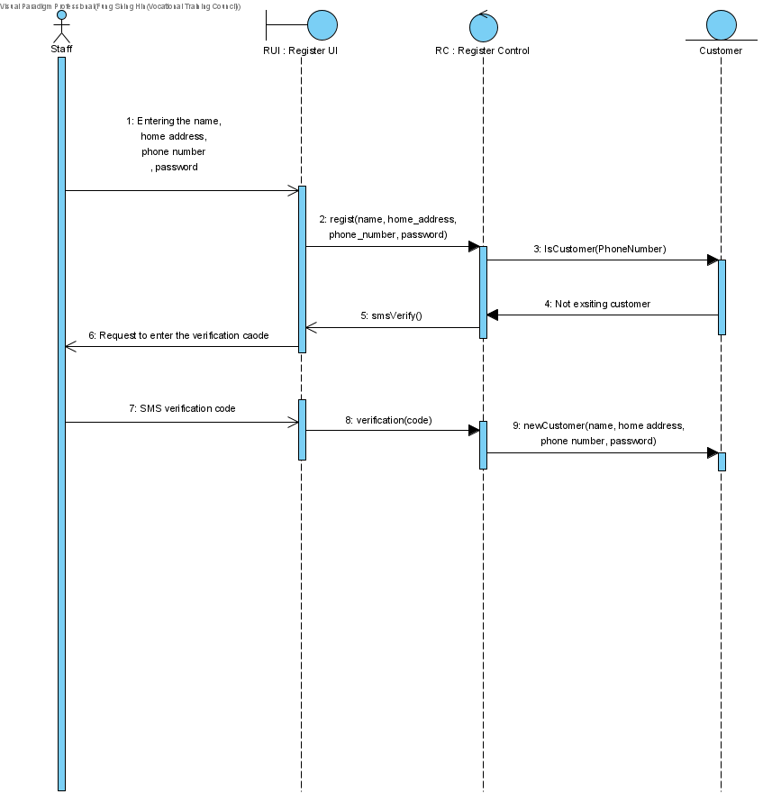

Figure : Help customer register (Sequence Diagram)



Figure : Help customer register (State Machine Diagram)

# *Data Sharing Software*

# *Share file*

|  |  |
| --- | --- |
| **Use case name** | Share file |
| **Use case ID** | UC-101 |
| **Super use case** |  |
| **Actor(s)** | Staff |
| **Secondary Actor** |  |
| **Brief description** | Staff can use the data sharing software to share file and data with other staff. |
| **Preconditions** | The customer has a valid account |
| **Post-conditions** | Staff shared file with other staff |
| **Flow of events** | 1. include(staffLogin)  2. Staff input staffID into the input bar  3. Staff drag file to the file drop area and send it  4. System will save the files in the company server |
| **Alternative flows and exceptions** |  |
| **Priority** |  |
| **Non-behavioral requirements** |  |
| **Assumptions** |  |
| **Issues** |  |
| **Source** |  |

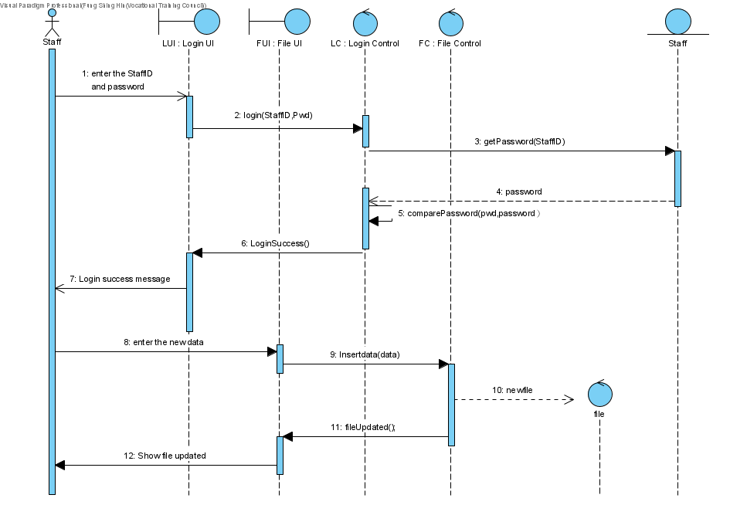

Figure : Share file (Sequence Diagram)

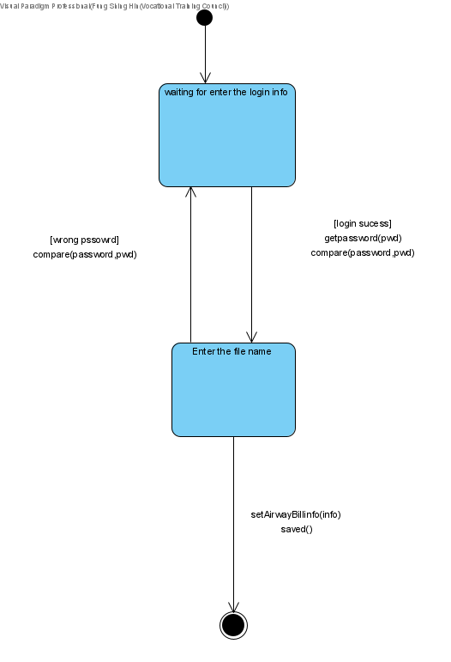

Figure : Share file (State Machine Diagram)

# *Read file*

|  |  |
| --- | --- |
| **Use case name** | Read file |
| **Use case ID** | UC-102 |
| **Super use case** |  |
| **Actor(s)** | Staff |
| **Secondary Actor** |  |
| **Brief description** | Staff can view received file and data in the data sharing software |
| **Preconditions** | Staff received file from other staff |
| **Post-conditions** | Staff read file from other staff |
| **Flow of events** | 1. include(staffLogin)  2. Staff click the “files” tab  3. Staff select the file they want to see  4. System show the file to staff that staff selected |
| **Alternative flows and exceptions** |  |
| **Priority** |  |
| **Non-behavioral requirements** |  |
| **Assumptions** |  |
| **Issues** |  |
| **Source** |  |

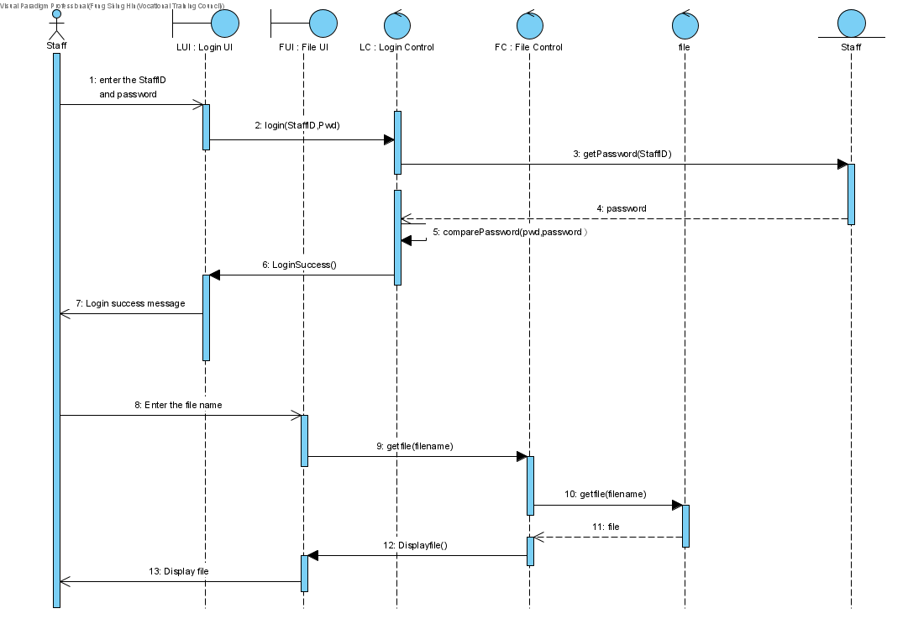

Figure : Read file (Sequence Diagram)

# *Download file*

|  |  |
| --- | --- |
| **Use case name** | Download file |
| **Use case ID** | UC-103 |
| **Super use case** |  |
| **Actor(s)** | Staff |
| **Secondary Actor** |  |
| **Brief description** | After staff view the files in file tab, they can choose to download those file |
| **Preconditions** | Staff is viewing a file in the software |
| **Post-conditions** | The file that the staff want is downloaded from company server |
| **Flow of events** | 1. include (read file)  2. Staff click download button  3. System will download the file from company server to staff’s computer |
| **Alternative flows and exceptions** |  |
| **Priority** |  |
| **Non-behavioral requirements** |  |
| **Assumptions** |  |
| **Issues** |  |
| **Source** |  |

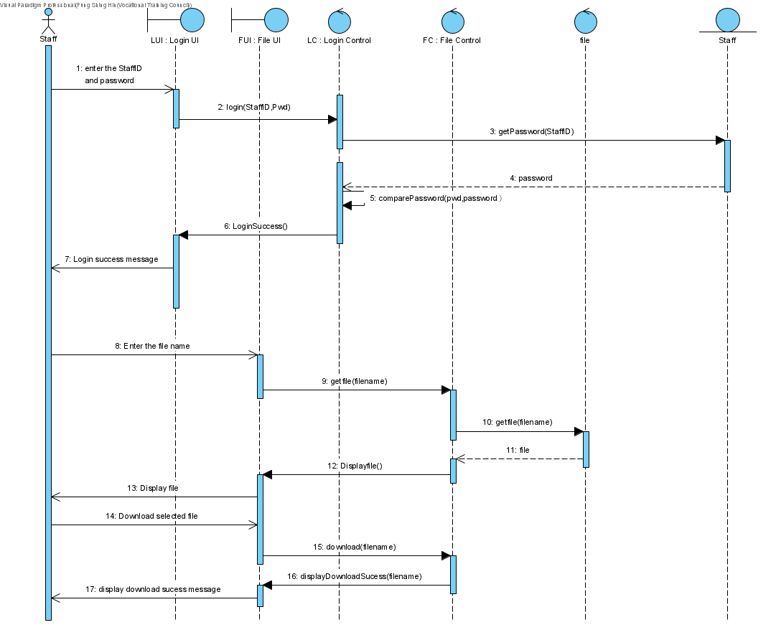

Figure : Download file (Sequence Diagram)

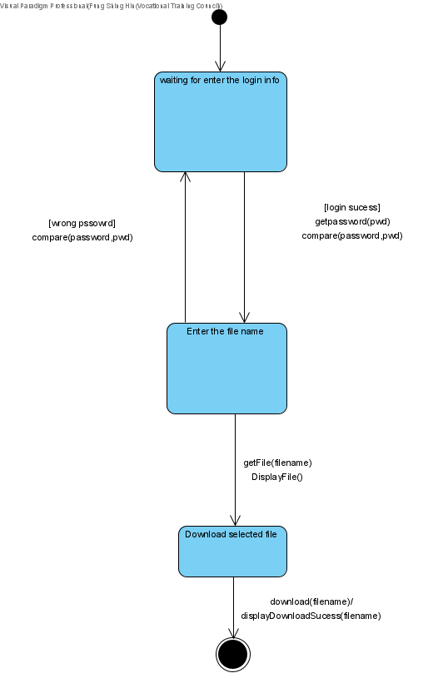

Figure : Download file (State Machine Diagram)

# *Delete files*

|  |  |
| --- | --- |
| **Use case name** | delete files |
| **Use case ID** | UC-104 |
| **Super use case** |  |
| **Actor(s)** | Staff |
| **Secondary Actor** |  |
| **Brief description** | If there are some files that are not useful anymore, staff can choose to delete them. |
| **Preconditions** | Staff is viewing a file in the software |
| **Post-conditions** | Files are deleted from the server |
| **Flow of events** | 1. include (read file)  2. Staff click delete file  3. Files are deleted from the server |
| **Alternative flows and exceptions** |  |
| **Priority** |  |
| **Non-behavioral requirements** |  |
| **Assumptions** |  |
| **Issues** |  |
| **Source** |  |

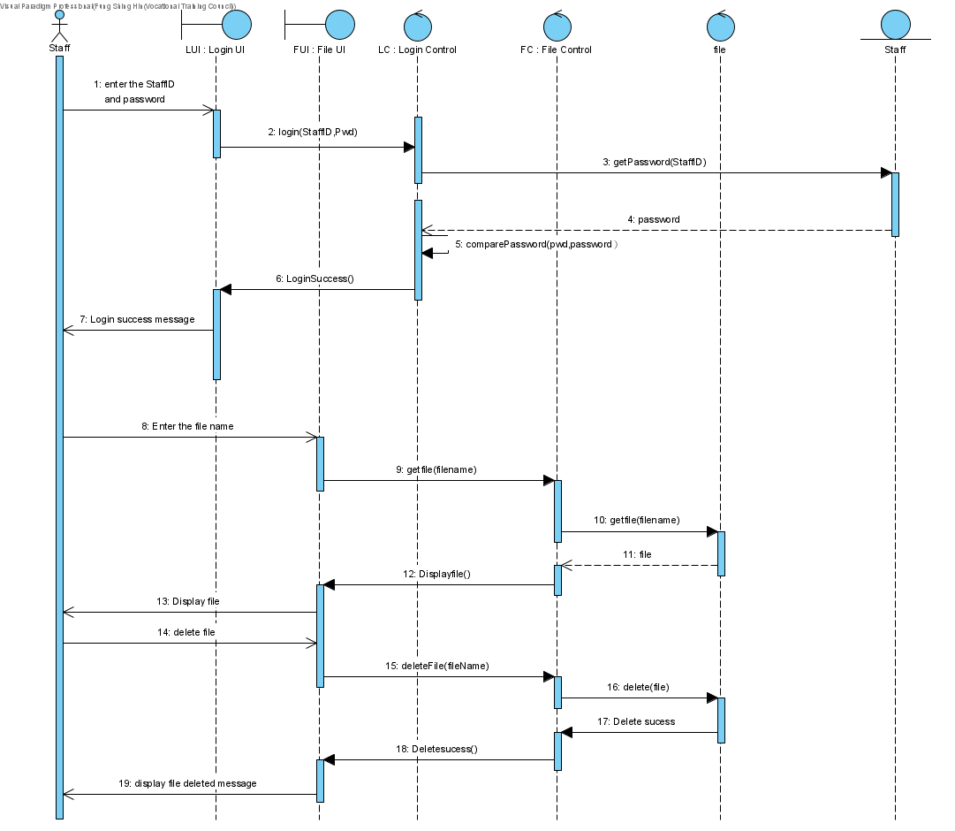

Figure : Delete Files (Sequence Diagram)

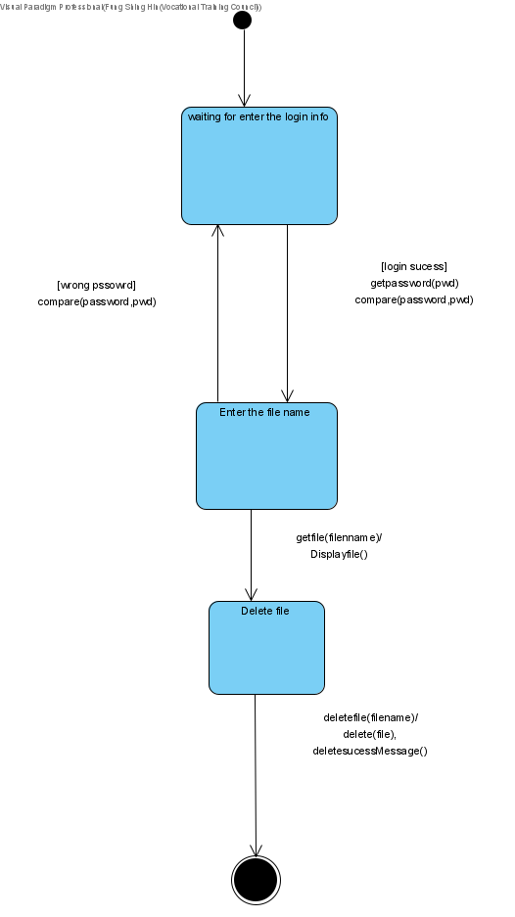

Figure : Delete Files (State Machine Diagram)

# *Staff Login*

|  |  |
| --- | --- |
| **Use case name** | staff Login |
| **Use case ID** | UC-105 |
| **Super use case** |  |
| **Actor(s)** | Staff |
| **Secondary Actor** |  |
| **Brief description** | Staff can login to the data sharing software to use the software. |
| **Preconditions** | Staff have a valid account |
| **Post-conditions** | Staff logged in to the system |
| **Flow of events** | 1. Staff enter staff id and password  2. System check the staff id and password  3. Staff login successful |
| **Alternative flows and exceptions** | System check that the password is wrong, System asks for re-login |
| **Priority** |  |
| **Non-behavioral requirements** |  |
| **Assumptions** |  |
| **Issues** |  |
| **Source** |  |

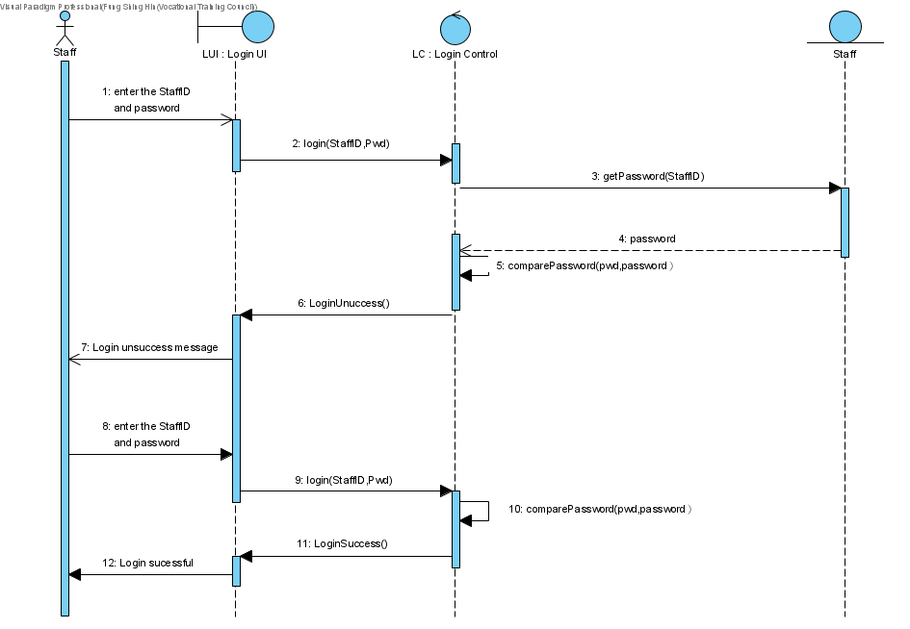

Figure : Staff Login (Sequence Diagram)

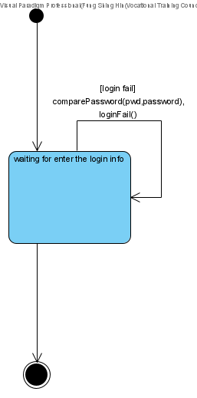

Figure : Staff Login (State Machine Diagram)

# *Intranet Portal for staff*

# *Portal login*

|  |  |
| --- | --- |
| **Use case name** | Portal login |
| **Use case ID** | UC-201 |
| **Super use case** |  |
| **Actor(s)** | Staff |
| **Secondary Actor** |  |
| **Brief description** | Staff can login to the Intranet Portal to work |
| **Preconditions** | Staff have a valid Portal account |
| **Post-conditions** | Staff logged in to the system |
| **Flow of events** | 1. Staff enter staff id and password  2. System check the staff id and password  3. Staff login successful |
| **Alternative flows and exceptions** | System check that the password is wrong, System asks for re-login |
| **Priority** |  |
| **Non-behavioral requirements** |  |
| **Assumptions** |  |
| **Issues** |  |
| **Source** |  |

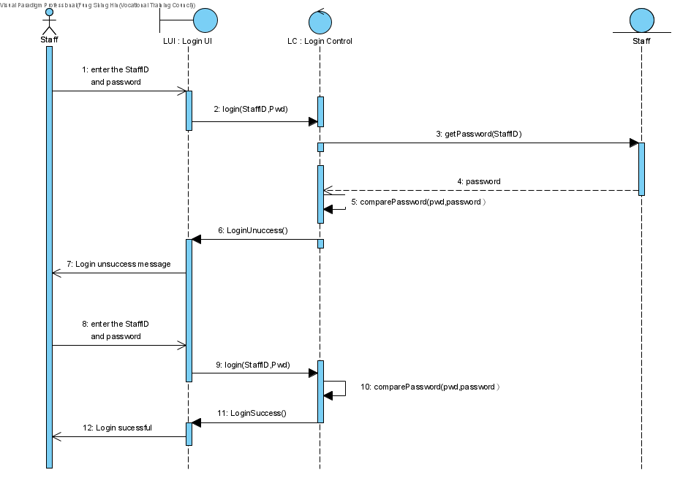

Figure : Portal login (Sequence Diagram)



Figure : Portal login (State Machine Diagram)

# *Retrieve simple information and status*

|  |  |
| --- | --- |
| **Use case name** | Retrieve simple information and status |
| **Use case ID** | UC-202 |
| **Super use case** |  |
| **Actor(s)** | Staff |
| **Secondary Actor** |  |
| **Brief description** | Staff can retrieve simple information and status to help with their work |
| **Preconditions** |  |
| **Post-conditions** |  |
| **Flow of events** | 1. include (Portal login)  2. Staff enter shipment no.  3. System show related information and status of shipment |
| **Alternative flows and exceptions** |  |
| **Priority** |  |
| **Non-behavioral requirements** |  |
| **Assumptions** |  |
| **Issues** |  |
| **Source** |  |

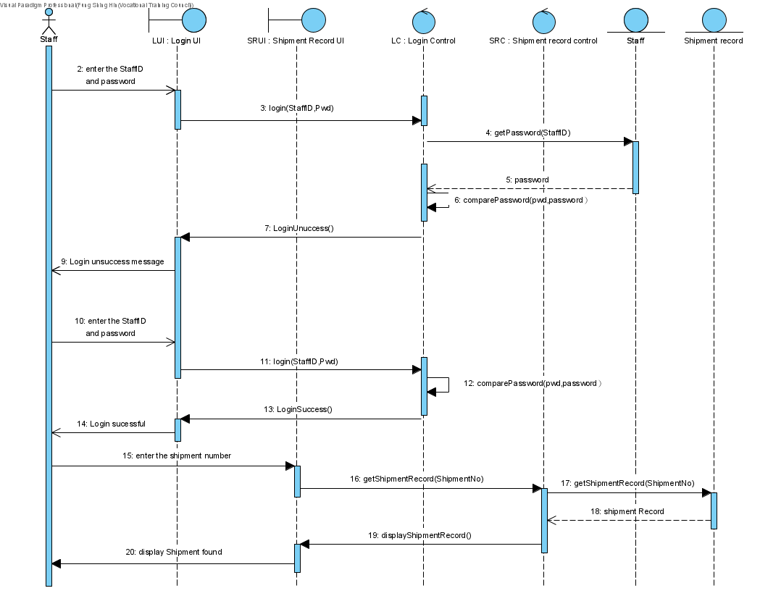

Figure : Retrieve simple information and status (Sequence Diagram)

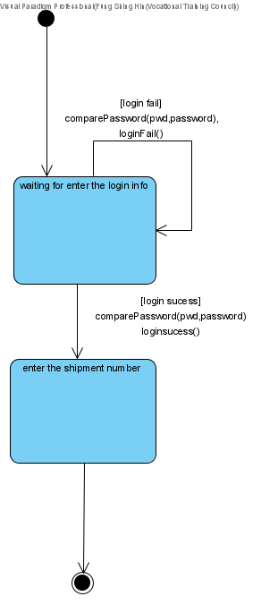

Figure : Retrieve simple information and status (State Machine Diagram)

# *Search and view shipment report and records*

|  |  |
| --- | --- |
| **Use case name** | search and view shipment report and records |
| **Use case ID** | UC-203 |
| **Super use case** | Staff |
| **Actor(s)** | Accounting staff |
| **Secondary Actor** |  |
| **Brief description** | Accounting staff can search and view shipment report and records to help with their accounting job |
| **Preconditions** |  |
| **Post-conditions** |  |
| **Flow of events** | 1. include(login)  2. Accounting staff enter shipment no.  3. System show related report and records |
| **Alternative flows and exceptions** | System check that the password is wrong, System asks for re-login |
| **Priority** |  |
| **Non-behavioral requirements** |  |
| **Assumptions** |  |
| **Issues** |  |
| **Source** |  |

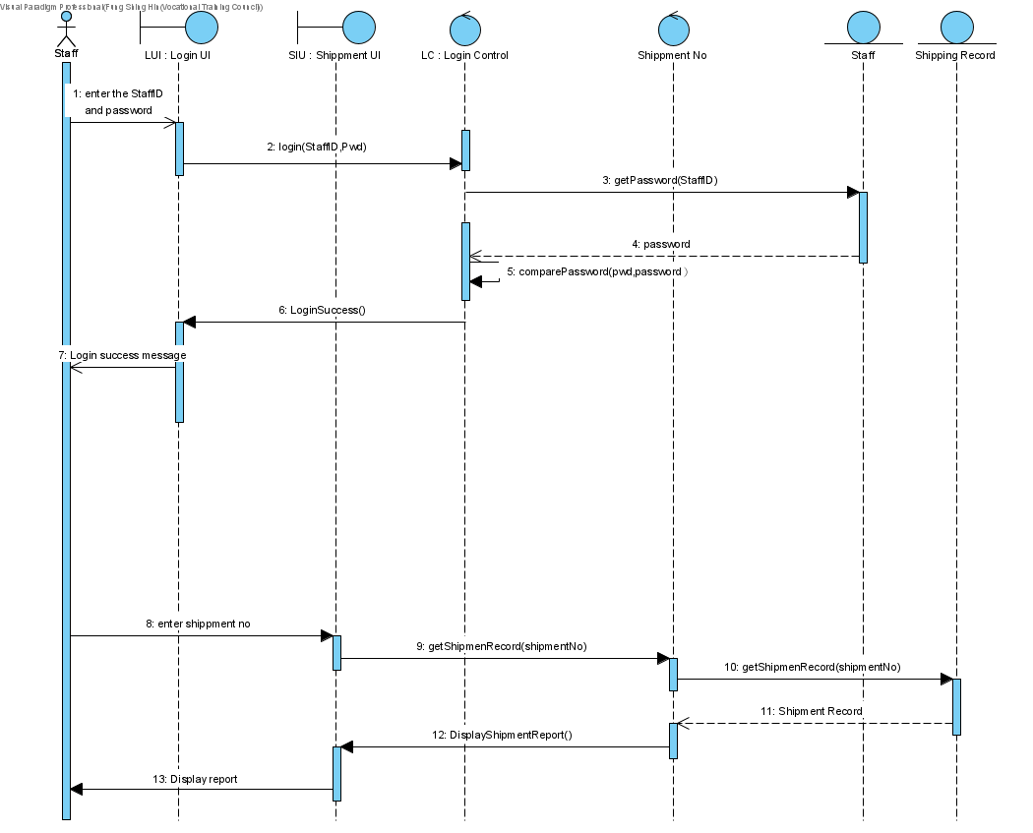

Figure : Search and view shipment report and records (Sequence Diagram)

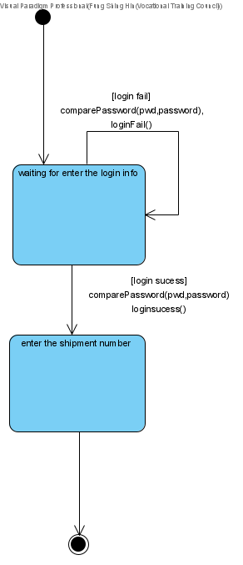

Figure : Search and view shipment report and records (State Machine Diagram)

# *Export report and records*

|  |  |
| --- | --- |
| **Use case name** | export report and records |
| **Use case ID** | UC-204 |
| **Super use case** | Staff |
| **Actor(s)** | Accounting staff |
| **Secondary Actor** |  |
| **Brief description** | Accounting staff can export report and records |
| **Preconditions** | Accounting staff searched and view shipment report and records |
| **Post-conditions** | File exported |
| **Flow of events** | 1. include (search and view shipment report and records)  2. Accounting staff click export button  3. System export the files as excel files |
| **Alternative flows and exceptions** |  |
| **Priority** |  |
| **Non-behavioral requirements** |  |
| **Assumptions** |  |
| **Issues** |  |
| **Source** |  |

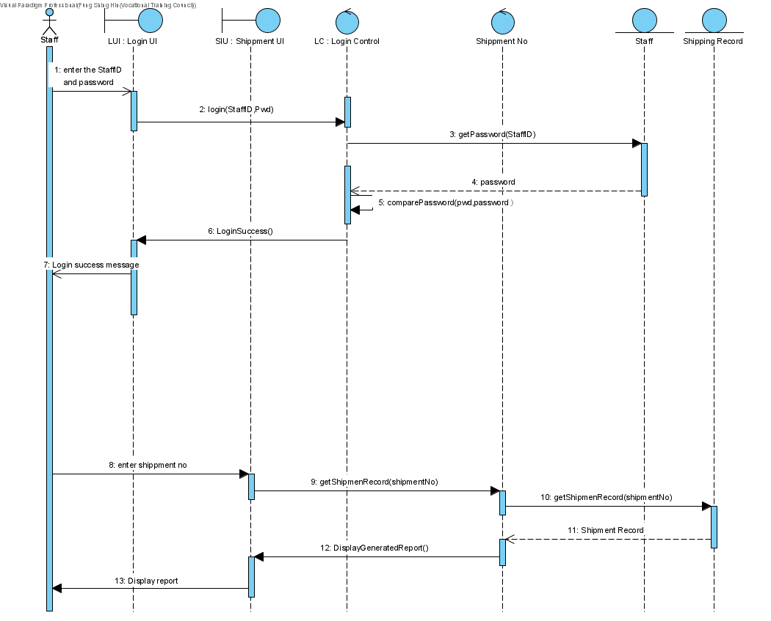

Figure : Export report and records (Sequence Diagram)

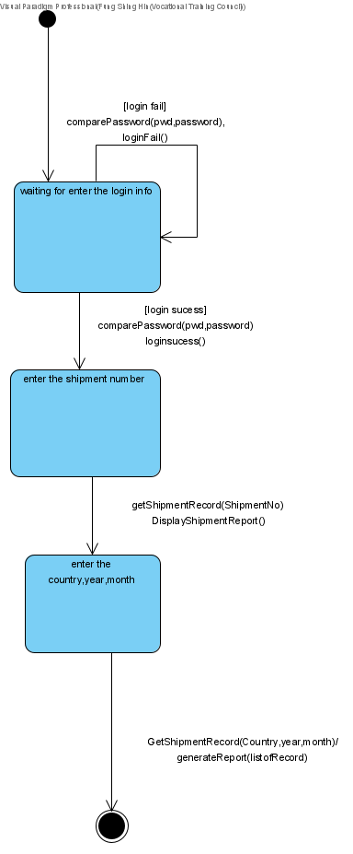

Figure : Export shipment report and records (State Machine Diagram)

# *Edit reports*

|  |  |
| --- | --- |
| **Use case name** | edit reports |
| **Use case ID** | UC-205 |
| **Super use case** | Accounting staff |
| **Actor(s)** | management staff |
| **Secondary Actor** |  |
| **Brief description** | Management staff can edit reports when they needed to |
| **Preconditions** | Management staff searched and view shipment report and records |
| **Post-conditions** | file is edited by management staff |
| **Flow of events** | 1. include (search and view shipment report and records)  2. Management staff click edit button  3. System open edit mode for the management staff  4. Management staff edit the file and save  5. System save as a new file and save in database. Also, the edit records are logged on the server. |
| **Alternative flows and exceptions** |  |
| **Priority** |  |
| **Non-behavioral requirements** |  |
| **Assumptions** |  |
| **Issues** |  |
| **Source** |  |

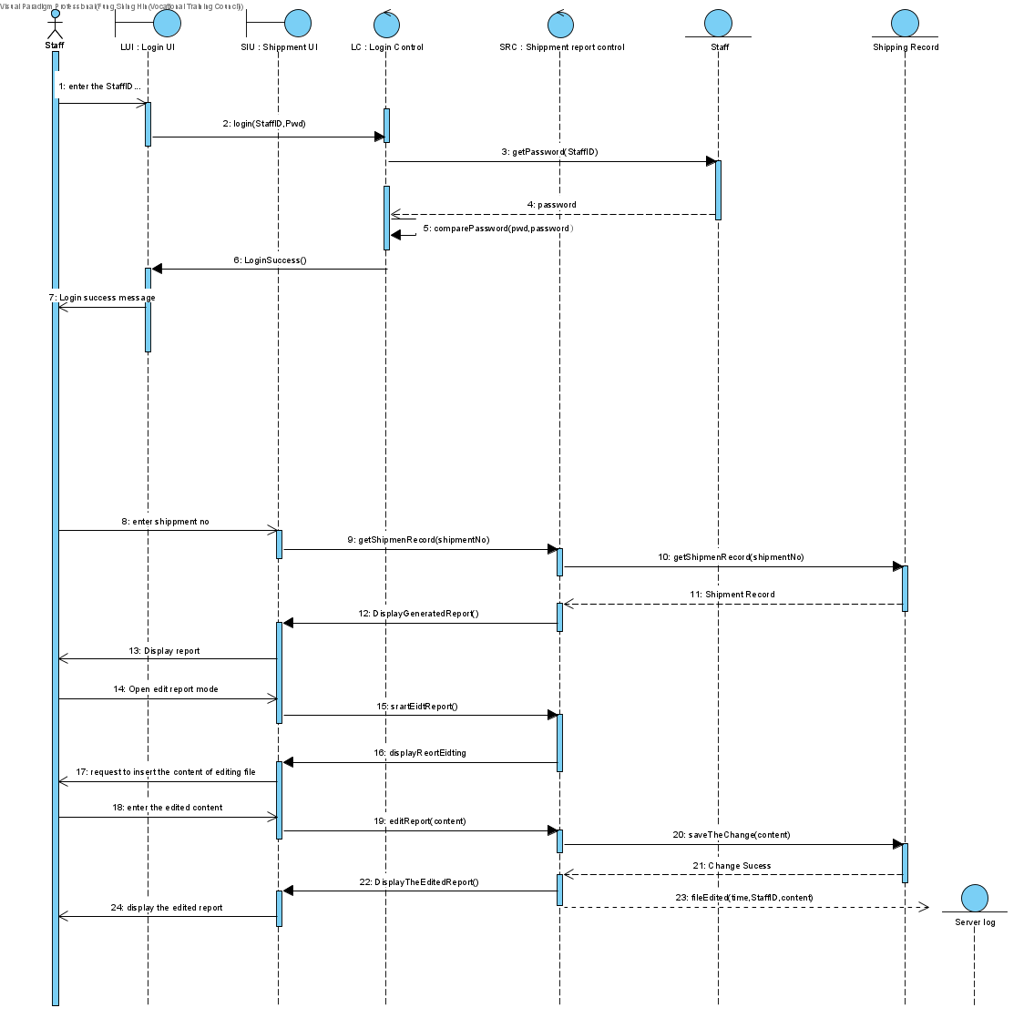

Figure : Edit reports (Sequence Diagram)

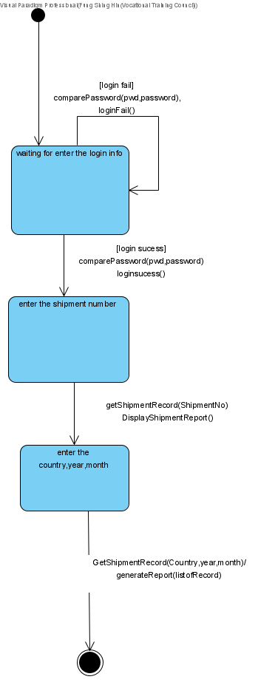

Figure : Edit reports (State Machine Diagram)

# *Generate reports*

|  |  |
| --- | --- |
| **Use case name** | generate reports |
| **Use case ID** | UC-206 |
| **Super use case** | Accounting staff |
| **Actor(s)** | management staff |
| **Secondary Actor** |  |
| **Brief description** | Management staff can generate reports by selecting shipment records |
| **Preconditions** |  |
| **Post-conditions** | Report is generated and saved in the database |
| **Flow of events** | 1. include (Portal Login)  2. management staff click the generate reports button  3. management staff enter the following attributes: country(optional), year and month or a lot of shipment no.  4. The system generates the report and saves it on the server. |
| **Alternative flows and exceptions** |  |
| **Priority** |  |
| **Non-behavioral requirements** |  |
| **Assumptions** |  |
| **Issues** |  |
| **Source** |  |

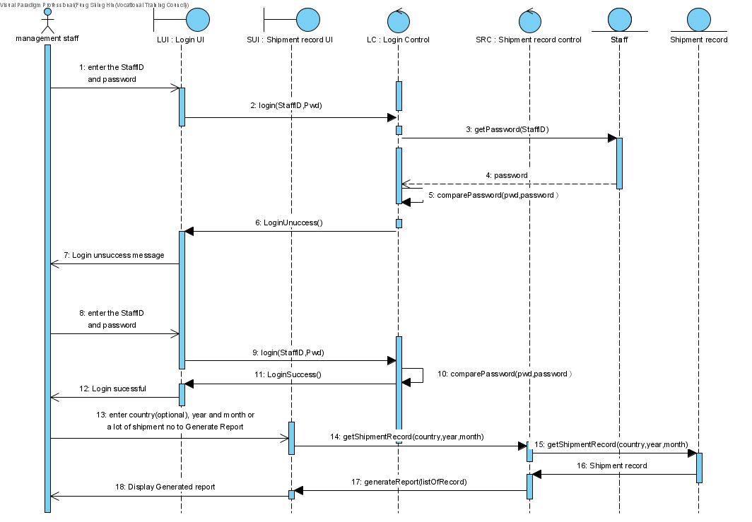

Figure : Generate reports (Sequence Diagram)



Figure : Export report (State Machine Diagram)

# Entity Relation Diagram (ERD)

Figure : ERD of the proposed system

# Database Design

# STAFF Table

|  |  |  |  |
| --- | --- | --- | --- |
| attribute | Type | Constraint | Description |
| staffNo | INT(11) | Primary Key | Primary Key of the **STAFF** table which stores an integer that uniquely identifies a Staff |
| staffName | VARCHAR(255) |  | Staff Name |
| isActive | TINYINT(1) |  | Whether the staff is still serving the company  1 – Yes  0 – No |
| staffDept | TINYINT(1) |  | 0 – Account  1 – Courier  2 – Customer Service  3 – Directorate  4 – Express Centre  5 – Operation Centre  6 – IT staff  7 – Managerial Staff |
| staffType | TINYINT(1) |  | 1 – Full-time staff  0 – part-time staff |
| salary | FLOAT |  | Monthly salary for full-time staff; Hourly salary for part-time staff. |
| dateOfEmployment | DATE |  | The date when the staff was employed |
| dateOfResignation | DATE |  | The date when the staff leaves the company |
| OCENTREoCentreID | INT(11) | Foreign Key | Referencing the oCentreID in the **OCENTRE** table |
| ECENTREeCentreID | INT(11) | Foreign Key | Referencing the eCentreID in the **ECENTRE** table |

# ECENTRE Table (Express Centre)

|  |  |  |  |
| --- | --- | --- | --- |
| attribute | Type | Constraint | Description |
| eCentreID | INT(11) | Primary Key | Primary Key of the **ECentre** table which stores an integer that uniquely identifies an Express Centre |
| address | LONGTEXT |  | Express Centre address |
| location | TINYINT(1) |  | 0 – Hong Kong Island  1– Kowloon Peninsula  2– New Territories  3 – Outlying Islands |
| isActive | TINYINT(1) |  | State of the Centre: In-operation or permanently closed  1 – Yes  2 – No |
| ECETNRE_staffNo | INT(11) | Foreign Key | Referencing the staffNo in the **STAFF** table |

# OCENTRE Table (Operation Centre)

|  |  |  |  |
| --- | --- | --- | --- |
| attribute | Type | Constraint | Description |
| oCentreID | INT(11) | Primary Key | Primary Key of the **OCcentre** table which stores an integer that uniquely identifies an Operation Centre |
| address | LONGTEXT |  | Operation Centre address |
| location | TINYINT(1) |  | 0 – Australia  1 – Hong Kong  2 – Japan  3 – Shanghai |
| region | TINYINT(1) |  | 0 – Asia-Pacific  1 – Americas  2 – Africa  3 – Europe  4 – Other Regions |
| isActive | TINYINT(1) |  | State of the Centre: In-operation or permanently closed  1 – Yes  2 – No |
| OCENTRE_staff_ID | INT(6) | Foreign Key | Referencing the staffNo in the **STAFF** table |

# CUSTOMER Table

|  |  |  |  |
| --- | --- | --- | --- |
| attribute | Type | Constraint | Description |
| cusID | INT(11) | Primary Key | Primary Key of the **Customer** table which stores an integer that uniquely identifies a customer |
| cusName | VARCHAR(255) |  | Customer Name |
| cusPhone | CHAR(8) | Check | Phone number of the Customer |
| cusPassword | VARCHAR(16) | Check | Password of the account owned by a customer |
| cusAddress | LONGTEXT |  | Address of the Customer |
| isActive | TINYINT(1) |  | State of the Account: Active or inactive  1 – Active  0 – Inactive |
| cusType | TINYINT(1) |  | 0 – Individual  1 – Express Account |
| ccType | TINYINT(1) |  | 0 – VISA  1 – MASTER  2 – UNION PAY  3 – AMERICAN EXPRESS  4 - Japan Credit Bureau |
| ccNo | CHAR(16) | Check | Credit Card Number if customer opts to store the number of company’s database for future use |
| ccExpiry | CHAR(4) |  | Expiry Date of the Credit Card |

ITEM Table

|  |  |  |  |
| --- | --- | --- | --- |
| attribute | Type | Constraint | Description |
| itemID | INT(11) | Primary Key | Primary Key of the **ITEM** table which stores an integer that uniquely identifies a Staff |
| description | LONGTEXT |  | Full description of the item |
| weight | FLOAT |  | Weight of the item |
| length | FLOAT |  | Length of the item |
| width | FLOAT |  | Width of the item |
| height | FLOAT |  | Height of the item, if applicable |
| date | DATE |  | Date of item received by EDE |
| AIRWAYBILLairwaybillID | INT(11) | Foreign Key | Referencing the airwayBillID in the **AIRWAYBILL** table |
| CUSTOMERcusID | INT(11) | Foreign Key | Referencing the cusID in the **CUSTOMER** table |

# AIRWAYBILL Table

|  |  |  |  |
| --- | --- | --- | --- |
| attribute | Type | Constraint | Description |
| airwayBillID | INT(11) | Primary Key | Primary Key of the **AIRWAYBILL** table which stores an integer that uniquely identifies an airwaybill |
| services | TINYINT(1) |  | 0 – Express Document Envelope  1 – Express Freight |
| destination | TINYINT(1) |  | 0 – Australia  1 – Hong Kong  2 – Japan  3 – Shanghai |
| deliveryAddress | LONGTEXT |  | Full address of the receiver |
| postCode | CHAR(6) |  | Post code of the receiving address, if applicable |
| receiverCompany | VARCHAR(255) |  | Full name of the receiving company, if applicable |
| receiverName | VARCHAR(255) |  | Full name of the receiver |
| receiverContact | VARCHAR(15) |  | Full contact of the receiver |
| declaredValue | FLOAT |  | Declared value of goods |
| contentDescription | LONGTEXT |  | Full description of the items to be sent with the airwaybill |
| weight | FLOAT |  | Weight of the shipment |
| length | FLOAT |  | Length of the shipment |
| width | FLOAT |  | Width of the shipment |
| height | FLOAT |  | Height of the shipment |
| date | DATE |  | Date of EDE receiving the airway bill |
| shipment_shipmentID | INT(11) | Foreign Key | Foreign key referencing the **Shipment** table |
| AIRWAYBILL_cusID | INT(11) | Foreign Key | Referencing the cusID in the **CUSTOMER** table |
| AIRWAYBILL_itemID | INT(11) | Foreign Key | Referencing the itemID in the **ITEM** table |
| INVOICEinvoiceID | INT(11) | Foreign Key | Referencing the invoiceID in the **INVOICE** table |

# SHIPMENT Table

|  |  |  |  |
| --- | --- | --- | --- |
| attribute | Type | Constraint | Description |
| shipmentID | INT(11) | Primary Key | Primary Key of the **SHIPMENT** table which stores an integer that uniquely identifies a Staff |
| destination | LONGTEXT |  | Destination address |
| sendDate | DATETIME |  | Send date of the shipment |
| itemCount | INT(11) |  | Number of items in the shipment |
| vehicleNo | VARCHAR(10) |  | Identifier of the vehicle with which the shipment is shipped |
| shipmentType | TINYINT(1) |  | 0 – Air  1 - Ground  2 – Sea |
| currentLoc | LONGTEXT |  | Current location |
| SHIPMENT_AirwayBillID | INT(11) | Foreign Key | Referencing the airwayBillID in the **AIRWAYBILL** table |

# PICKUP Table

|  |  |  |  |
| --- | --- | --- | --- |
| attribute | Type | Constraint | Description |
| pickupID | INT(11) | Primary Key | Primary Key of the **PICKUP** table which stores an integer that uniquely identifies a Staff |
| pickupDate | DATETIME |  | Pick up date as instructed by customers |
| services | TINYINT(1) |  | 0 – Express Document Envelope  1 – Express Freight |
| PICKUP_cusID | INT(11) | Foreign Key | Referencing the cusID in the **CUSTOMER** table |
| PICKUP_address | LONGTEXT | Foreign Key | Referencing the address in the **CUSTOMER** table |

# FEE Table

|  |  |  |  |
| --- | --- | --- | --- |
| attribute | Type | Constraint | Description |
| feeID | INT(11) | Primary Key | Primary Key of the **FEE** table which stores an integer that uniquely identifies a Staff |
| feeType | ENUM |  | 0 – Express Document Envelope  1 – Express Freight |
| fee | FLOAT |  | Corresponding amount of fee required |

# PAYMENT Table

|  |  |  |  |
| --- | --- | --- | --- |
| attribute | Type | Constraint | Description |
| paymentID | INT(11) | Primary Key | Primary Key of the **PAYMENT** table which stores an integer that uniquely identifies a Staff |
| paymentAmount | FLOAT |  | Total amount required to be pay |
| paymenDueDate | DATETIME |  | Payment Due Date |
| paymentStatus | TINYINT(1) |  | Payment Status  0 – Payment not settled  1 – Payment settled |
| paymentMethod | TINYINT(1) |  | 0 – Cash  1 – Cheque  2 – Credit Card  3 – e-payment |
| CUSTOMERcusID | INT(11) | Foreign Key | Referencing the cusID in the **CUSTOMER** table |
| AIRWAYBILLairwayBillID | INT(11) | Foreign Key | Referencing the airwayBillID in the **AIRWAYBILL** table |

# INVOICE Table

|  |  |  |  |
| --- | --- | --- | --- |
| attribute | Type | Constraint | Description |
| invoiceID | INT(11) | PRIMARY KEY | Primary Key of the **INVOICE** table which stores an integer that uniquely identifies a Staff |
| INVOICE_airwayBillID | INT(11) | Foreign Key | Referencing the cusID in the **CUSTOMER** table |
| CUSTOMERcusID | INT(11) | Foreign Key | Referencing the airwayBillID in the **AIRWAYBILL** table |

# SHIPMENTREPORT Table

|  |  |  |  |
| --- | --- | --- | --- |
| attribute | Type | Constraint | Description |
| reportID | INT(11) | Primary Key | Primary Key of the **SHIPMENTREPORT** table which stores an integer that uniquely identifies a Staff |
| country | VARCHAR(255) |  | Name of Country shipped |
| year | INT(4) |  | Year shipped |
| month | INT(2) |  | Month shipped |
| SHIPMENTREPORT_shipmentNo | INT(11) | Foreign Key | Referencing the shipmentNo in the **SHIPMENT** table |

# User Interface Design

# Design Overview



Figure : Rebranded Company Logo

This year marks a critical watershed for Eastern Delivery Express. With the permission of the management team, a modernized system software is developed to fulfill the expanding needs of the company, as well as the courier industry as a whole. To celebrate, EDE also rebranded themselves by having a new company logo. It is expected that the new logo could give customers and staff members a refreshed look by using a colur tone that is striking to one’s eye. The User Interface of the new management system and user portal also follows this rebranding direction to give users a sense of holistic service. The new Company logo is placed on the left portion of the first screen of the application (i.e., the login screen) which would give user a striking effect and give a good branding image of the Company to user.

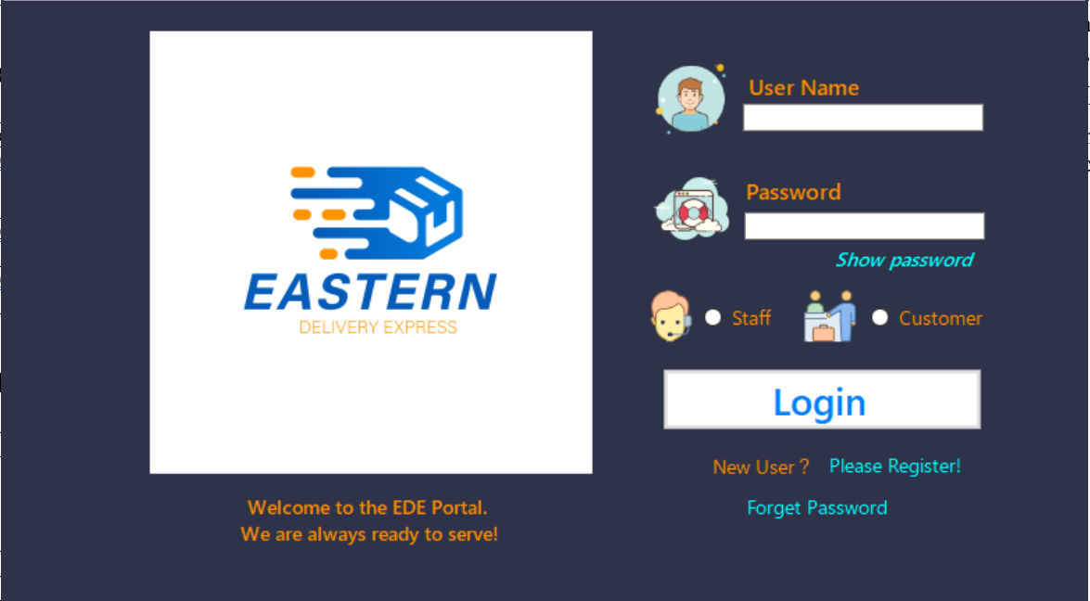

Figure : Login UI with Large Company Logo

# Color tone

|  |
| --- |
| The color tone of the modernized system has been designed to fit into the new branding of the Company. Therefore, the colors mainly used in the application are mainly variation of orange color and blue color to give a holistic experience to the user of the application. It is purposefully designed to be in line with the new logo of the company, with an expectation that this measure could help customers to remember the EDE brand. Screenshots of the Staff portal and the Customer portal have been included below for illustration. Figure : Staff Dashboard (Light color tone) |
| Figure : Customer Dashboard (Dark color tone) |

# The use of flat icons

To meet industry standards and the modern design appearance, flat icons have been widely used in the new management system. To follow Microsoft and Android’s bold move to a very clean minimalistic interface, it is expected that using flat icons and flat UI could catch up with modern design standards.

|  |  |
| --- | --- |
| Figure : Flat icons (Navigation Bar) | Figure : Flat icons (Function1) |
| Figure : Flat icons (Function2) |

In addition, the use of icons in the user interface is expected to enhance usability and user experience. It is hoped that users of the application do not necessarily read the whole line of a sentence or buttons as these icons that is related to the function itself is a very good visual aids that could speak for themselves. Further to that, some users who may not be familiar with English could also understand what the function of a button or an interface is. It is expected that the use of icons could enhance usability of the system. For sure, from time to time the system shall be upgraded, especially when the company now has a plan to expand their business to country that mother tongue is not English. Proper translation shall be included future updates, but it is believed that merely using icon for better illustration would be fine for now.

# Customer UI

The Customer UI uses a dark color tone to give users a steadfast impression. The dashboard is mainly divided into two parts, with a navigation bar on the left and a dashboard area on the right.

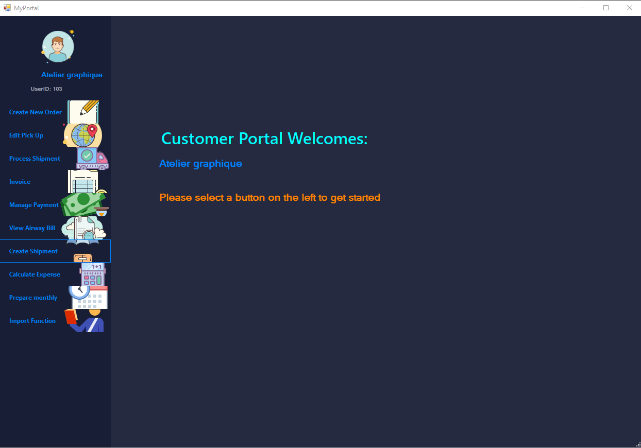

Figure : Customer Dashboard

The use of big icons on the navigation bar, as illustrated in the figure shown on next page, allows users to easily grabs what the function is for each button. For some users, it might be even possible for them to skip the text and learn what the function is for each button. Big icon also entertains users such as elderly who might not be able to read text rapidly. Such icons would enhance their usability.

In certain UI, animation has been added to enhance the interaction between the system and the customer. On design level, it is expected that interactive UI would bring fun to users. On practical level, interaction such as moving image and progress bar indicates that the system is still connected (i.e., there is no software failure). Using inly still UI is difficult for users to identifies if the system is still connected or working.

|  |  |
| --- | --- |
| Figure : Screenshot for Customer UI 1 | Figure : Screenshot for Customer UI 2 |
| Figure : Screenshot for Customer UI 3 |

# Staff UI

Similar to the Customer UI, Staff UI also uses the navigation bar approach which is commonly use in modern design. Unlike the Customer UI, however, the Staff UI adopts a light color tone of the main portal UI, for two reasons. The first one is that, using big contrast in color is an easy way to identify which portal one is using. This also applies to screen that is restricted to user of certain levels, as shown in Figure.85. The second reason for such approach, on the other hand, is that staff may use the UI for a long period of time each day,

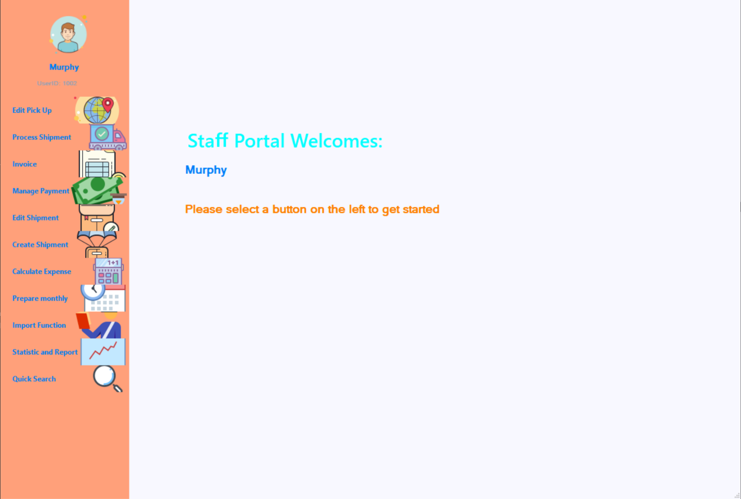

Figure : Screenshot for Staff UI 1

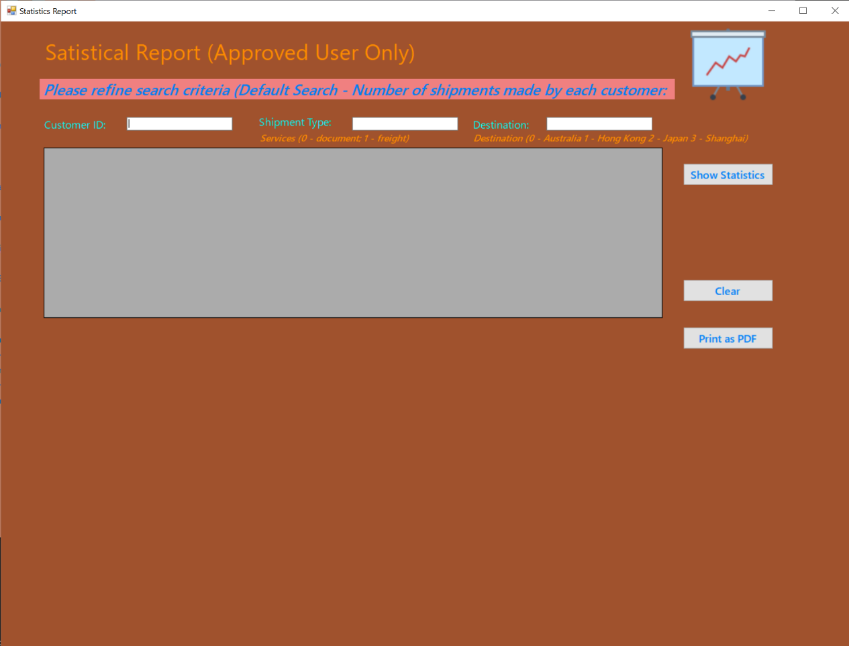

Figure : Screenshot for Staff UI 2

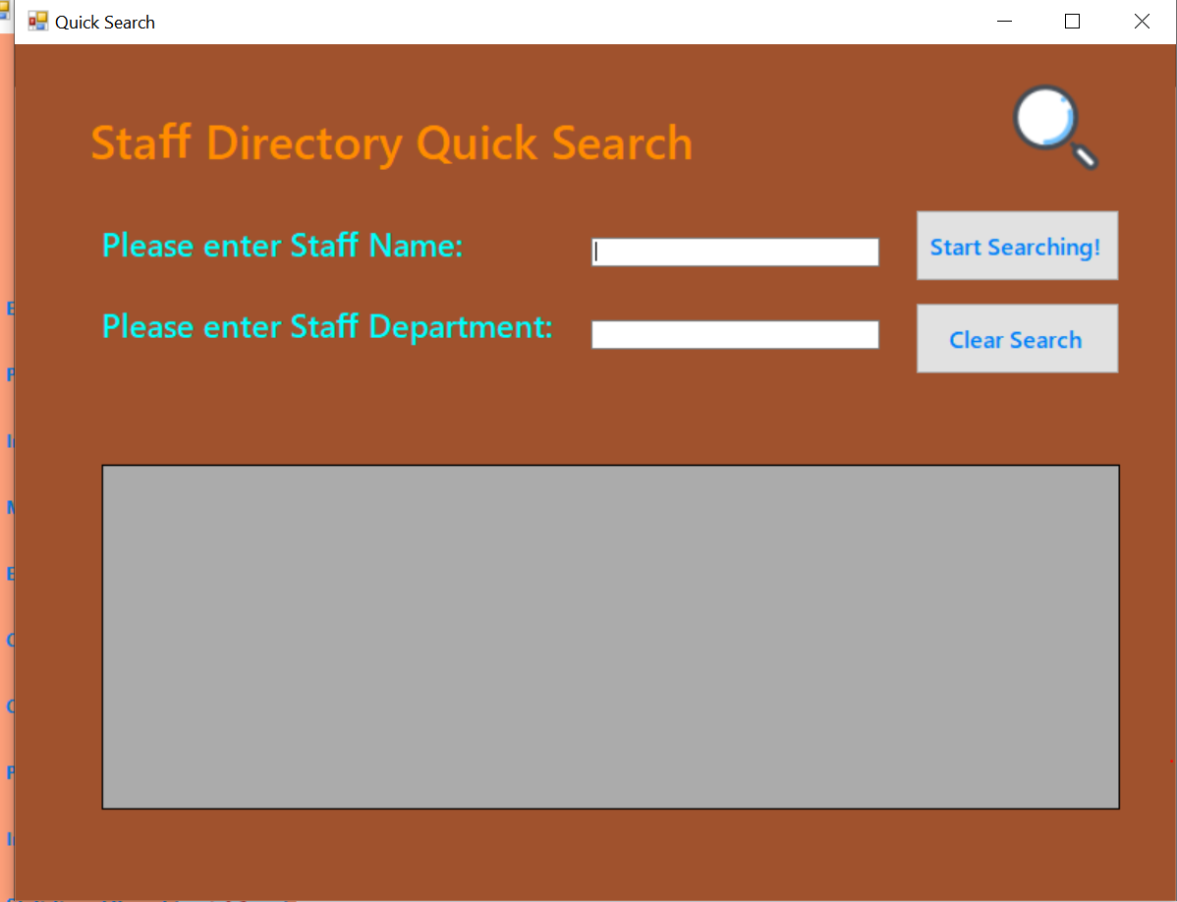

Figure : Screenshot for Staff UI 3

# The navigation bar and pop-up approach

As mentioned in previous section, a navigation bar approach is adopted to catch up with modern design standards and user experience. The navigation bars for Staff UI and Customer UI are excerpted below for illustration

|  |  |
| --- | --- |
| Figure : Navigation Bar (Staff UI) | Figure : Customer UI |

In addition to the navigation bar, a pop-up window approach has been adopted in this modernized EDE software application. Unlike tradition software management system, such as embed POS system which could only perform one task in a time (because of that function taking up the whole screen), the EDE system allows pop-up to allow multi-tasking of users as illustrated in the figure below.

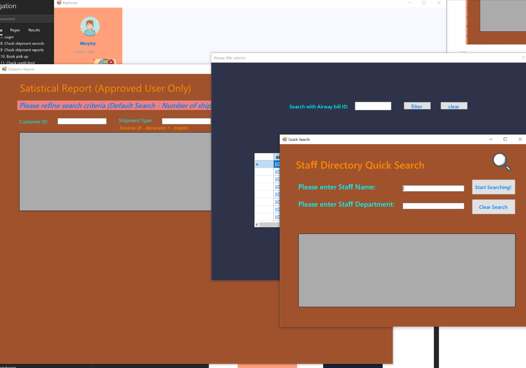

Figure : Pop-up approach

With such approach, users are allowed to perform several tasks on one screen. This is particularly useful if, for instance, a staff member is required to perform task a customer profile search together with an airway bill search with the same customer. Multi-window pop ups allow users to compare information side-by-side and thus enhance productivity. Same applies to customer as well. For instance, the customers are allowed to compare expected shipping expense using the calculation function with the actual amount charged by the Company to avoid dispute.

# Enhance Data Security

To enhance data security, certain UIs are restricted to approved user only.

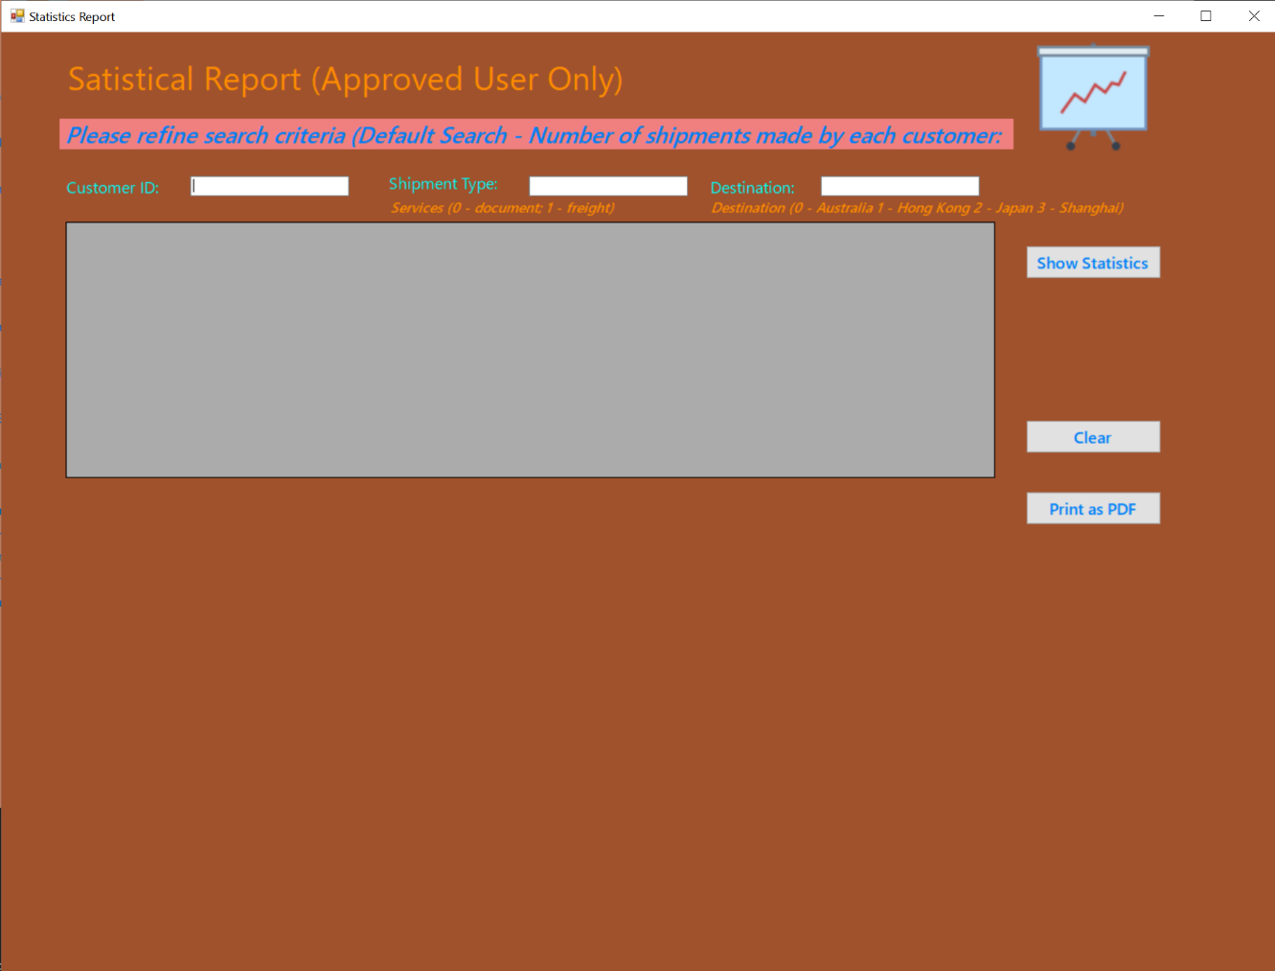

Figure : Restricted access of certain UI

# UI Design Summary

To reiterate, the modernized UI design of the EDE software application adopts modern design approach in line with contemporary design standards as well as the rebranding of the Company itself, as shown in the fact that the new logo and the system shared similar color tone. A navigation bar and pop-up window approach are used in the software application to increase productivity by allowing users to perform multitasking. Big flat icons are used in the new system to attract eyeball of the user and for enhancing usability of users in needed, such as elderly who might not be able to read text easily. It is hoped that the UI design could bring users an overall enhanced user experience.

# Test Plan

|  |  |
| --- | --- |
| Test Case | Login |
| Primary Actor | Customer, Staff |
| Pre-Condition | Users have an account |
| Scenario | A customer login to system |
| Test of Flow | * Enters valid login name and password. * Press "Login" button |
| Input Data | Login Name: C103  Password: 103 |
| Expected Output | Login success |

|  |  |
| --- | --- |
| Actual Output | Login success |

|  |  |
| --- | --- |
| Test Result | Pass |

|  |  |
| --- | --- |
| Test Case | Login |
| Primary Actor | Customer, Staff |
| Pre-Condition | User has an account |
| Scenario | A customer login to system with invalid password |
| Test of Flow | * Enters invalid login name and password * Press "Login" button |
| Input Data | Login Name: C103  Password: 10323 (incorrect) |
| Expected Output | Login unsuccess |

|  |  |
| --- | --- |
| Actual Output | Login success |

|  |  |
| --- | --- |
| Test Result | Pass |

|  |  |
| --- | --- |
| Test Case | Register new account |
| Primary Actor | Customer |
| Pre-Condition | User do not have an account |
| Scenario | A customer signup for an account |
| Test of Flow | * Click "New Customer" Button in Login Page * Enter required information |
| Input Data | Login Name: Fung1013  Password: Fung10123  confirm-Password: Fung10123  First Name: Sam  Last Name: Fung  Email: [Fung1013@gmail.com](mailto:Fung1013@gmail.com)  Address: 13 Tuen Mun Road, Tuen Mun, NT, Hong Kong |
| Expected Output | Signup success |

|  |  |
| --- | --- |
| Actual Output | Signup success |

|  |  |
| --- | --- |
| Test Result | Pass |

|  |  |
| --- | --- |
| Test Case | Sign up |
| Primary Actor | Customer |
| Pre-Condition | User do not have an account |
| Scenario | A customer signup enters invalid password |
| Test of Flow | * Click "New Customer" Button in Login Page * Enter required information. * Enter invalid Email Address |
| Input Data | Login Name: Fung1013  Password: Fung10123  confirm-Password: Fung10123  First Name: Sam  Last Name: Fung  Email: Fung1013  Address: 13 Tuen Mun Road, Tuen Mun, NT, Hong Kong |
| Expected Output | Alert Email invalid |
| Actual Output | Alert Email invalid |
| Test Result | Pass |

|  |  |
| --- | --- |
| Test Case | Sign up |
| Primary Actor | Customer |
| Pre-Condition | User do not have an account |
| Scenario | A customer signup enters invalid password |
| Test of Flow | * Click "New Customer" Button in Login Page * Enter required information. * Enter Existing Username |
| Input Data | Login Name: Fung1013 (Existing username)  Password: Fung10123  confirm-Password: Fung10123  First Name: Sam  Last Name: Fung  Email: Fung1013@gmail.com  Address: 13 Tuen Mun Road, Tuen Mun, NT, Hong Kong |
| Expected Output | Alert Username Was Existing |
| Actual Output | Alert Username Was Existing |
| Test Result | Pass |

|  |  |
| --- | --- |
| Test Case | Sign up |
| Primary Actor | Customer |
| Pre-Condition | User do not have an account |
| Scenario | A customer signup enters Existing Email |
| Test of Flow | * Click "New Customer" Button in Login Page * Enter required information. * Enter Existing Email |
| Input Data | Login Name: Fung1013  Password: Fung10123  confirm-Password: Fung10123  First Name: Sam  Last Name: Fung  Email: [Fung1013@gmail.com](mailto:Fung1013@gmail.com) (Existing)  Address: 13 Tuen Mun Road, Tuen Mun, NT, Hong Kong |
| Expected Output | Alert Email Was Existing |
| Actual Output | Alert Email Was Existing |
| Test Result | Pass |

|  |  |
| --- | --- |
| Test Case | Forgot Password |
| Primary Actor | Customer |
| Pre-Condition | The customer has an account |
| Scenario | A customer forgot password |
| Test of Flow | * Click "Forgot Password" in Login Page * Enter email and Username of the account. * Enter the new Password of the account. * Click "Summit" Button |
| Input Data | Username: Fung1013 New Password: Fung10123 Retype New Password: Fung10123 Customer Email: Fung1013@gmail.com |
| Expected Output | Password will edit if the Username and the Customer Email existed. |
| Actual Output | Password will edit if the Username and the Customer Email is existed. |
| Test Result | Pass |

|  |  |
| --- | --- |
| Test Case | Create New Pickup |
| Primary Actor | Customer |
| Pre-Condition | A customer has an account |
| Scenario | A customer creates new pickup with missing Address |
| Test of Flow | * Include (Login) * Click "Create New Order" in the Menu * Enter required information. * Click "Submit" Button |
| Input Data | Pickup Date Time: 2021-06-30 12:30:00  Express Type: Freight  Sender Address: Null value |
| Expected Output | Create new pickup unsuccess, System requires the user enter the pickup |
| Actual Output | Create new pickup unsuccess, System requires the user enter the pickup |
| Test Result | Pass |

|  |  |
| --- | --- |
| Test Case | Generate invoice |
| Primary Actor | Customer, |
| Pre-Condition | A customer has an account |
| Scenario | A customer views the order history and click to generate the invoice |
| Test of Flow | * Include (Login) * Click "invoice" Button. * Enter Airway bill id to search the bill ID. * Click "submit" Button. * Click the column of the Order history to view the invoice. * Select the Save as PDF |
| Input Data |  |
| Expected Output | Generated a pdf file with invoice show the directory |
| Actual Output | Generated a pdf file with invoice show the directory |
| Test Result | Pass |

|  |  |
| --- | --- |
| Test Case | Generate invoice |
| Primary Actor | Customer |
| Pre-Condition | A customer has an account |
| Scenario | A customer views the order history and click to generate the invoice |
| Test of Flow | * Include (Login) * Click "invoice" Button. * Enter Airway bill id to search the bill ID. * Click "submit" Button. * Click the column of the Order history to view the invoice. * Select the Save as BPM file |
| Input Data |  |
| Expected Output | Generated a BMP file with invoice and show the directory |
| Actual Output | Generated a BMP file with invoice and show the directory |
| Test Result | Pass |

|  |  |
| --- | --- |
| Test Case | Pay the bill |
| Primary Actor | Customer |
| Pre-Condition | A customer has an account Customer had created order in the specific month |
| Scenario | A customer Pay the payment with a monthly invoice |
| Test of Flow | * Include (Login) * Click "Manage Payment" in the Menu * Enters the month and the Year to search the monthly payment. * Click Pay button * The User Select the payment method. * Enter Credit Card information. * Click "Submit" Button |
| Input Data | Month:6 Year:2021  Credit Card: 5599 1023 3030 1239  CVV: 123 |
| Expected Output | Payment success |
| Actual Output | Payment success |
| Test Result | Pass |

|  |  |
| --- | --- |
| Test Case | Pay the bill |
| Primary Actor | Customer |
| Pre-Condition | A customer has an account Customer had created order in the specific month |
| Scenario | A customer Pay the payment with a monthly invoice with incorrect credit card information |
| Test of Flow | * Include (Login) * Click "Manage Payment" in the Menu * Enters the month and the Year to search the monthly payment. * Click Pay button * The User Select the payment method. * Enter Credit Card information. * Click "Submit" Button |
| Input Data | Month:6 Year:2021  Credit Card: 99 1023 3030 1239  CVV: 12 |
| Expected Output | Payment unsuccessful |
| Actual Output | Payment unsuccessful |
|  |  |
| Test Result | Pass |

|  |  |
| --- | --- |
| Test Case | Pay the bill |
| Primary Actor | Customer |
| Pre-Condition | A customer has an account Customer had created order in the specific month |
| Scenario | A customer Pay the payment with a monthly invoice with not placed the order |
| Test of Flow | * Include (Login) * Click "Manage Payment" in the Menu * Enters the month and the Year to search the monthly payment. * Click Pay button |
| Input Data | Month:6 Year:2023 |
| Expected Output | Unable to search the bill |
| Actual Output | Unable to search the bill |
| Test Result | Pass |

|  |  |
| --- | --- |
| Test Case | Pay the bill |
| Primary Actor | Customer |
| Pre-Condition | A customer has an account Customer had created order in the specific month |
| Scenario | A customer Pay the payment with a monthly invoice with not placed the order |
| Test of Flow | * Include (Login) * Click "Manage Payment" in the Menu * Enters the month and the Year to search the monthly payment. * Click the row of the data gird * Select the E-payment as the payment method. * Select the Payment as the payment method and scan the QR code |
| Input Data |  |
| Expected Output | Payment unsuccessful |
| Actual Output | Payment unsuccessful |
| Test Result | Pass |

|  |  |
| --- | --- |
| Test Case | Pay the bill |
| Primary Actor | Customer |
| Pre-Condition | A customer has an account Customer had created order in the specific month |
| Scenario | A customer Pay the payment with an individual order history |
| Test of Flow | * Include (Login) * Click "Manage Payment" in the Menu * Enters the month and the Year to search the monthly payment. * Click the row of the data gird * Select the Cheque as the payment method. * The user uploads the cheque to the System |
| Input Data | The photo of the cheque |
| Expected Output | Waiting for the staff the check the payment |
| Actual Output | Waiting for the staff the check the payment |
| Test Result | Pass |

|  |  |
| --- | --- |
| Test Case | View the airway bill |
| Primary Actor | Customer |
| Pre-Condition | A customer has an account Customer had created order |
| Scenario | A customer checks the order history and check the current location of the airway bill |
| Test of Flow | * Include (Login) * Click "Manage Payment" in the Menu * Enters the month and the Year to search the monthly payment. * Click the row of the data gird * The system will show more details of the order. |
| Input Data | · |
| Expected Output | The System show the details of the selected order |
| Actual Output | The System show the details of the selected order |
| Test Result | Pass |

|  |  |
| --- | --- |
| Test Case | Place a new Document Order Less than |
| Primary Actor | Customer |
| Pre-Condition | A customer has an account |
| Scenario | The customer enters the information of the shipment and create a shipment |
| Test of Flow | * Include (Login) * Click "Create shipment" in the Menu. * Select the Document shipment. * enters the required information. * clicks next page to fill the other information. * Click the submit button |
| Input Data | Company Name: Western Fruit Company Deliver address: Shang Hai EDE operation center Post Code: 000000 Country: China SHANGHAI Contact Person: ANDY TAM Contact: 86-10123498 Contact Email: WESTERNFRUIT@gmail.com Weight:2KG Content Description: Letter |
| Expected Output | The System store the data in database |
| Actual Output | The System store the data in database |
| Test Result | Pass |

|  |  |
| --- | --- |
| Test Case | Place a new Document Order Weight Grater Than 3 KG |
| Primary Actor | Customer |
| Pre-Condition | A customer has an account |
| Scenario | The customer enters the information of the shipment and create a shipment |
| Test of Flow | * Include (Login) * Click "Create shipment" in the Menu. * Select the Document shipment. * enters the required information. * clicks next page to fill the other information. * Click the submit button |
| Input Data | Company Name: Western Fruit Company Deliver address: Shang Hai EDE operation center Postcode: 000000 Country: China SHANGHAI Contact Person: ANDY TAM Contact: 86-10123498 Contact Email: WESTERNFRUIT@gmail.com Weight:5KG Content Description: Letter |
| Expected Output | The System Alert the error Message |
| Actual Output | The System Alert the error Message |
| Test Result | Pass |

|  |  |
| --- | --- |
| Test Case | Place a new Package Shipment Weight Less Than 999 KG |
| Primary Actor | Customer |
| Pre-Condition | A customer has an account |
| Scenario | The customer enters the information of the shipment and create a shipment |
| Test of Flow | * Include (Login) * Click "Create shipment" in the Menu. * Select the Package shipment. * enters the required information. * clicks next page to fill the other information. * Click the submit button |
| Input Data | Company Name: Western Fruit Company Deliver address: Shang Hai EDE operation center Postcode: 000000 Country: China SHANGHAI Contact Person: ANDY TAM Contact: 86-10123498 Contact Email: WESTERNFRUIT@gmail.com Declared Value: 123 Weight:5KG Content Description: Water Melon Harmonized commodity code:OD213 Dimensions(cm) 12L 13W 12H |
| Expected Output | The System Alert the error Message |
| Actual Output | The System Alert the error Message |
| Test Result | Pass |

|  |  |
| --- | --- |
| Test Case | Place a new Package Shipment Weight Grater Than 999 KG |
| Primary Actor | Customer |
| Pre-Condition | A customer has an account |
| Scenario | The customer enters the information of the shipment and create a shipment |
| Test of Flow | * Include (Login) * Click "Create shipment" in the Menu. * Select the Packet shipment. * enters the required information. * clicks next page to fill the other information. * Click the submit button |
| Input Data | Company Name: Western Fruit Company Deliver address: Shang Hai EDE operation center Postcode: 000000 Country: China SHANGHAI Contact Person: ANDY TAM Contact: 86-10123498 Contact Email: WESTERNFRUIT@gmail.com Declared Value: 123 Weight:5999KG Content Description: Water Melon Harmonized commodity code:OD213 Dimensions(cm) 12312L 1323W 2312H |
| Expected Output | The System Alert the error Message |
| Actual Output | The System Alert the error Message |
| Test Result | Pass |

|  |  |
| --- | --- |
| Test Case | Calculate Shipping expense for document express within 3KG |
| Primary Actor | Customer |
| Pre-Condition | A customer has an account |
| Scenario | The customer enters the information of the shipment information to calculate the shipping expands |
| Test of Flow | * Include (Login) * Click "Create shipment" in the Menu. * Select the Packet shipment. * enters the required information. * Click the calculate button |
| Input Data | Express Type: EDE Express Freight weight: 2kg |
| Expected Output | 608 |
| Actual Output | 608 |
| Test Result | Pass |

|  |  |
| --- | --- |
| Test Case | Calculate Shipping expense for document express with Greater than 3KG |
| Primary Actor | Customer |
| Pre-Condition | A customer has an account |
| Scenario | The customer enters the information of the shipment information to calculate the shipping expands |
| Test of Flow | * Include (Login) * Click "Create shipment" in the Menu. * Select the Packet shipment. * enters the required information. * Click the calculate button |
| Input Data | Express Type: EDE Express Freight weight: 9kg |
| Expected Output | Alert error message |
| Actual Output | Alert error message |
| Test Result | Pass |

|  |  |
| --- | --- |
| Test Case | Calculate Shipping expense for Packets express The Weight within 999KG |
| Primary Actor | Customer |
| Pre-Condition | A customer has an account |
| Scenario | The customer enters the information of the shipment information to calculate the shipping expands |
| Test of Flow | * Include (Login) * Click " Calculate Expense " in the Menu. * Select the Packet shipment. * enters the required information. * Click the calculate button |
| Input Data | Express Type: EDE Document Express Freight weight: 58kg  Country: China SHANGHAI |
| Expected Output | 2030 |
| Actual Output | As the Expected Output |
| Test Result | Pass |

|  |  |
| --- | --- |
| Test Case | Calculate Shipping expense for Packets express The Weight greater than 999KG |
| Primary Actor | Customer |
| Pre-Condition | A customer has an account |
| Scenario | The customer enters the information of the shipment information to calculate the shipping expands |
| Test of Flow | * Include (Login) * Click " Calculate Expense " in the Menu. * Select the Packet shipment. * enters the required information. * Click the calculate button |
| Input Data | Express Type: EDE Document Express Freight weight: 9992kg  Country: China SHANGHAI |
| Expected Output | Alert error message |
| Actual Output | AS the Expected Output |
| Test Result | Pass |

|  |  |
| --- | --- |
| Test Case | Calculate Shipping expense for Packets express The Weight less than 0KG |
| Primary Actor | Customer |
| Pre-Condition | A customer has an account |
| Scenario | The customer enters the information of the shipment information to calculate the shipping expands |
| Test of Flow | * Include (Login) * Click " Calculate Expense" in the Menu. * Select the Packet shipment. * enters the required information. * Click the calculate button |
| Input Data | Express Type: EDE Document Express Freight weight: -1kg  Country: China SHANGHAI |
| Expected Output | Alert error message |
| Actual Output | AS the Expected Output |
| Test Result | Pass |

|  |  |
| --- | --- |
| Test Case | Calculate Shipping expense for Packets express The Weight less than 0KG |
| Primary Actor | Customer |
| Pre-Condition | A customer has an account |
| Scenario | The customer enters the information of the shipment information to calculate the shipping expands |
| Test of Flow | * Include (Login) * Click "Calculate Expense" in the Menu. * Select the Packet shipment. * enters the required information. * Click the calculate button |
| Input Data | Express Type: EDE Document Express Freight weight: -1kg  Country: China SHANGHAI |
| Expected Output | Alert error message |
| Actual Output | AS the Expected Output |
| Test Result | Pass |

|  |  |
| --- | --- |
| Test Case | Get the monthly payment invoice |
| Primary Actor | Customer |
| Pre-Condition | A customer has an account Customer have the payment that already paid the bill |
| Scenario | The customer enters check the payment record in the database and get the invoice in the database. |
| Test of Flow | * Include (Login) * Click "Monthly Invoice" in the Menu. * Enter the Month. * enters the Year. * Click Open button. |
| Input Data | Year: 2021 month: 7 |
| Expected Output | Show the monthly airway bill |
| Actual Output | Show the monthly airway bill |
| Test Result | Pass |

|  |  |
| --- | --- |
| Test Case | Get the monthly payment invoice |
| Primary Actor | Customer |
| Pre-Condition | A customer has an account Customer have the payment that already paid the bill |
| Scenario | The customer enters check the payment record in the database and get the invoice in the database. |
| Test of Flow | * Include (Login) * Click "Monthly Invoice" in the Menu. * Enter the Month. * enters the Year. * Click Open button. |
| Input Data | Year: 2024 month: 7 |
| Expected Output | No monthly airway bill will show |
| Actual Output | No monthly airway bill will show |
| Test Result | Pass |

|  |  |
| --- | --- |
| Test Case | Get the monthly payment invoice with wrong input |
| Primary Actor | Customer, |
| Pre-Condition | A customer has an account Customer have the payment that already paid the bill |
| Scenario | The customer enters check the payment record in the database and get the invoice in the database. |
| Test of Flow | * Include (Login) * Click "Monthly Invoice" in the Menu. * Enter the Month. * enters the Year. * Click Open button. |
| Input Data | Year: 2024 month: 14 |
| Expected Output | No monthly airway bill will show |
| Actual Output | No monthly airway bill will show |
| Test Result | Pass |

|  |  |
| --- | --- |
| Test Case | Add the new regular import products |
| Primary Actor | Customer |
| Pre-Condition | A customer has an account |
| Scenario | The customer adds the product that will always import to Hong Kong. |
| Test of Flow | * Include (Login) * Click "Import Function" in the Menu. * Click "Add regular import products". * Enter all the cells. * Click add new supplies button. |
| Input Data | Full Description of Goods: Grapes Product: Grapes 1012 Reason for Export: For sale Unit Weight: 13 KG |
| Expected Output | Show the success message and add the data into the database |
| Actual Output | Show the success message and add the data into the database |
| Test Result | Pass |

|  |  |
| --- | --- |
| Test Case | Add the new regular import products with the existing productid |
| Primary Actor | Customer, |
| Pre-Condition | A customer has an account |
| Scenario | The customer adds the product that will always import to Hong Kong. |
| Test of Flow | * Include (Login) * Click "Import Function" in the Menu. * Click "Add regular import products". * Enter all the cells. * Click add new supplies button. |
| Input Data | Full Description of Goods: Grapes Product: Grapes 1012 (Existing Procut ID) Reason for Export: For sale Unit Weight: .13 KG |
| Expected Output | Show the alert message that the data is already existed into the database |
| Actual Output | Show the alert message that the data is already existed into the database |
| Test Result | Pass |

|  |  |
| --- | --- |
| Test Case | Edit and view the regular import products |
| Primary Actor | Customer |
| Pre-Condition | A customer has an account and already added the product into the database |
| Scenario | The customer edits and view the product that will always import to Hong Kong. |
| Test of Flow | * Include (Login) * Click "Import Function" in the Menu. * Click "Edit and view Regular import". * Click the productID to Edit the regular import products. * Click submit button. |
| Input Data | Full Description of Goods: Grapes Product: Grapes231012 Reason for Export: For sale Unit Weight: .13 KG |
| Expected Output | Show the success message and updated into the data into the database |
| Actual Output | Show the success message and updated into the data into the database |
| Test Result | Pass |

|  |  |
| --- | --- |
| Test Case | Customers send a new regular import product order |
| Primary Actor | Customer, |
| Pre-Condition | A customer has an account and already added the product into the database |
| Scenario | The customer sends the product that will always import to Hong Kong. |
| Test of Flow | * Include (Login) * Click "Import Function" in the Menu. * Click "new order of the import". * Customers fill in all the cell * Click submit button. |
| Input Data | Receiver Name: Chan Tai Man Recover Phone Number: 20232304 Reviver Address: Tsing Yi IVE campus Company Name: VTC Receiver Email: 213234@vtc.com |
| Expected Output | Show the success message and updated into the data into the database |
| Actual Output | Show the success message and updated into the data into the database |
| Test Result | Pass |

|  |  |
| --- | --- |
| Test Case | Customers send a new regular import product order with print the invoice |
| Primary Actor | Customer |
| Pre-Condition | A customer has an account and already added the product into the database |
| Scenario | The customer sends the product that will always import to Hong Kong. |
| Test of Flow | * Include (Login) * Click "Import Function" in the Menu. * Click "new order of the import". * Customers fill in all of the cell * Click submit and print invoice button. |
| Input Data | Receiver Name: Chan Tai Man Receiver Phone Number: 20232304 Reviver Address: Tsing Yi IVE campus Company Name: VTC Receiver Email: 213234@vtc.com |
| Expected Output | Show the success message and updated into the data into the database, and there will be show the invoice path to the customer |
| Actual Output | Show the success message and updated into the data into the database, and there will be show the invoice path to the customer |
| Test Result | Pass |

|  |  |
| --- | --- |
| Test Case | Process shipment with the Norma case |
| Primary Actor | Staff |
| Pre-Condition | The airway bill was created, and the shipment does not finish |
| Scenario | The staff update the latest location of the shipment |
| Test of Flow | * Include (Login) * Click "Process shipment" in the Menu. * Insert the airway bill id. * Click submit button. |
| Input Data | Airway Bill Number:10023 shipment status: the shipment was finished |
| Expected Output | System sends the email to the customer that reporting the latest location of the shipment.  There will have an Message Box to show that the Status was updated.  Update the latest location in the database |
| Actual Output | System sends the email to the customer that reporting the latest location of the shipment.  There will have an Message Box to show that the Status was updated.  Update the latest location in the database |
| Test Result | Pass |

|  |  |
| --- | --- |
| Test Case | Process shipment with the case that the airway bill does not exists |
| Primary Actor | Staff |
| Pre-Condition | The airway bill was created, and the shipment does not finish |
| Scenario | The staff update the latest location of the shipment |
| Test of Flow | * Include (Login) * Click "Process shipment" in the Menu. * Insert the airway bill id. * Click submit button. |
| Input Data | Airway Bill Number:100245 (not exists) shipment status: the shipment was finished |
| Expected Output | Alert Message that the Airway bill number does not exist in the database |
| Actual Output | Alert Message that the Airway bill number does not exist in the database |
| Test Result | Pass |

|  |  |
| --- | --- |
| Test Case | Process shipment with the Norma case |
| Primary Actor | Customer |
| Pre-Condition | The airway bill was created, and the shipment does not finish |
| Scenario | The staff update the latest location of the shipment |
| Test of Flow | * Include (Login) * Click "Process shipment" in the Menu. * Insert the airway bill id. * Click submit button. |
| Input Data | Airway Bill Number:10023 |
| Expected Output | The system shows the current location of the airway bill id |
| Actual Output | The system shows the current location of the airway bill id |
| Test Result | Pass |

|  |  |
| --- | --- |
| Test Case | Process shipment with the not exists airway bill |
| Primary Actor | Customer |
| Pre-Condition | The airway bill was not created, |
| Scenario | The staff update the latest location of the shipment |
| Test of Flow | * Include (Login) * Click "Process shipment" in the Menu. * Insert the airway bill id. * Click submit button. |
| Input Data | Airway Bill Number:10023(no such airway bill id) |
| Expected Output | The system show that the Product does not exist in the database |
| Actual Output | The system show that the Product does not exist in the database |
| Test Result | Pass |

# User Guide

# Public Function:

Public Function can be used by both staff and customer.

# Login

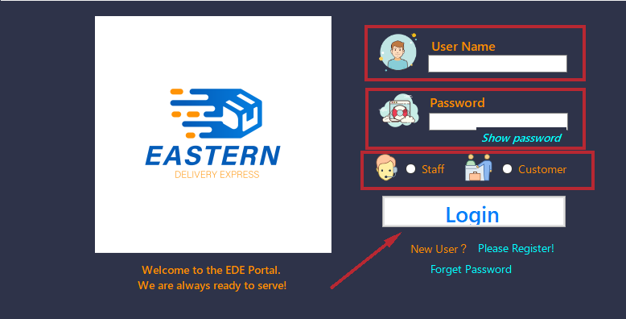

Figure 92: Login Interface

A login screen shall be prompted when the user starts the modernized EDE application software. To login, please enter your username and password in the login page. After that, please choose your role, in this case “Customer,” and then click the Login button to login.

|  |  |
| --- | --- |
| Figure 93: Login successful message | Figure 94:Incorrect password message |

After the login button is clicked, the username and password shall be cross checked with the value stored on the database in EDE. If the login credentials match with those stored in the database, a login successful pop up shall be prompted. After clicking the “OK” button, the login process would be successful, and the portal page shall show up.

|  |  |  |
| --- | --- | --- |
| Figure 95: Missing username message | Figure 96: Missing password message | Figure 97: Missing role message |

In some cases, the login process would be unsuccessful, due to several possible reasons. For instance, if the user entered incorrect password or username (as shown in Figures 94), or did not fill in any information, a login unsuccessful pop-up message with explanation message shall be shown on screen. If the user forgot to select role, they will also be notified. After clicking the “OK” button, the pop-up message shall be closed, and the system shall return to the login screen. The user would then have to return to process 1. Login to login to the system.

# Pickup Booking Management

# Edit pick up

‘

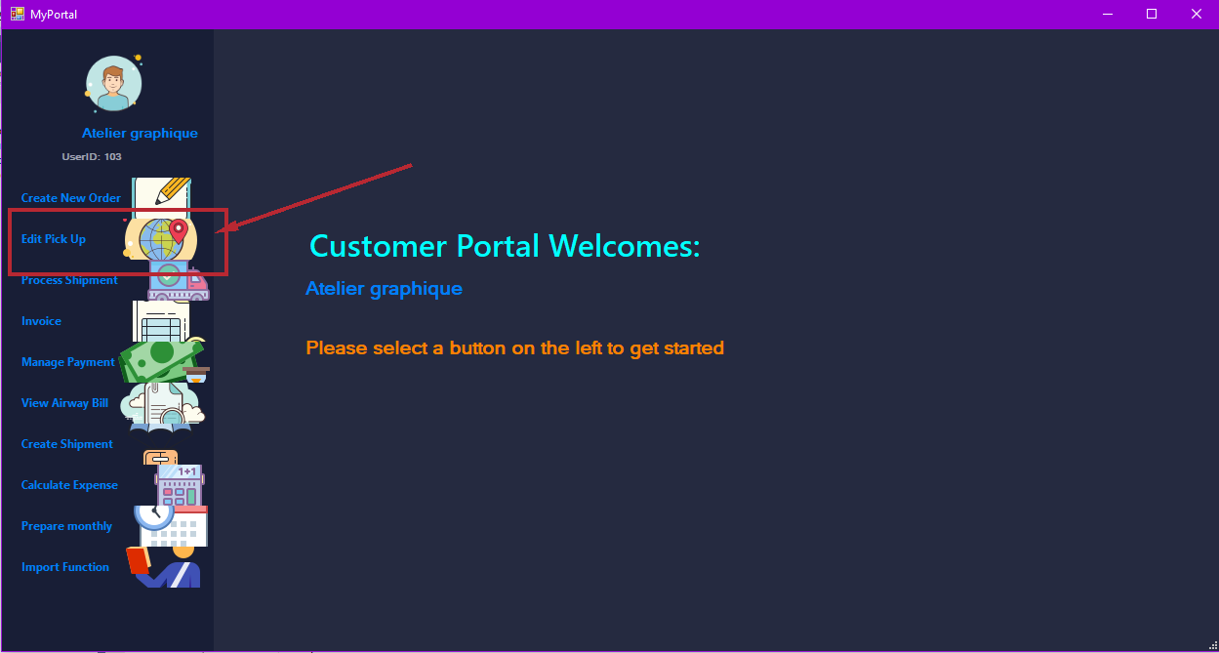

Figure 122: Edit Pick Up

After login, user shall see the menu. Please click the “Edit pick up” button to start editing.

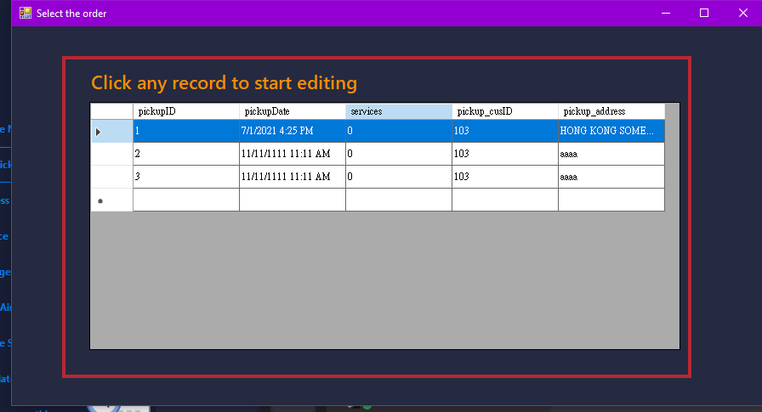

Figure 123: Pick-up Order table

A table of pick-up order shall be shown on screen. User shall then choose the record they would like to edit by double clicking the record.

Figure 124: Edit Pickup Order Form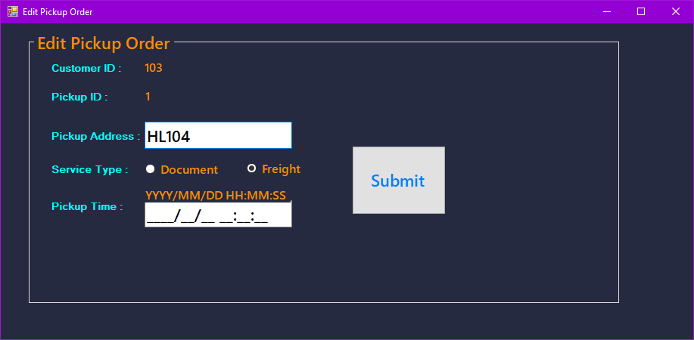

The record shall be shown on screen. User shall then be able to change the content of the table. After finishing the procedure, users are required to click the “Submit” button. A successful message will should up after clicking the “Submit” button, then the pickup record should be update successfully.

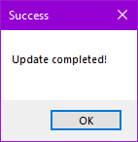

Figure 125: Update complete message

# Handling Import function

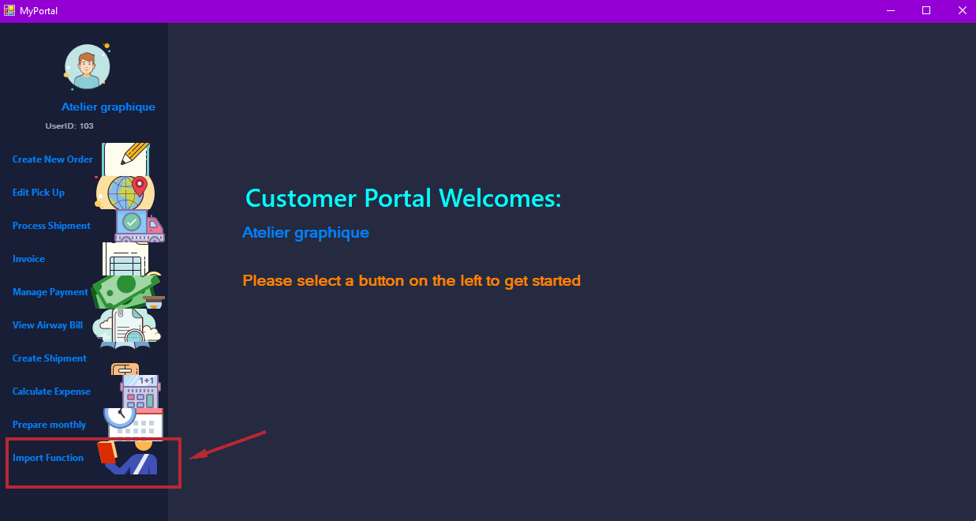*Figure 181: Import Function*

After login, you will see the menu, please click the “Import Function” button to use the import Function.

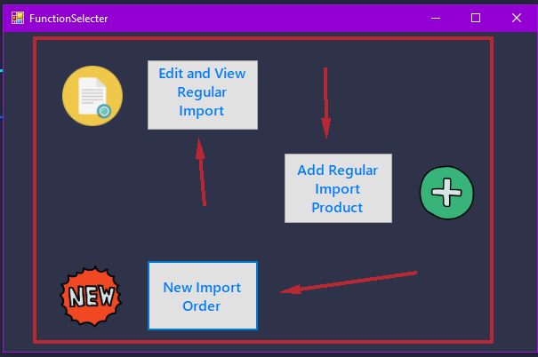

Figure 182: Import functions selector

A selector window will show up.User can choose the action to perform.

# Create regular import service

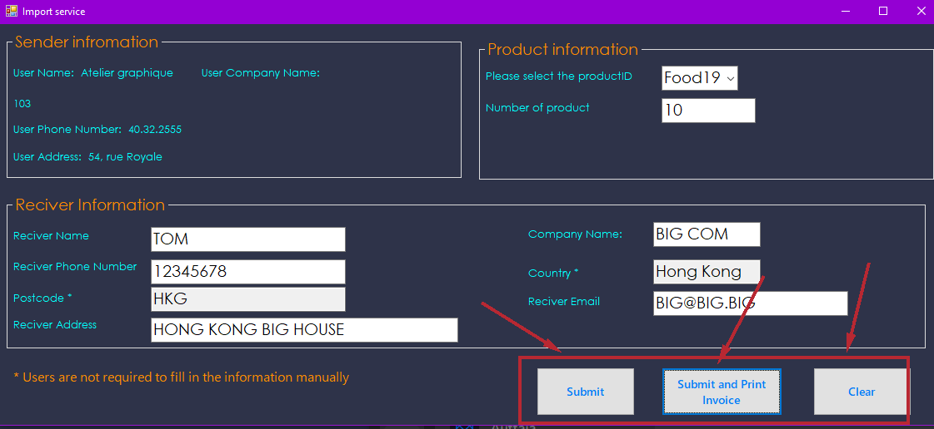

Figure 183: Regular import function form

To create new import order, user can click on the “New Import Order” button. A import service windows will should up. User should fill in the form to continue. If user want to clear the form, user can click the “Clear” button on the right down corner of the window.

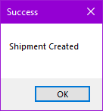

Figure 184: Shipment created message

If click on the “Submit” button, a success message will show up to tell user the process is success.

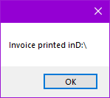

Figure 185: Invoice printed message

If click on the “Submit and Print Invoice” button, a success message will show up to tell user the process is success and Invoice is printed.

# Edit regular import service

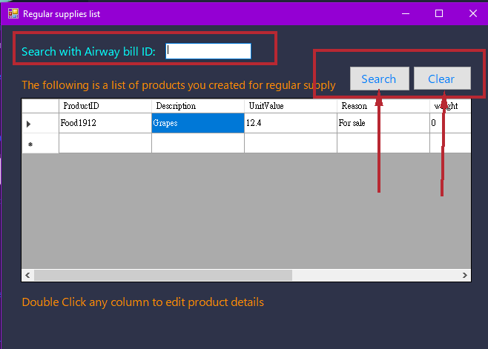

Figure 186: Regular import service

To create new import order, user can click on the “New Import Order” button. A regular supplies list windows will should up. Users choose the record they want to edit by double click on the record. User may enter airway bill ID and click the search “Button” to filter the table. They can also click the “Clear” button to show all record.

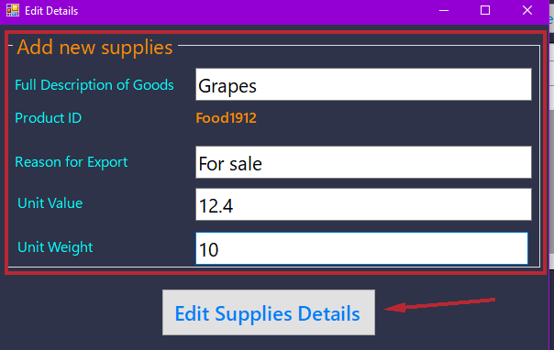

Figure 187: Edit Supplies Details

A “Edit Details” record will show up. User can edit the content of the record. Once finish editing, click the “Edit Supplies Details” button to finish the process.

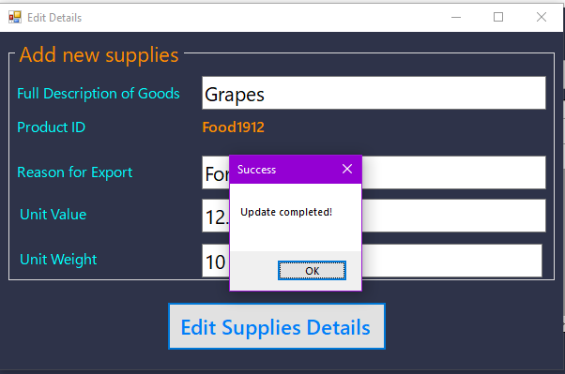

Figure 188: Edit details successful

A successful message should pop up. The edit process is finished.

# Add regular import product

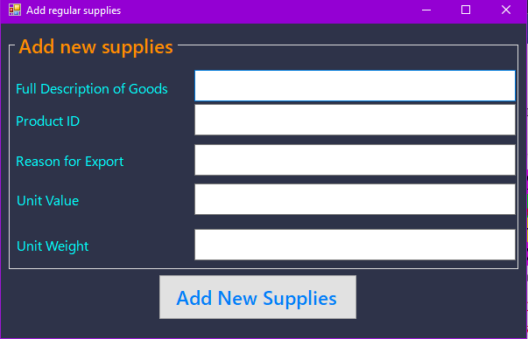

Figure 189: Add regular supplies

To create new import order, user can click on the “New Import Order” button. A “Add regular supplies” form should show up. User should fill in all required information.

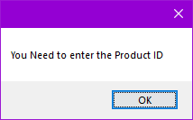

Figure 190: New supplies error message

If some input is not accepted by the system, a pop-up message will show up, user should correct their input in order to add new supplies.

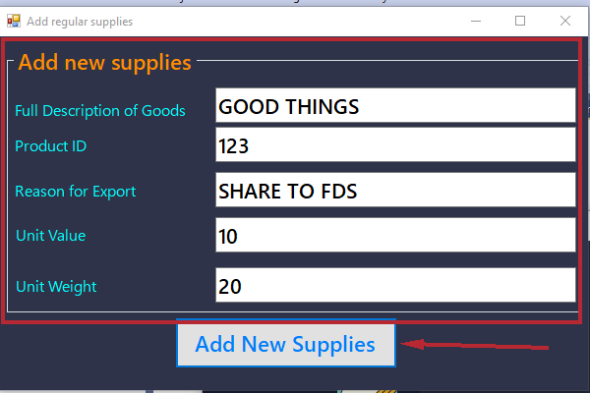

Figure 191: Add new supplies

Fill in all required data then click the “Add New Supplies” button.

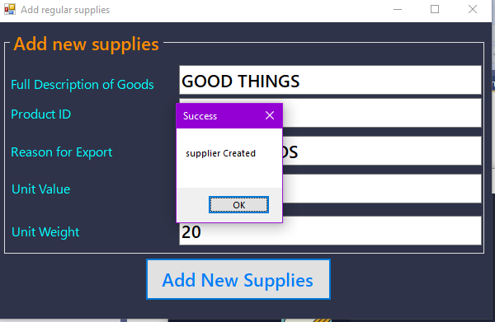

Figure 192: Supplier created

A successful message should pop up. The process is complete.

# Create shipment

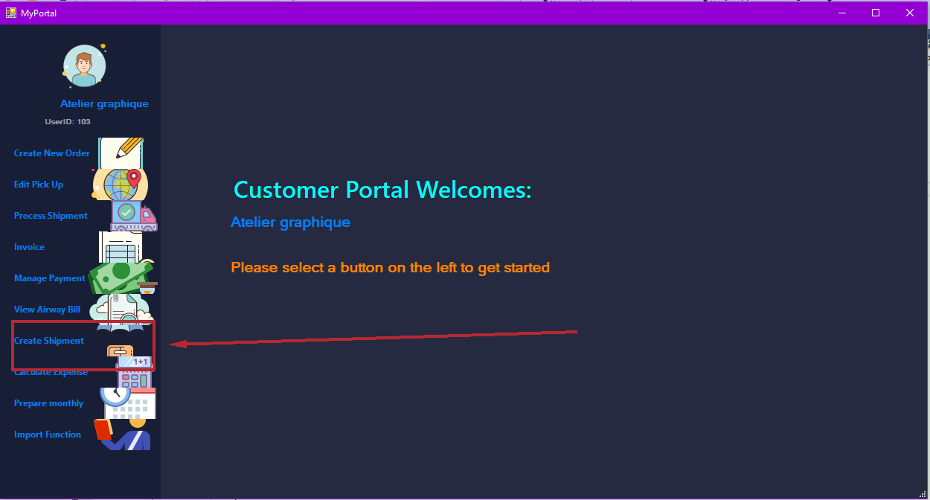Figure 92: Create Shipment

After login, user can click the “Create Shipment” button.

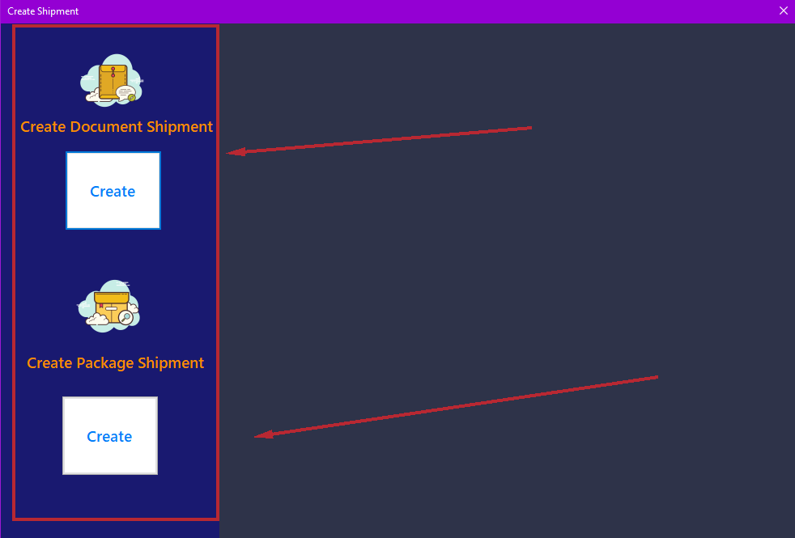Figure 93: Select document type

A “Create Shipment” window should show up.

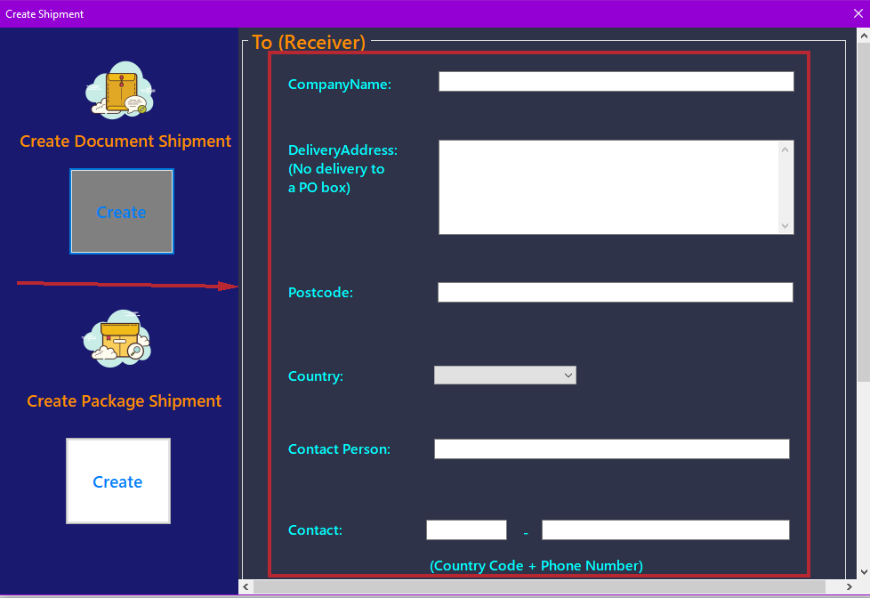Figure 94: Shipment form

There should be two buttons for the users to choose from, one is for creating a document shipment, and the other one is to create a package shipment. Users are required to choose the appropriate one to create a suitable order. A pop-up windows shall be shown on the right, which is a form for user to fill in information regarding the shipment. Illustrated below will be an example of creating a document shipment. The procedure for creating a package shipment shall be same as creating a document shipment.

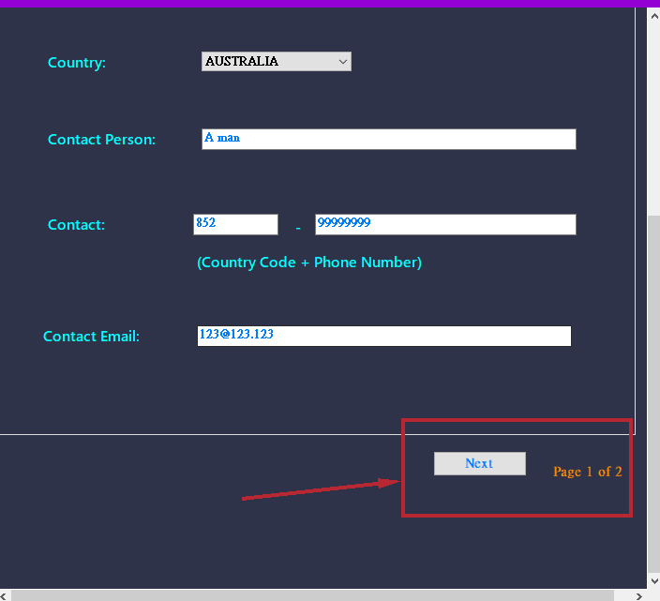

Figure 95: Click "Next" and follow the instruction shown on screen

After filling in the form, users are required to click “Next” to go to the next page and continue to fill in the form until all pages are filled in.

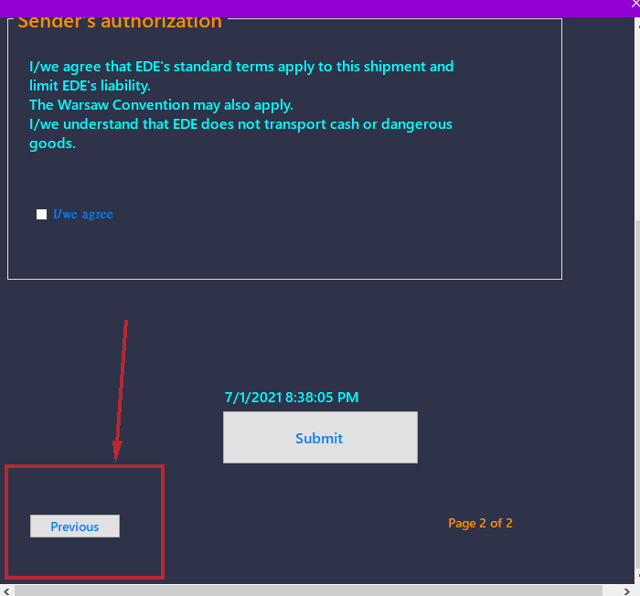

Figure 96: Illustrating how to go back from pages

If users suspected that there is wrong input filled in the form, simply click the “Previous” button to go back to the last page.

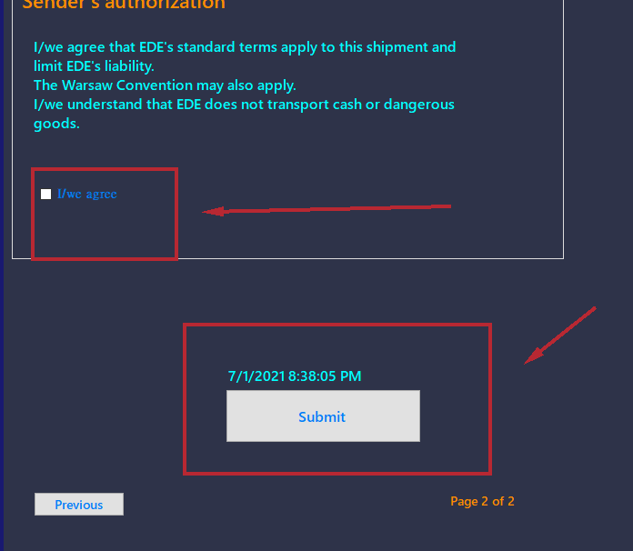

Figure 97: Submitting the form

After filling in the columns, user must agree the terms and condition by clicking the appropriate button.

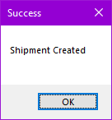

Figure 98: Shipment Created

After submitting the form, a message shall be popped up to let the user knows the process is successful. Press “OK” to continue.

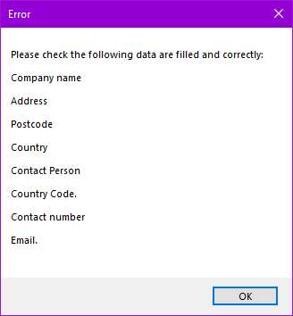

Figure 99: Incorrect input alert

If there are any columns that are not filled in or if there is any wrong input, a pop-up message shall be shown on screen to let user knows which column is wrong or not filled in. Users must correct their input before going to next page or submit the shipment form.

# Customer:

Customer function only can used by customers.

# Menu Program / Login

# Account registration

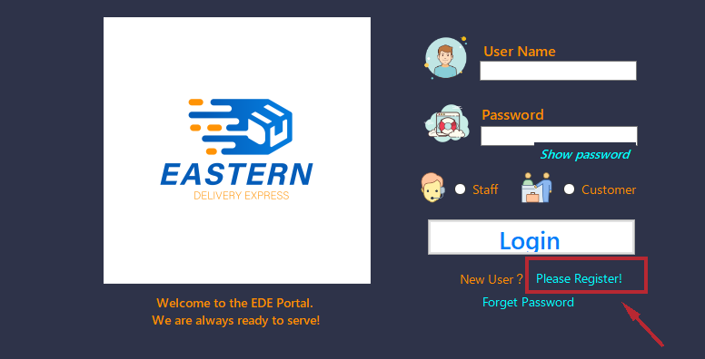

Figure : Login UI (Account Registration)

New customers or existing customers who do not already own an online account are required to register a new account to enjoy the modernized features of the new EDE system application. Simply by clicking the “Please Register” link, customer shall be redirected to the page for self-registration.

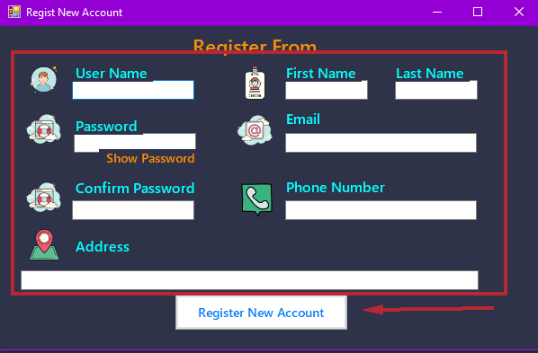

Figure : Registration form

After clicking the “Please register!” button, a register form shall be shown on screen. Users are required to fill in all the required information before clicking the “Register New Account” button. If any of the information are not supplied by the user, the system shall prompt a message to remind user which information is missing (as shown in Figures 100-105).

On the other hand, there might be scenario that the system refuses to accept the values inputted by the user. For instance, the username has already been taken by another user, an error message shall also pop out. Users are required to change their input in accordance with the error message.

|  |  |
| --- | --- |
| Figure : Email format mismatch message | Figure : Username missing message |
| Figure : Name missing message | Figure : Phone format mismatch message |
| Figure : Username taken message | Figure : Address missing message |

If all the information passes the system check, a new online account shall be registered, and a register successful message shall subsequently be popped up (as shown on Figures 106 and 107 next page). After clicking the “OK” button to finish the registration process, the system shall return to the login screen and user should login to the system with the newly created account to enjoy EDE’s modernized service.

|  |  |
| --- | --- |
| Figure : Registration process starts message | Figure : Registration process finishes message |

# Forgot Password

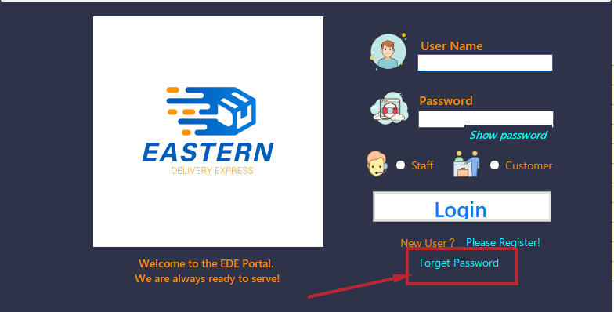

Figure : Login UI (Forgot Password)

If it happens that a user would like to reset password or they have forgot their password, they could simply click the “Forget Password” button to start the reset password process. A reset password form shall pop up (as shown on next page).

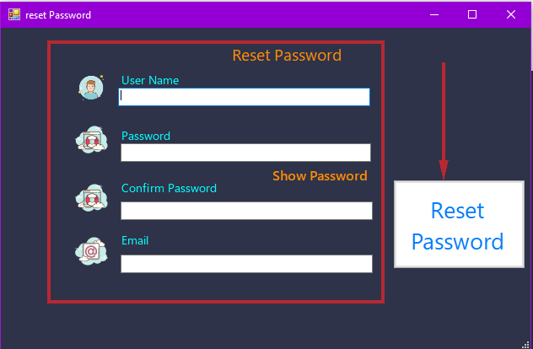

Figure : Reset password form

By filling in all the required information as instructed on screen, the password would be reset.

|  |  |
| --- | --- |
| Figure : Reset password in progress | Figure : Reset password finish |

A reset password successful message (Figures 110 and 111) shall show up if the information is all correctly. Also, a finish message would show up to let the user knows that the process is finished.

Similar to the case of registering a new account, there might be scenario that the system refuses to accept the values inputted by the user. For instance, the passwords entered by the user do not match with each other, an error message shall also pop out. Users are required to change their input in accordance with the error message.

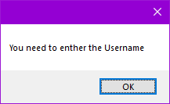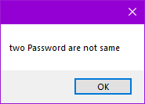

Figure : Enter username alert Figure : Password not identical alert

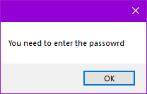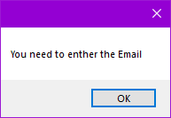

Figure : Enter password alert Figure : E-mail field empty alert

If any of the information is not filled or not accepted by the system, a message should be prompted to let the user knows which information are required to be input again.

# Express Document/ Package Express Management

# Pickup Booking Management

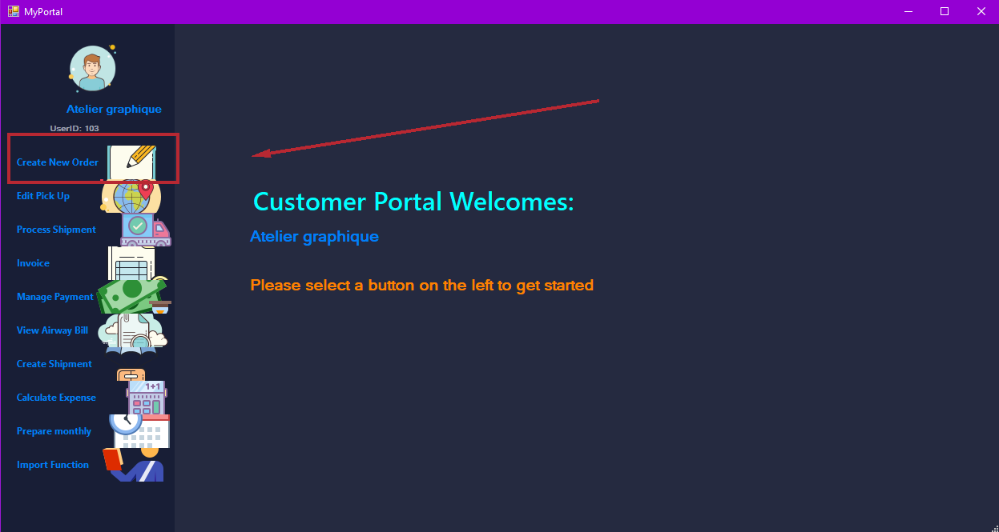

Figure : Create New Order

After logging in to the system, a menu would prompt to the user. To create a new order, customers are required to select the “Create New Order” button to create a booking pick up.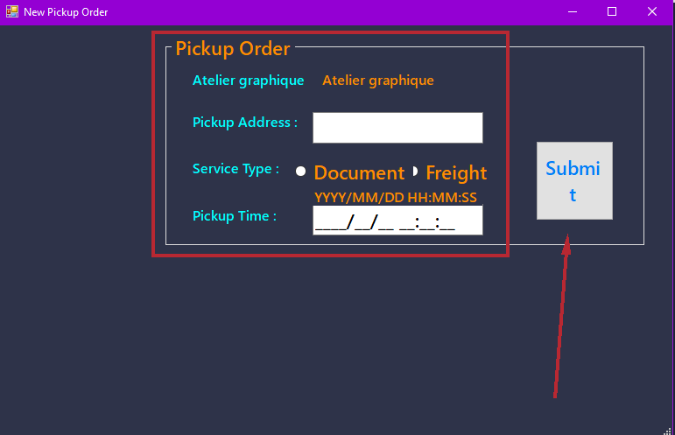

Figure : New Pickup Order form

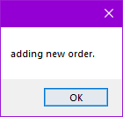

Figure : Adding new order alert

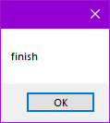

Figure : Finished adding new order alert

By filling in all the columns on the table and subsequently clicking the “Submit” button, a pop-up message shall be shown to tell the user the process is finished given that all the information has been entered correctly. Users to click “OK” to confirm.

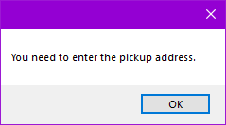

Figure : Pickup address required alert

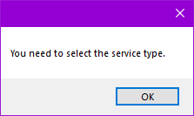

Figure : Service Type required alert

If any of the column is not filled in or the input is not what the system expected, some pop-up message in accordance with the error shall be prompted on screen to remind user. Users must follow the message to adjust their input.

# Calculate shipping expenses

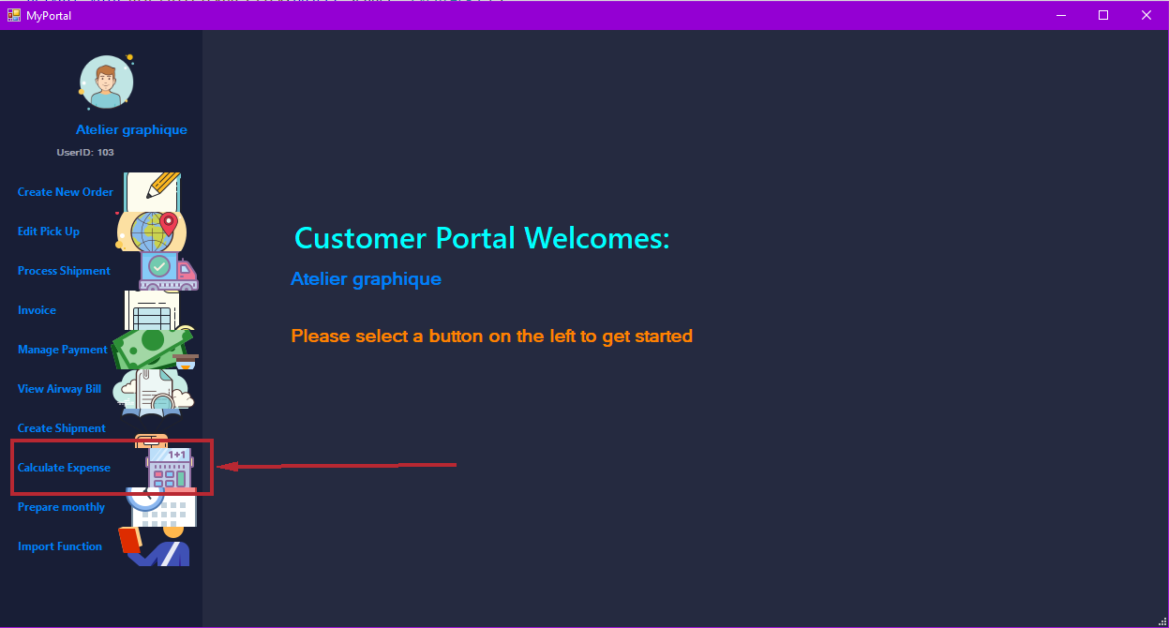

Figure : Calculate Shipment Expenses

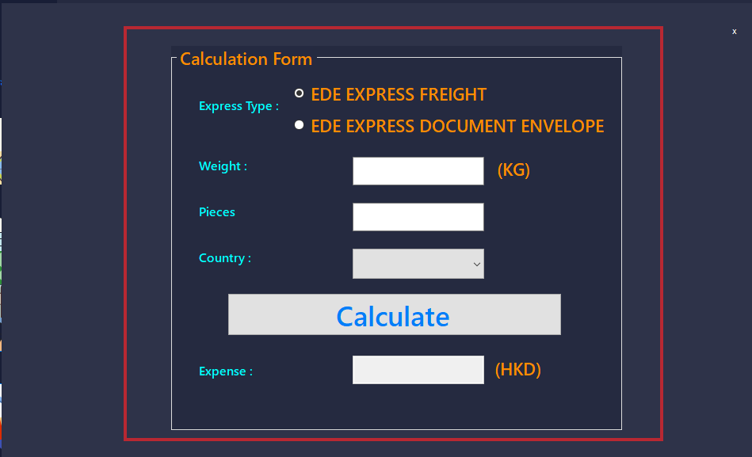

Figure : Expense Calculation Form

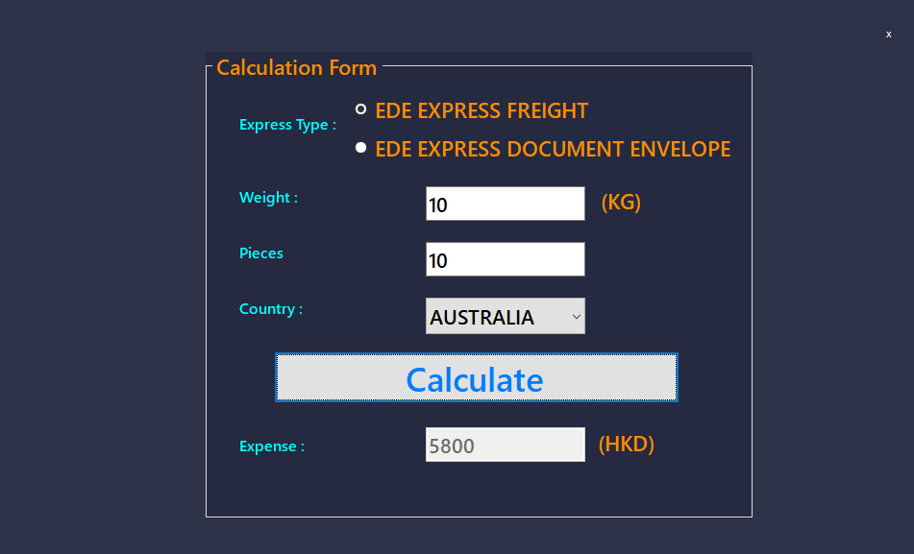

Figure : Expense Calculation Form (continued)

If you are calculating expense for the express freight, choose the express type then fill in the weight and choose the country for shipment, lastly click the calculate button, the expense will show on the bottom of the form. Calculate document envelope expense should be the same but there is no need to choose the “Country”.

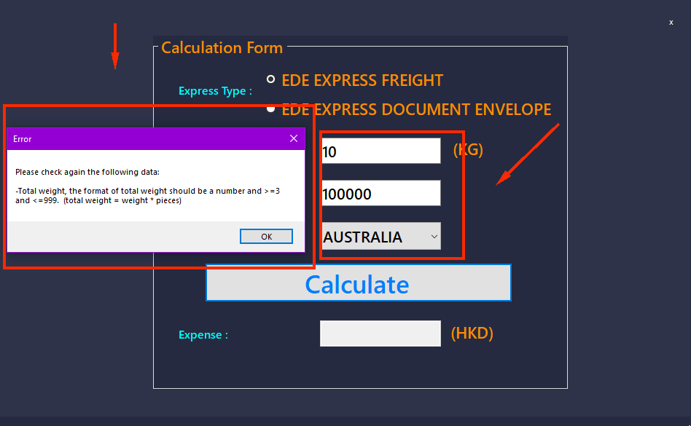

Figure : Expense Calculation Form (error)

An error message would show up if the input is not accepted.

# Generate EDE airway bills

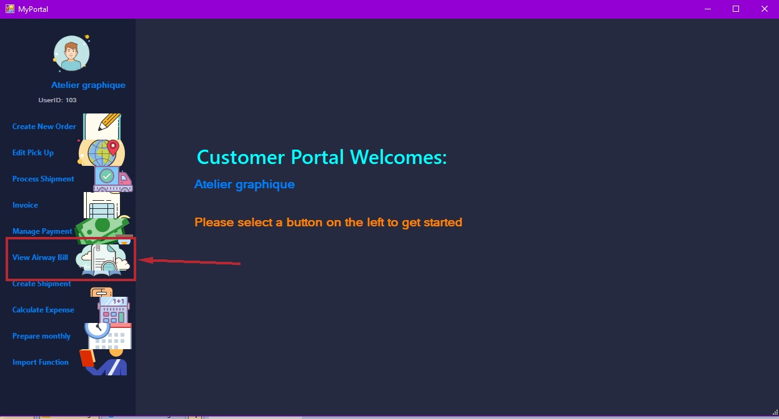

Figure : Generate EDE airway bills

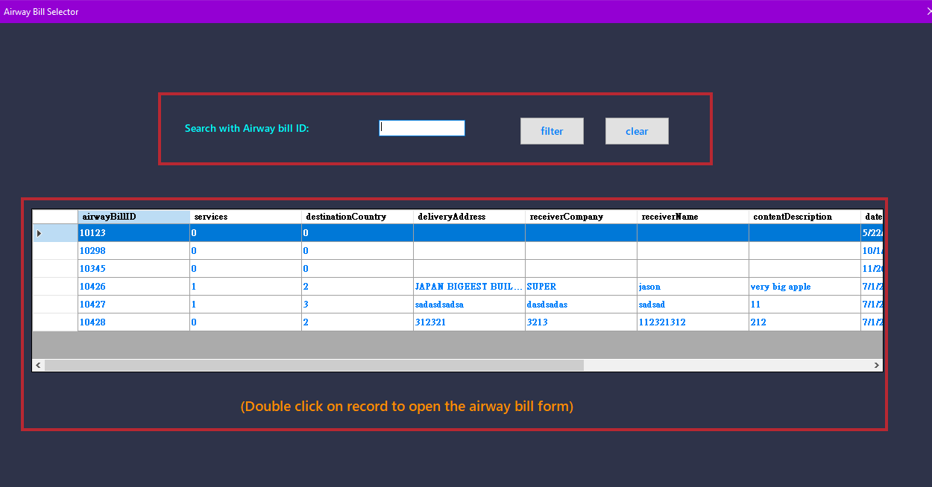

Figure : Airway Bill selector

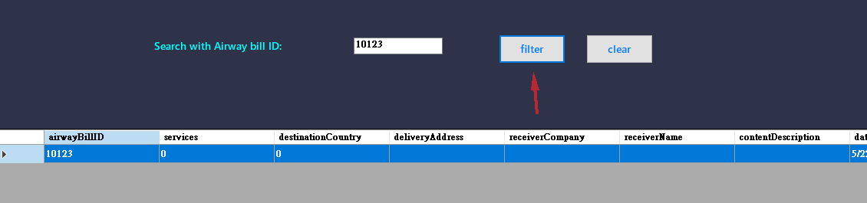

Figure : Airway bill selector (continued)

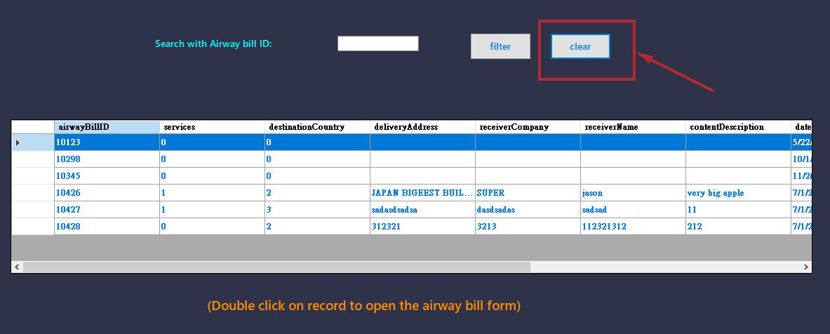

Figure : Airway bill selector (continued)

Click “clear” if you want the table with all your airway bill.



Figure : Airway bill selector (continued)

Double click on the record that you want to view.

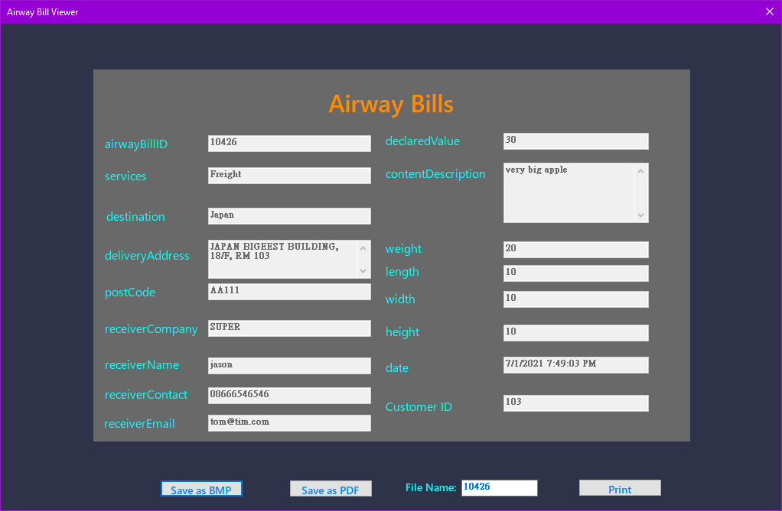

Figure : Airway bill viewer

Then the airway bill form will show.

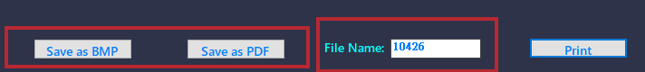

Figure : Generate bill in BMP or PDF format

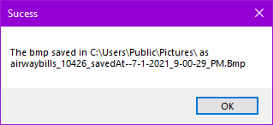

Figure : Generate successful message

If you want to save the airway bill to your computer, you can either click “Save as BMP” or “Save as PDF”. A successful message should show. If you want to change the filename, you can enter the name you want in the “File Name” textbox. The file will be saved in “C:\Users\Public\Pictures\”.

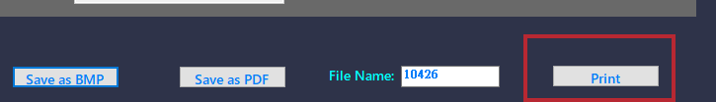

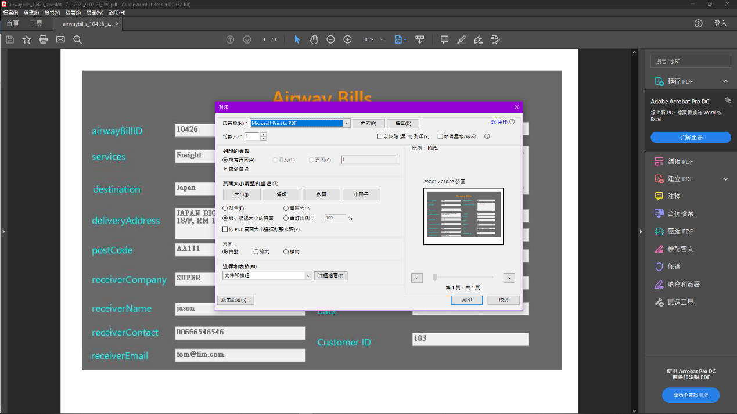

Figure : Printer prompt dialogue

If you want to print the airway bill, you can click print, a print form should show up.

# Track Shipment Status

.

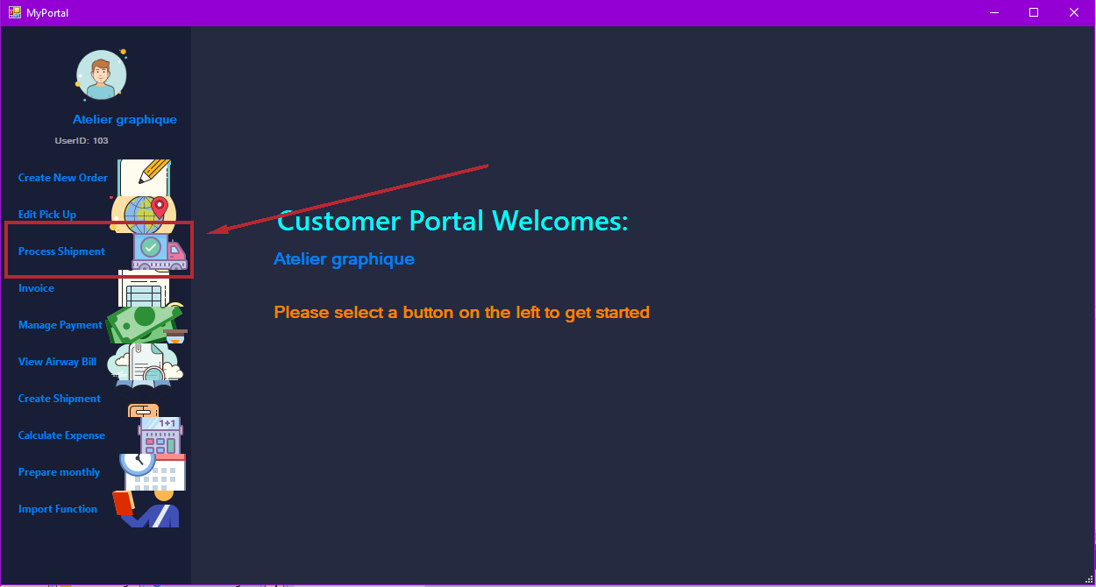

Figure : Process Shipment

After login and go to the menu window, click the “Process Shipment” to track shipment.

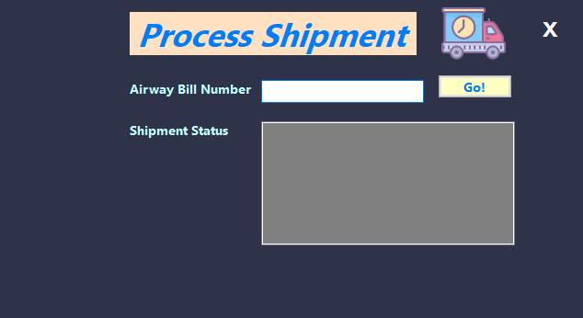

Figure : Process Shipment form

Click the process shipment in the menu, a process shipment form should show up.

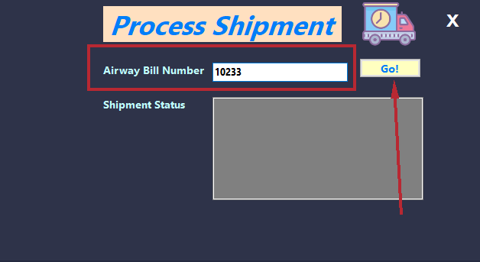

Figure : Search for airway bill

Enter the airway bill number textbox, and click the “Go” button.

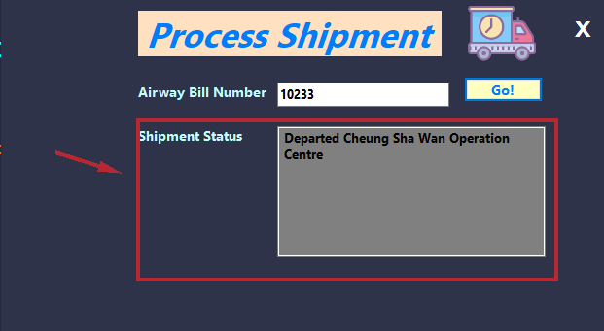

Figure : Shipment status

Then result would be show in the area below.

# Bill and Payment Management

# Generate invoice

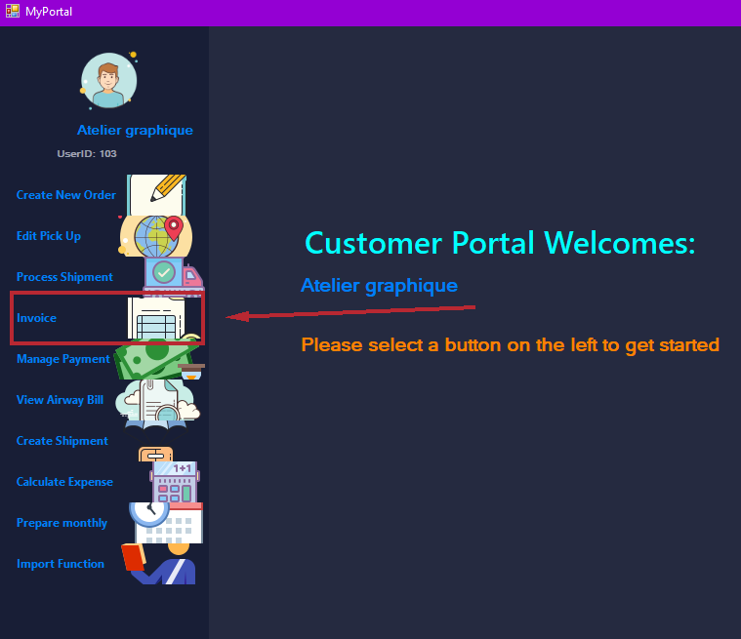

After login, go to the

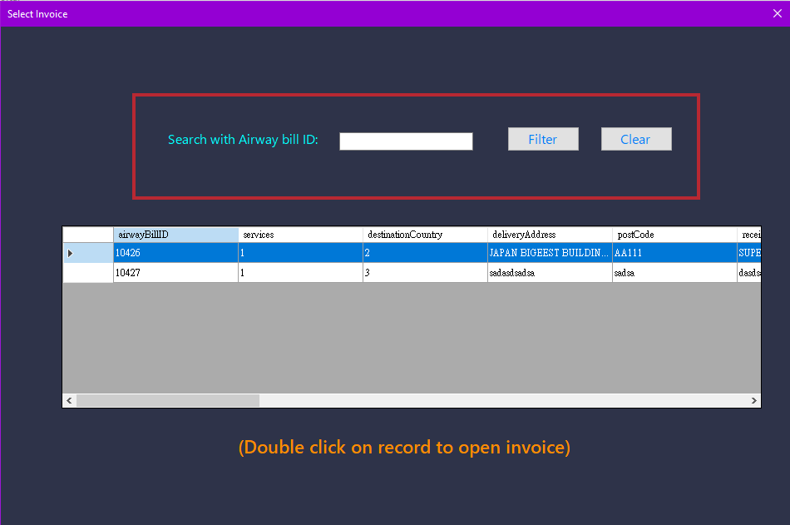

Figure : Select invoice

A window should show up.

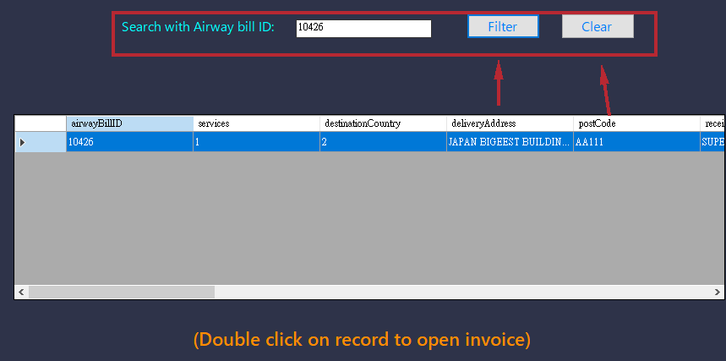

Figure : Select invoice (continued)

You can enter the airway bill text box and click the “Filter” button to filter the form below or click the “Clear” button to reset the table.

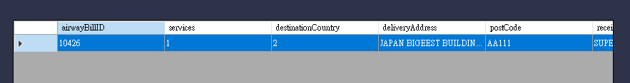

Figure : Select invoice (continued)

Double click on the record that you want to see.

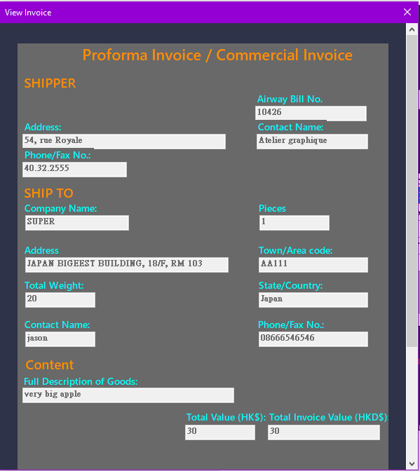

Figure : View invoice

The invoice of the record should show up. Scroll down to see more action.

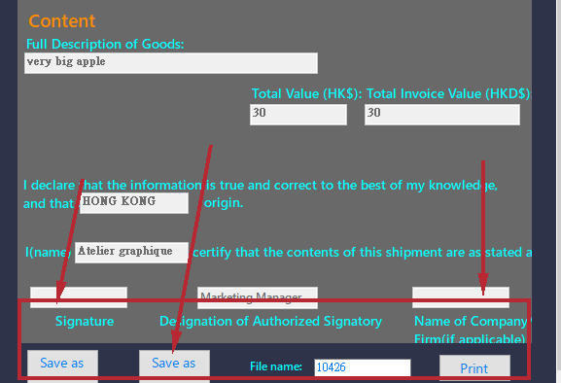

Figure : Save or Print invoice for record if necessary

Click on those buttons if you want to perform those action.

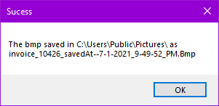

Figure : Save successful message

A message box would show up after user click those buttons to tell the details of the action.

# Prepare monthly invoice

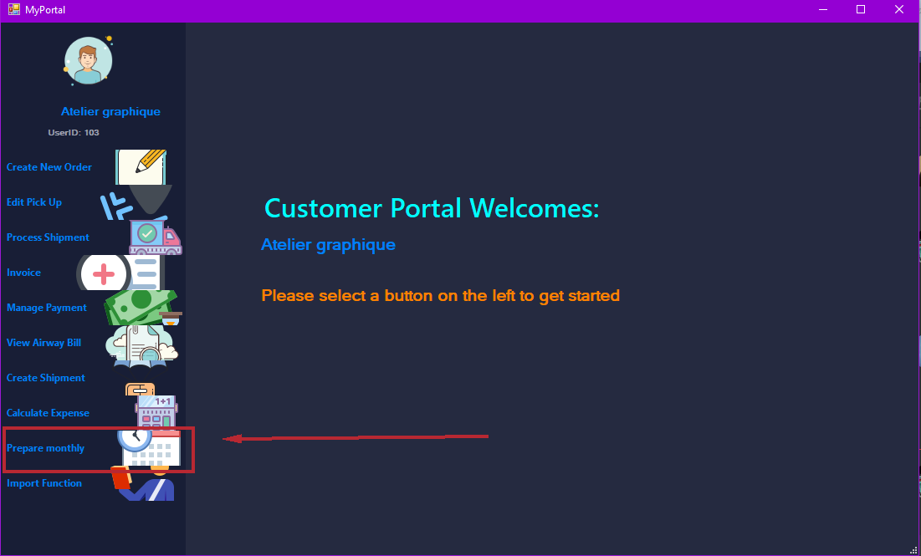

Figure : Monthly Invoice

Choose the “Prepare monthly” button in the menu.

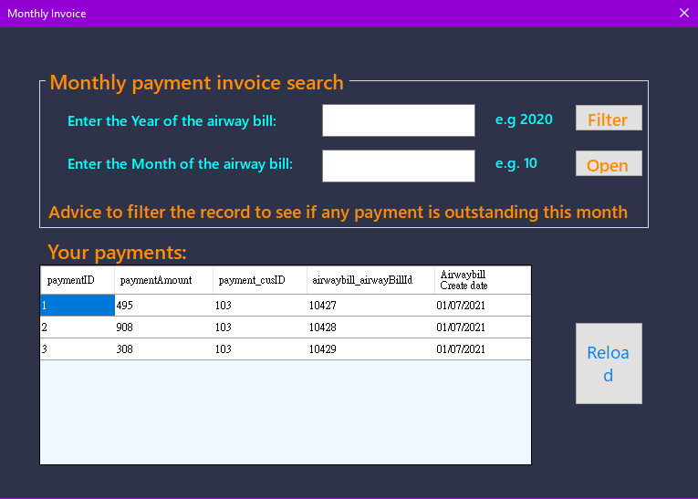

Figure : Monthly invoice form

A “Monthly Invoice” window should show up. There should be an input field with two button to let user perform searching and a table below to show all records, the reload button can be used to reload the record table.

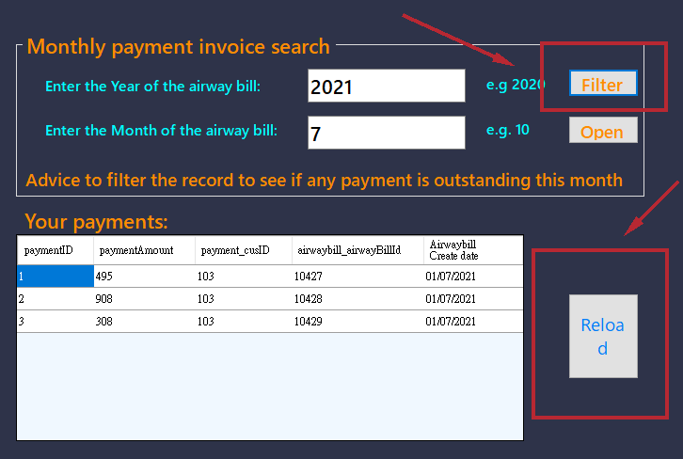

Figure : Monthly invoice form (filter function)

If you want to filter the table, enter the year and month of the airway bill, and click “Filter”, the table below should be updated. And if you do not want a filtered table, you can click the “Reload” button you reset the table. Then click “Open” to view the monthly invoice.

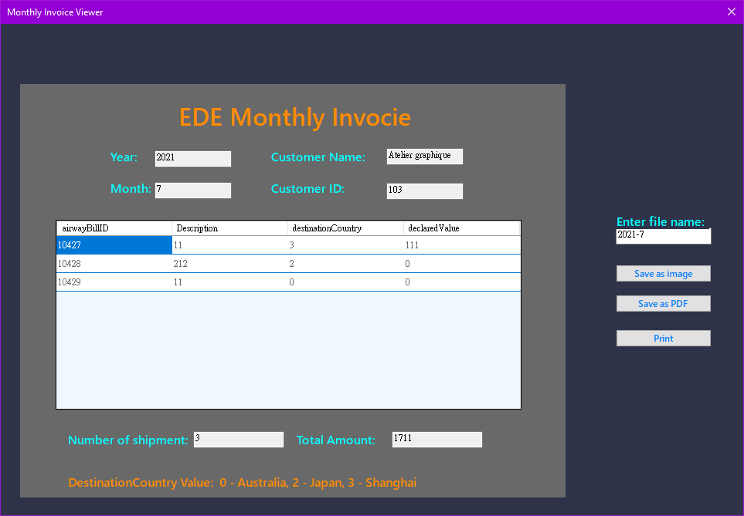

Figure : Filtered monthly invoice

Then the monthly invoice would show up.

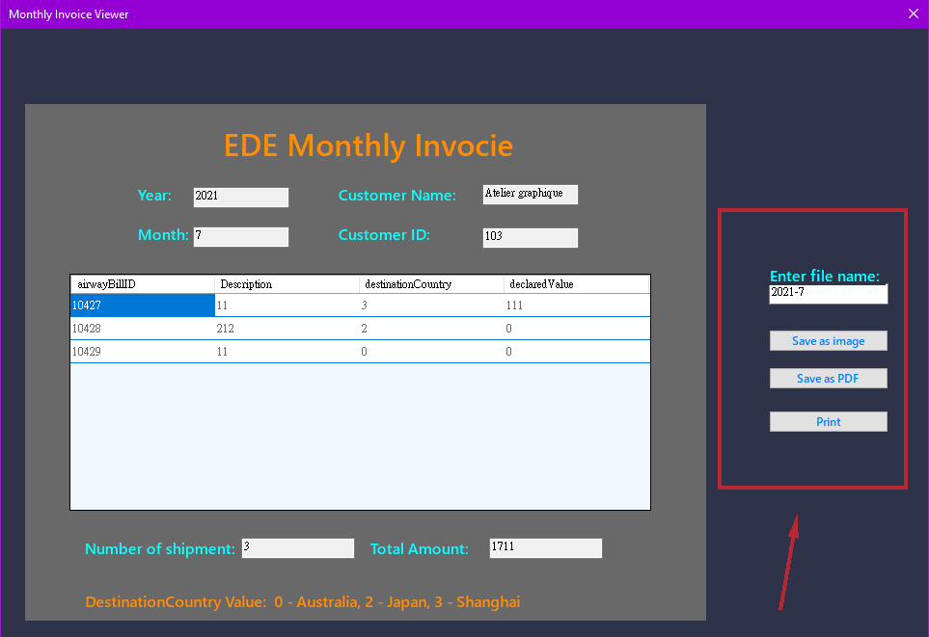

Figure : Additional save and print function (similar to previous section)

Click on of those buttons if you want to perform those action.

# Manage payment

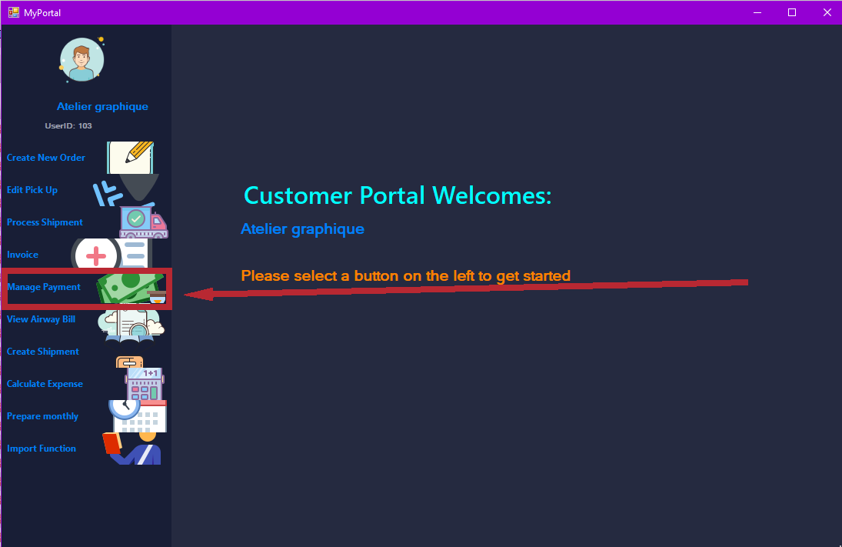

Figure : Manage payment

After login, you will see the menu, please click the “Manage Payment” button to pay the payment.

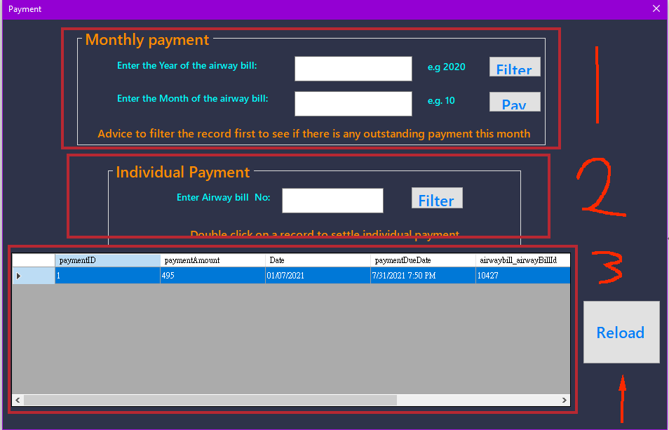

Figure : Choose monthly or individual payment

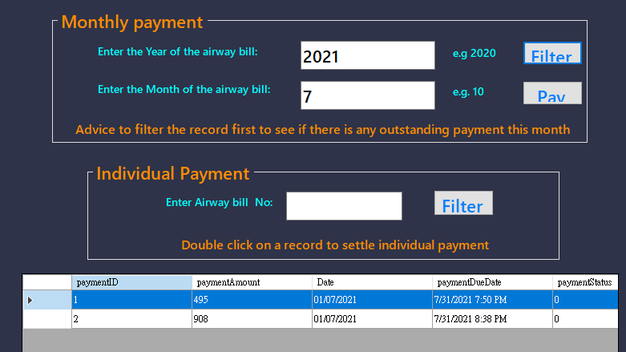

Figure : Choose monthly or individual payment (continued)

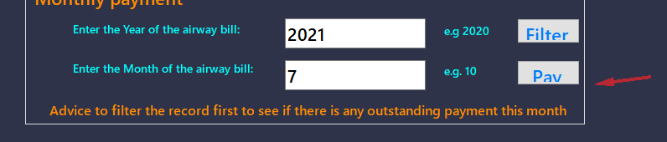

Figure : Pay button

If you want to pay with monthly payment, fill in the monthly payment form, then click filter. The table in the bottom should updated, you can see all payment in the month. If you want to see all payment, you can click “Reload” button to reset the table. Click pay to pay. And if you just want to pay with one payment, double click the record on the table.

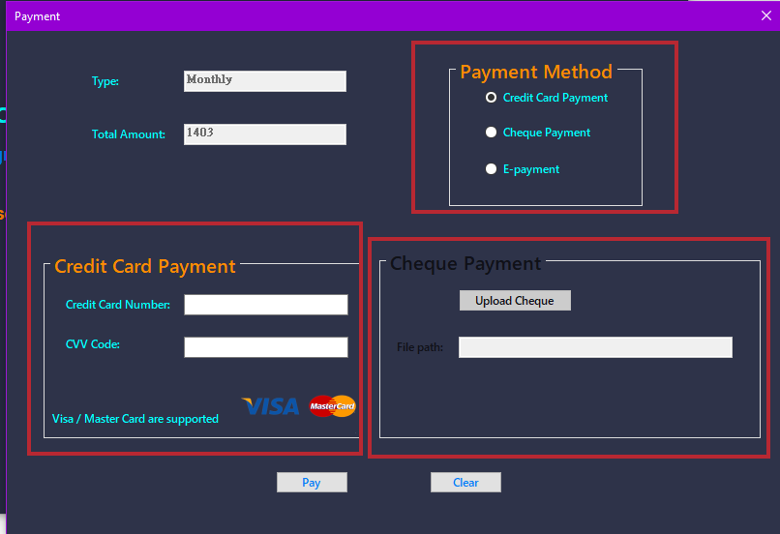

Figure : Payment method

If you want to pay with credit or cheque, choose the right radio button in the payment method table, and fill in required input, for cheque payment, you must upload the photo of the cheque. Then click the “Pay” button. If you want to pay with “E-payment”, please click “Pay” to continue.

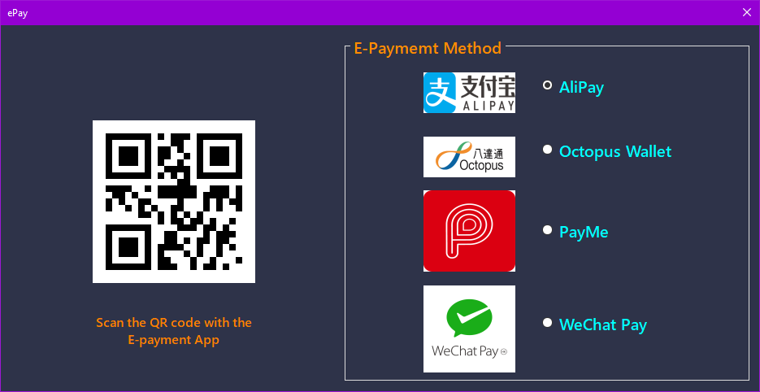

Figure : e-payment

If you choose to pay with “E-payment”, you will see this window, please choose your e-payment method, and scan the QR code with the right e-payment app.

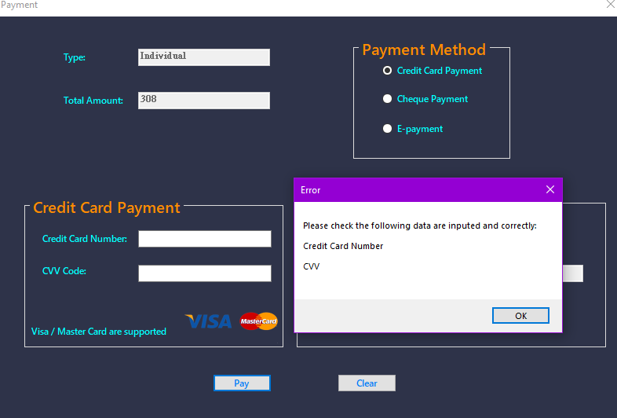

Figure : Credit card payment

If there are any input that not accepted by the system, a message would show up and tell the user which input in not accepted, user must correct the input in order to continue.

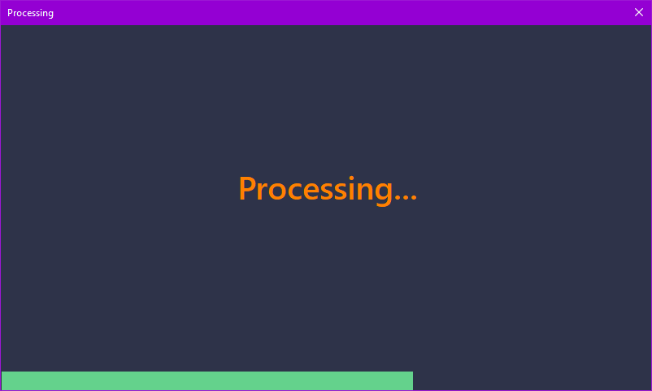

Figure : Payment in progress message

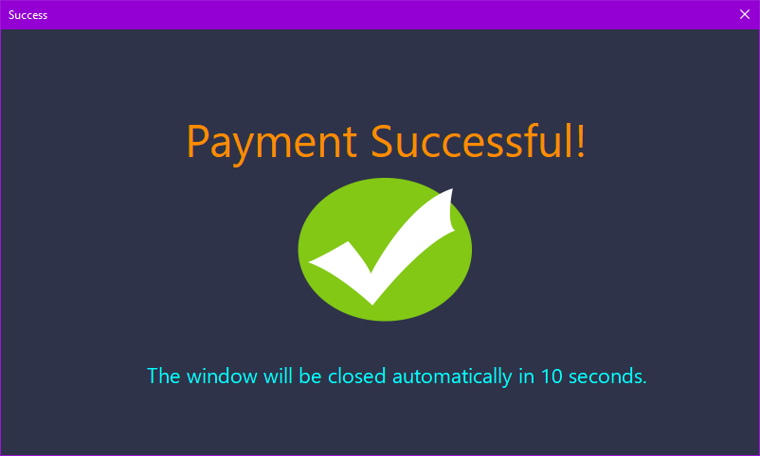

Figure : Payment successful message

After choosing the payment you want to pay with and fill in the required input, you should see the processing window, after the payment process is done, a payment successful message will show. The payment is now successful.

# Staff:

# Edit the pickup

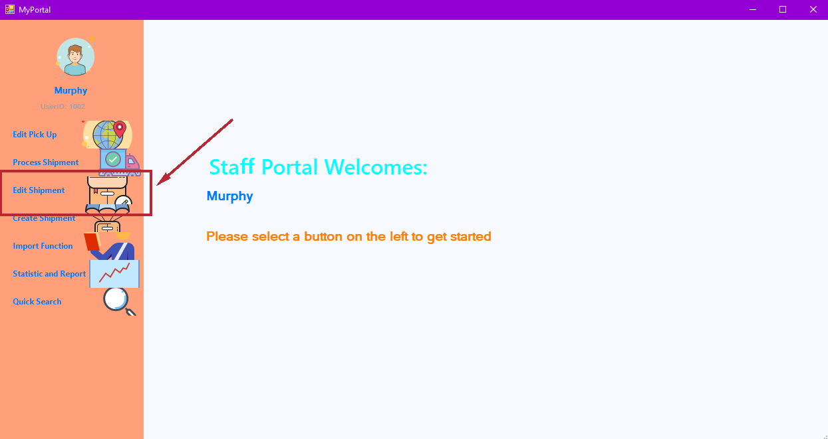

Figure 161: Edit pickup

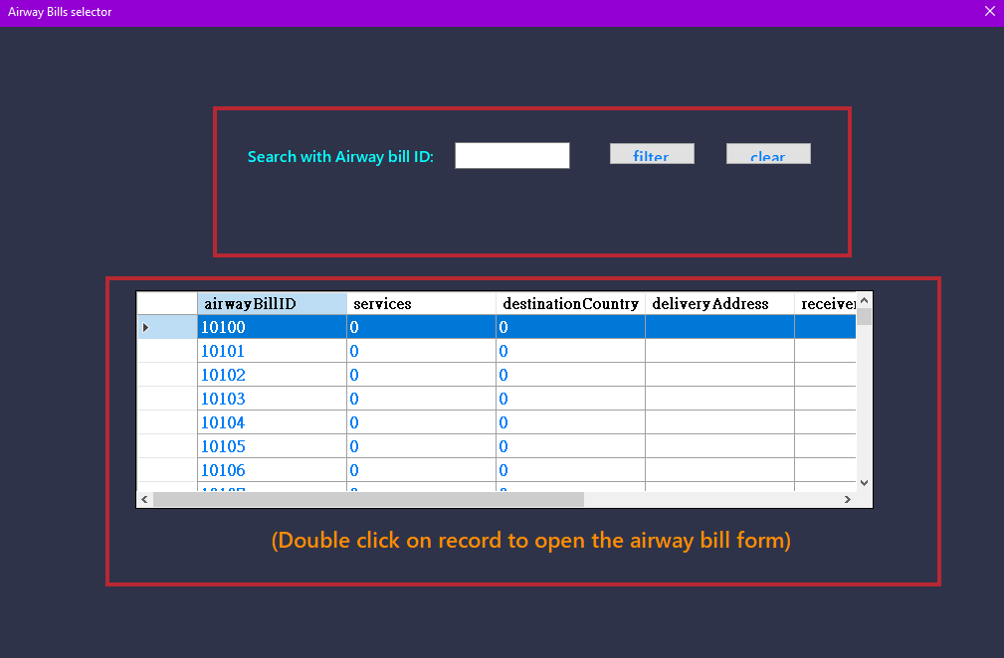

Figure 162: Airway bill selector

An airway bills selector window shall be shown. Double click any record to open the airway bill form for editing.

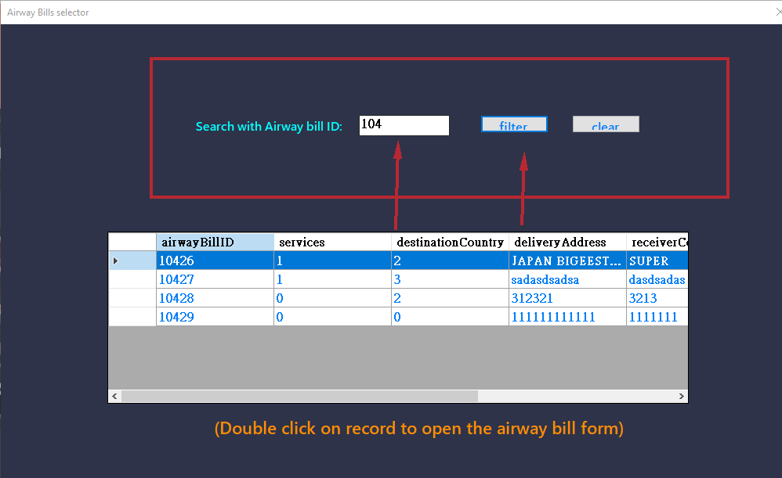

Figure 163: Airway bill selector (continued)

If user would like to filter the table, simply enter the airway bill id to the textbox and click filter to filter record.

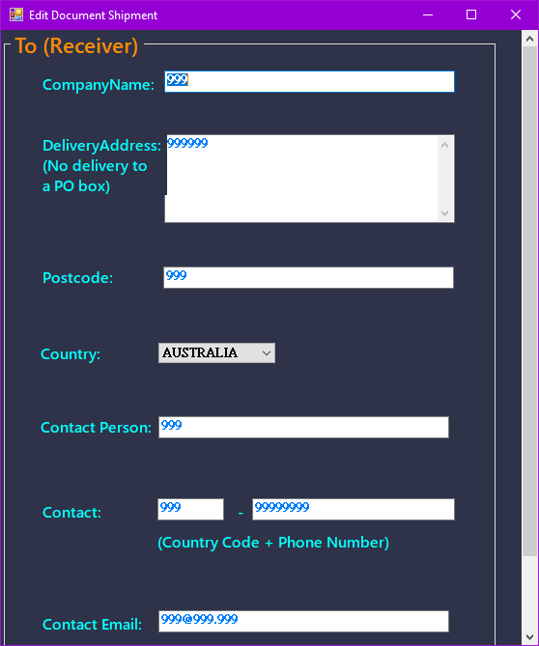

Figure 164: Edit Shipment

After double click on one record on the table, the filled airway bill form will show up, user may edit the content they want to change.

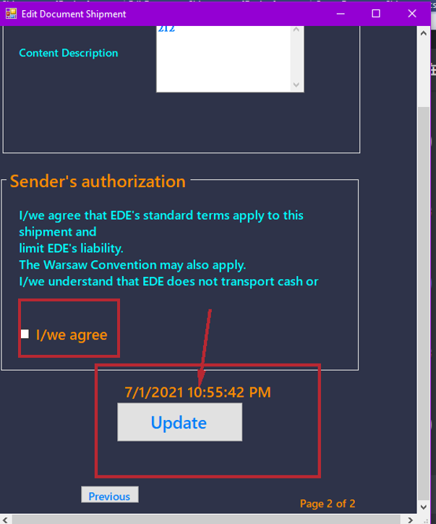

Figure 165: Edit Shipment (continued)

After finishing the change, check the “agree” box and click the “Update” button. A successful message will show up to tell user the update is finished.

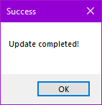

Figure 166: Update completed message

# Process Shipment

s

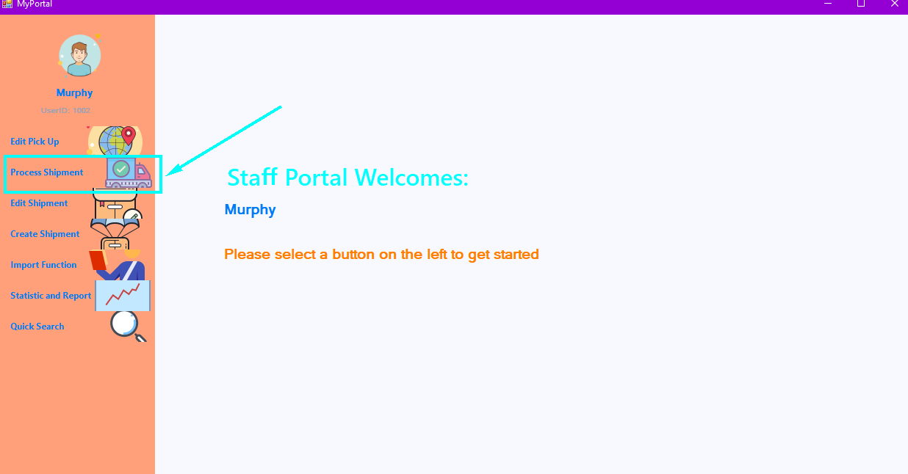

Then enter the airway bill number in the textbox and click

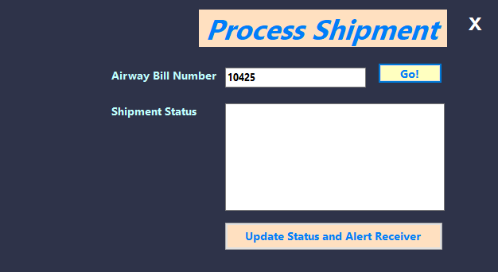

Figure 167: Search for airway bill (staff)

A process shipment form should show up.

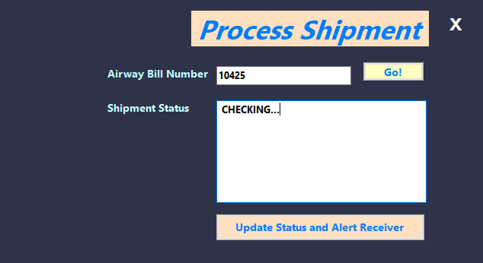

Figure 168: Shipment status update (staff)

Staff members could enter the airway bill number and click go to check if airway bill number exist, then type the status message in the “Shipment Status” textbox. Then click the “Update Status and Alert Receiver” button.

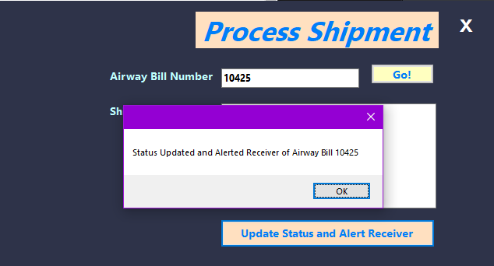

Figure 169: Shipment updated, and alert sent message

A successful message would show up to tell the user the shipment status is updated and alerted the receiver.

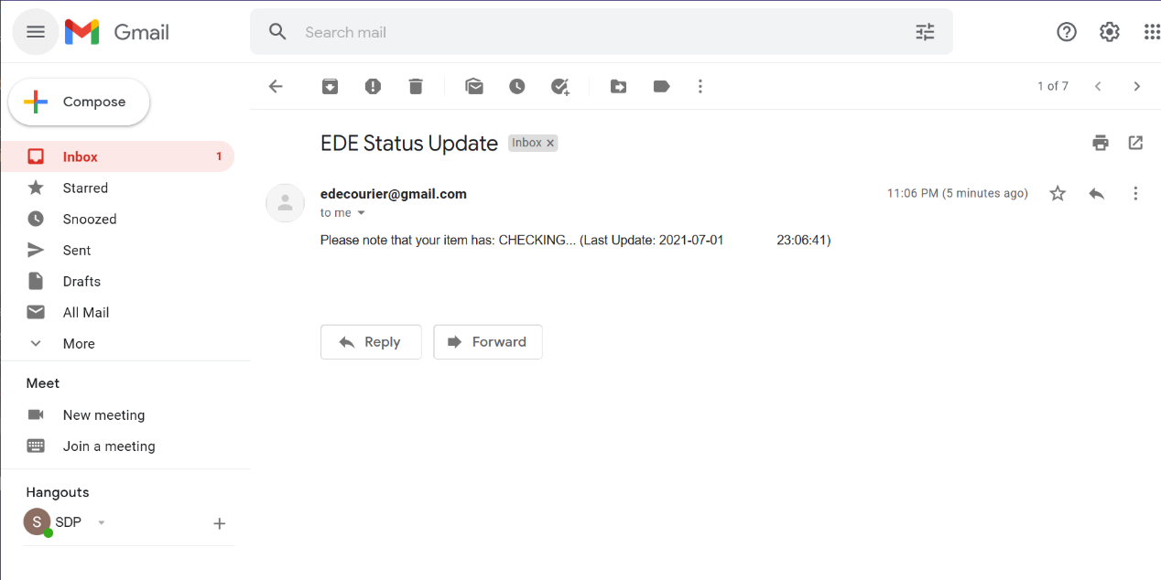

Figure 170: E-mail sent to receiver

The receiver would receive a message for the shipment status update by email.

# Advanced function

# Searching functions (Management)

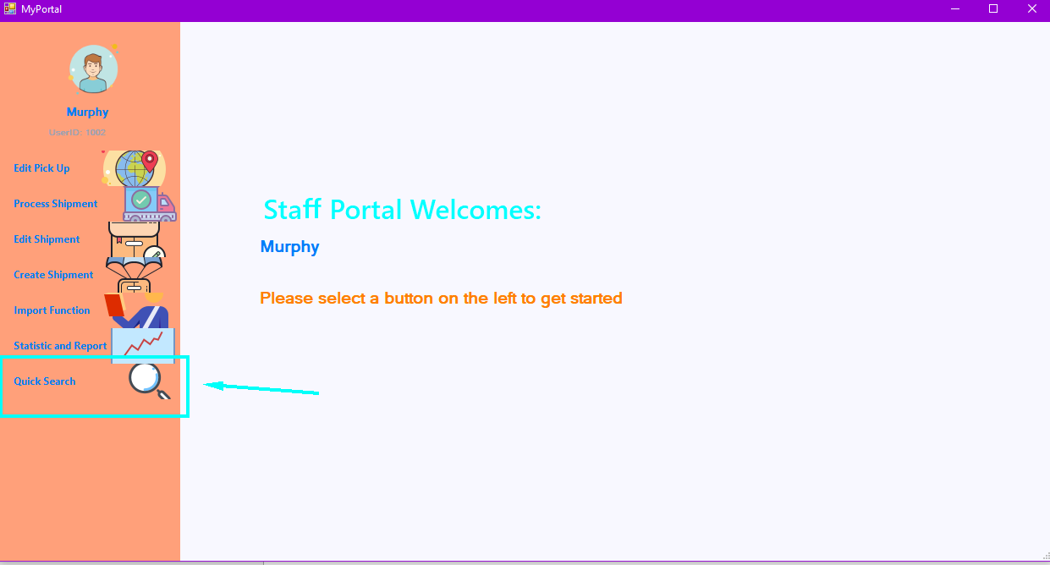

Figure : Search Functions (Management)

After login, you will see the menu, please click the “Quick Search” button to perform a quick search.

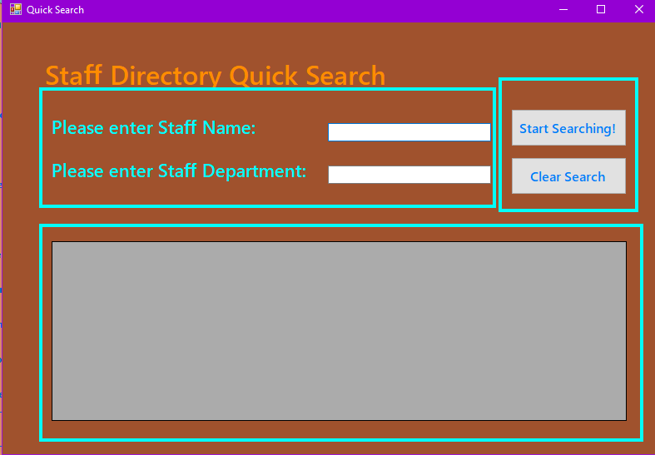

Figure : Search Staff Directory

You should see the “Quick Search” window. There are three parts, one is the search constraint textbox, one is buttons, one is the result table.

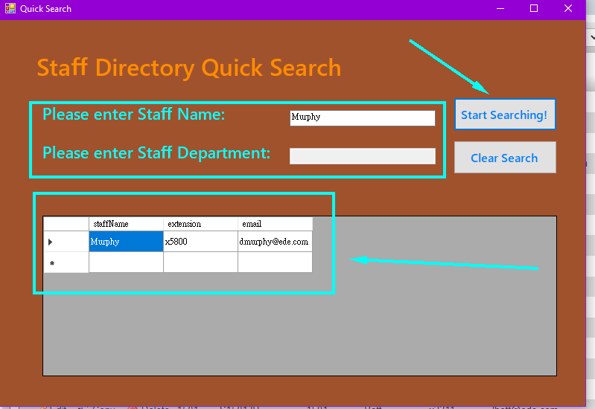

Figure : Search Staff Directory (continued)

To perform a quick search, please fill in the search constraint textbox and click “Start Searching” button. The search records should show on the result table area. Lastly, user can choose to click the “Clear Search” button to clear search result to perform next search.

# Searching functions (General Staff)

Sometimes it might be useful for general staff to quickly retrieve airwaybill information to answer questions from customers. Therefore, the quick search function for general staff shall focus on searching airwaybill.

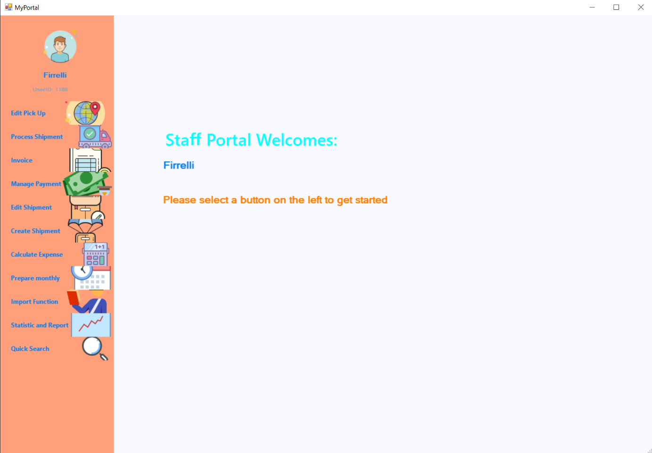

Figure : Search Functions (General Staff)

After login, you will see the menu, please click the “Quick Search” button to perform a quick search.

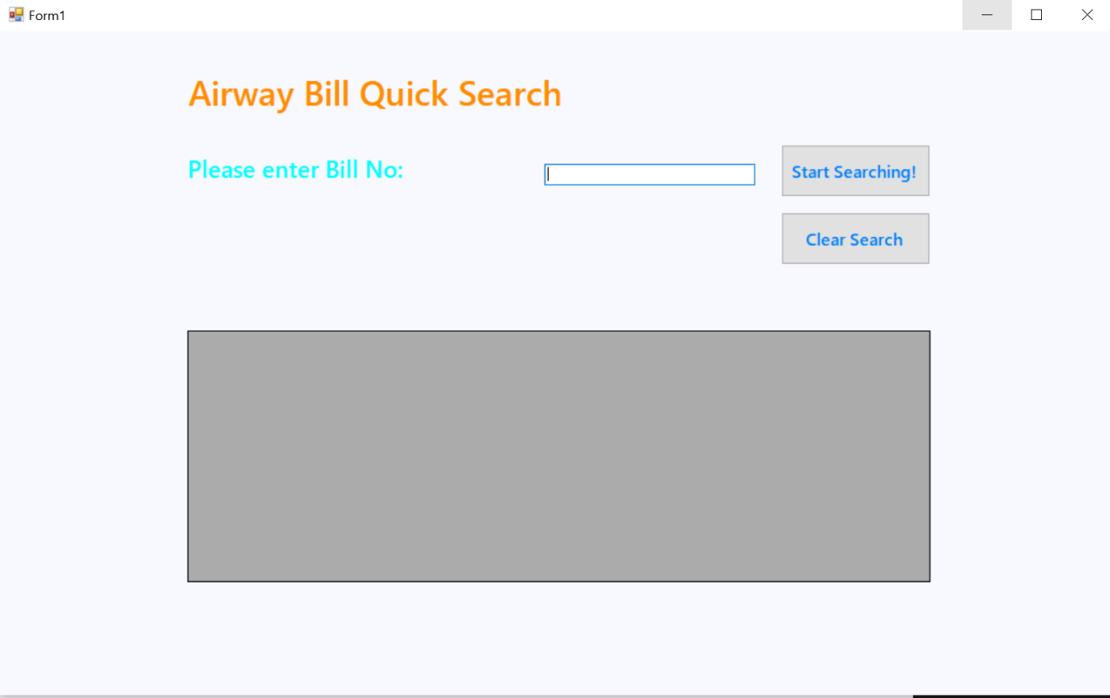

Figure : Search Airway bill

To perform a quick search, please fill in the search constraint textbox and click “Start Searching” button. The search records should show on the result table area. Lastly, user can choose to click the “Clear Search” button to clear search result to perform next search.

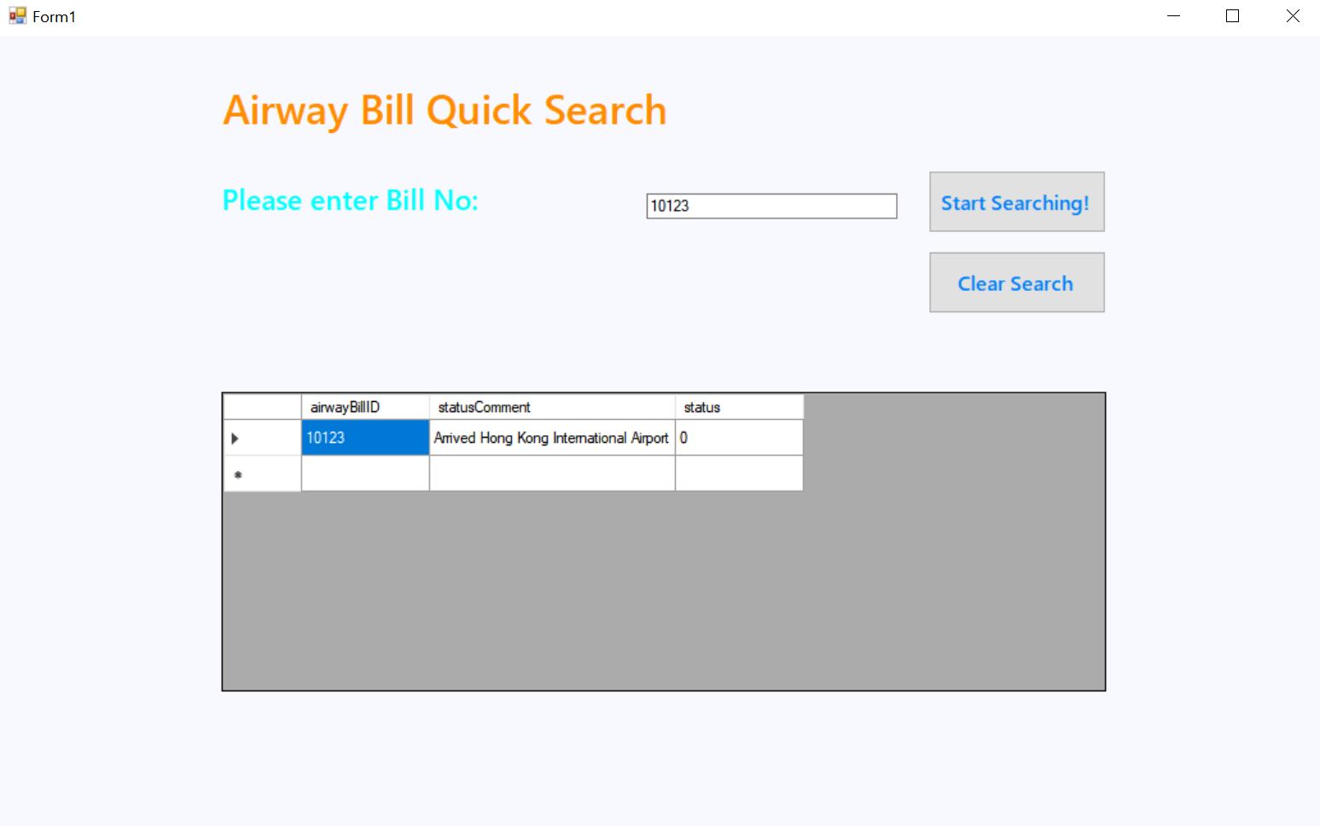

Figure : Quick search airway bill

# Statistical Reports (authorized users only)

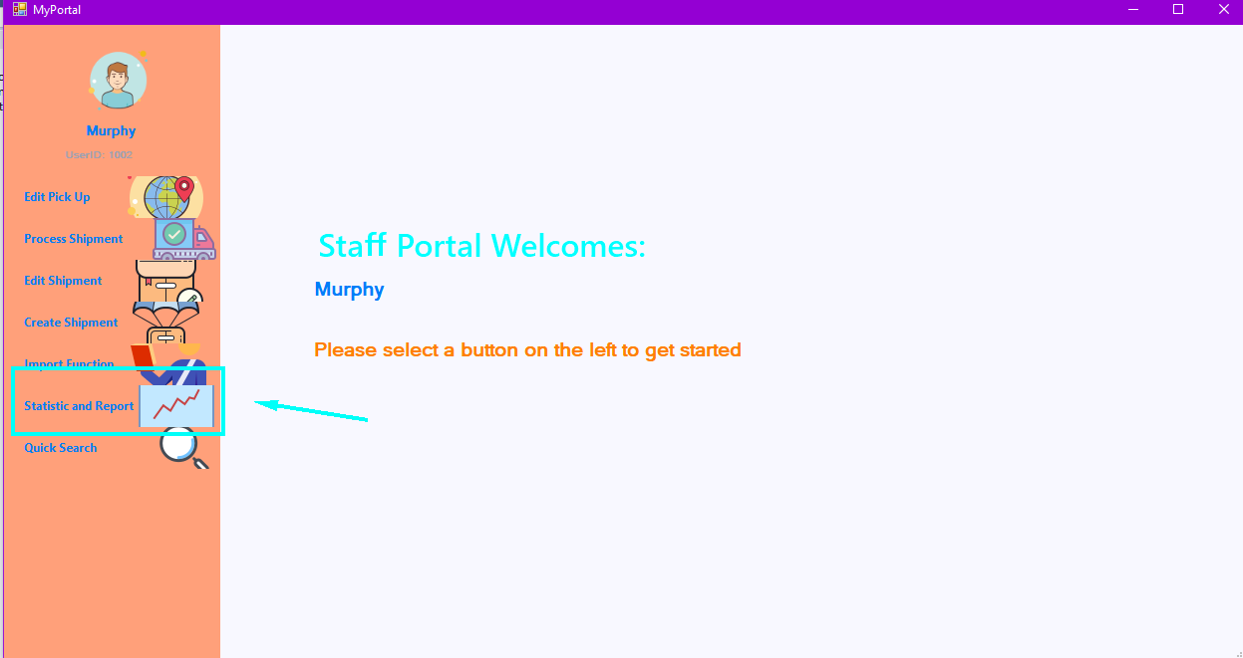

Figure : Statistic and Report

After login, you will see the menu, please click the “Manage Payment” button to generate reports.

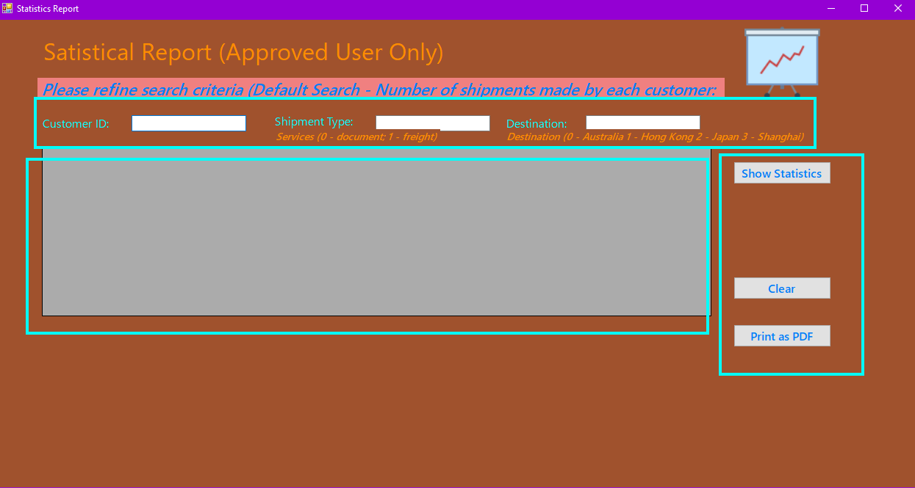

Figure : Statistic and Report (continued)

You will see there is three part of the form, a table, some input textbox and some button.

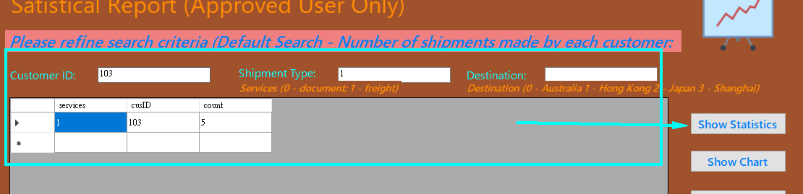

Figure : Refine statistic criteria

If you want to perform a search action, please enter the constraint of the result search.

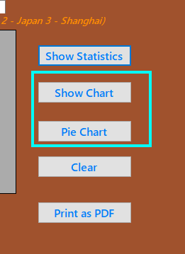

Figure : Create chart

After search, you shall see two new buttons show up, the “Show” Chart and “Pie Chart” button.

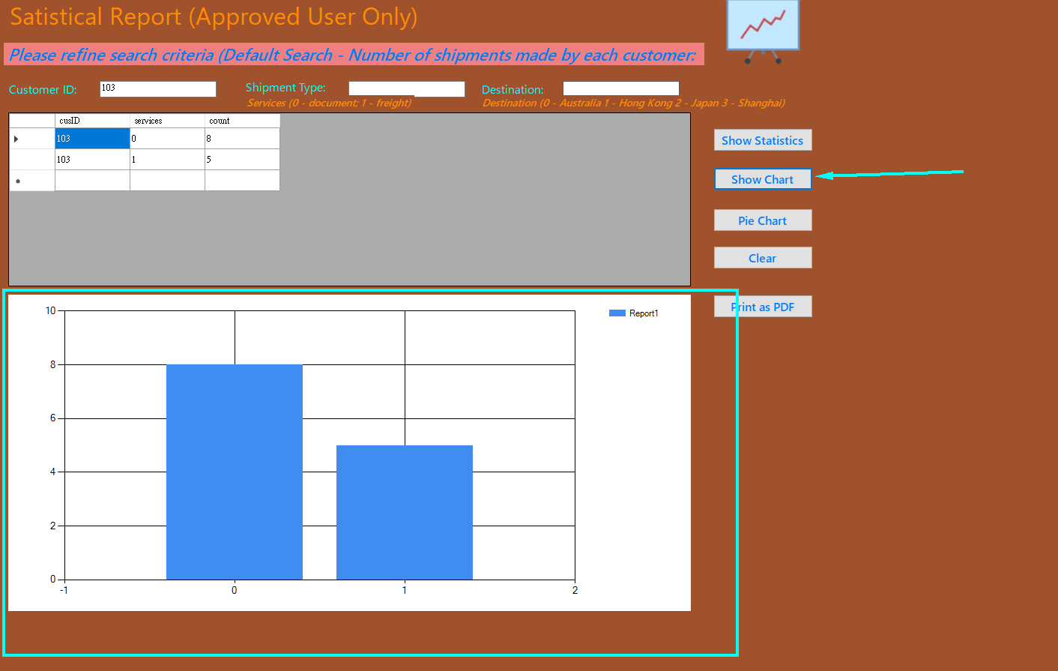

Figure : Create Chart (continued)

If you want to see a chart of the result, click “Show Chart”, the chart should be shown under the record table.

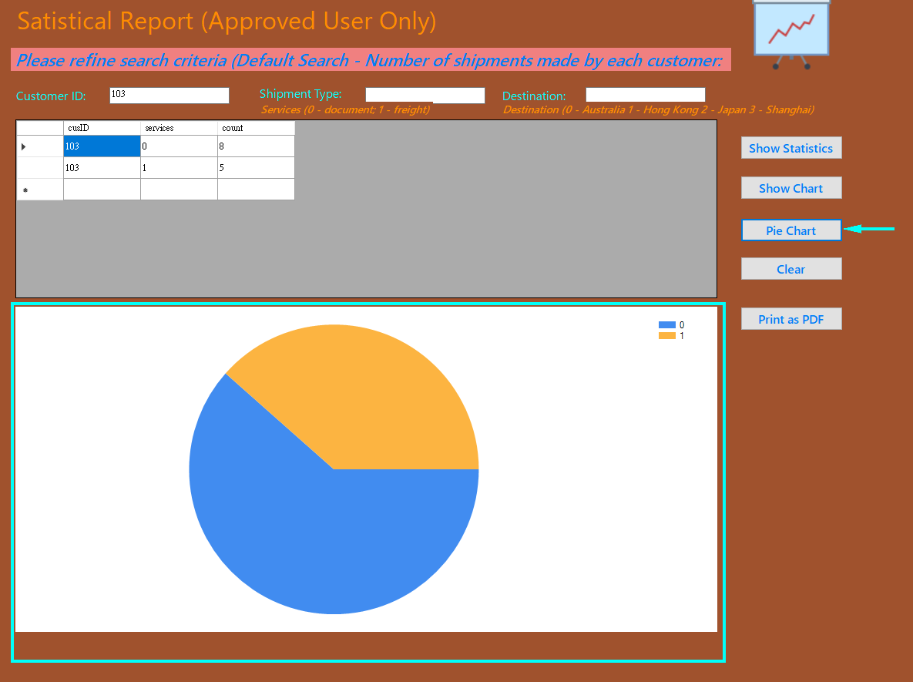

Figure : Change to Pie Chart

If you want to see a pie chart of the result, click “Pie Chart”, the chart should be shown under the record table.

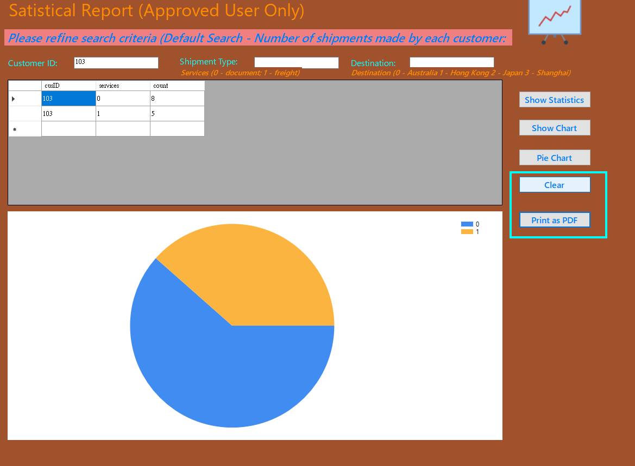

Figure : Addition functions (print as PDF)

Once user done searching, user can either choose “Clear” button to clear the search result to perform the next search or click “Print as PDF” button the save the search result.

# Project Schedule (Gannt chart and tasks dependency)

The following Gannt chart have covered all stages of the project.

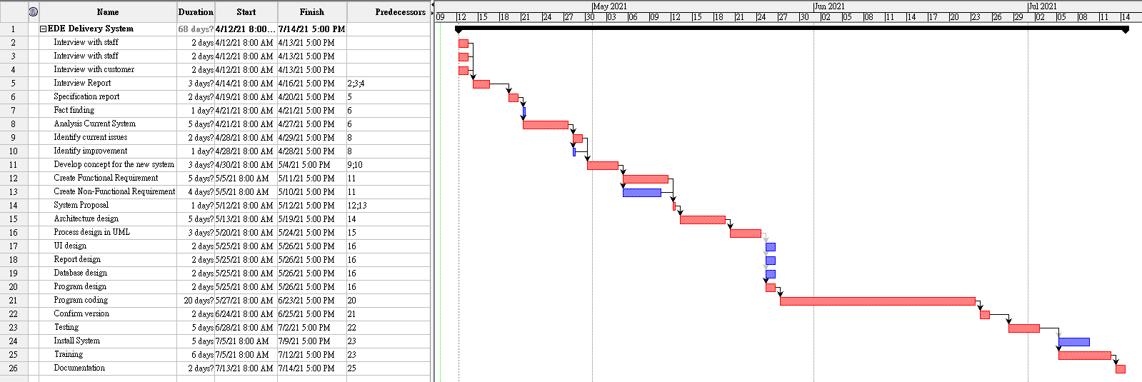

# Task Dependency

|  |  |
| --- | --- |
| **Tasks** | **Dependency** |
| **Planning Phase** | |
| Interview with staff |  |
| Interview with manager |  |
| Interview with customer |  |
| Interview Report | All Interviews |
| Specification report | Interview Report |
| **Analysis phase** | |
| Fact finding | Specification report |
| Analysis Current System | Specification report |
| Identify current issues | Analysis Current System |
| Identify improvement | Analysis Current System |
| Develop concept for the new system | Identify current issues, Identify improvement |
| Create Functional Requirement | Develop concept for the new system |
| Create Non-Functional Requirement | Develop concept for the new system |
| System Proposal | Create Non-Functional Requirement  Create Functional Requirement |
| **Design phase** | |
| Architecture design | System Proposal |
| Process design in UML | Architecture design |
| UI design | Process design in UML |
| Report design | Process design in UML |
| Database design | Process design in UML |
| Program design | UI design, Report design, Database design |
| **Implement phase** | |
| Program coding | Program design |
| Confirm version | Program coding |
| Testing | Confirm version |
| Install System | Testing |
| Training | Install System |
| Documentation | Install System |

# Conclusion

The development cycle of the proposed system proceeds to the final stage with this Final report and the second prototype. After the approval of the previous System Analysis and Design Report as well as the Requirement Specification Report which analyzes the current operation of the company by reviewing the computer system currently in use and conducting user experience interviews, final adjustment has been made to the proposed system. This report outlines the significance of having a modernized system at EDE by illustrating the user interface, test plan and user guide.

As it is revealed that the major issue of EDE is emerged from the computer system that is currently in use, this Final Report also attempts to outline the functional models within the object-oriented system development for the proposed system for EDE by bringing attention to the use cases and activity diagrams. More specifically, use case diagrams and their respective use case descriptions of the three major component of the proposed system, namely Company System, Staff Data Sharing Software and Staff Intranet Portal, are detailed in this report, followed by sequence diagrams and state machines diagrams which specifies the behavioral model of the proposed system, and the structural model with class diagram. Initial design of the database system as well as the Entity Relation Diagram (ERD) has also been outlined in this report. In addition, the major benefits of implementing the system, namely increased transparency, reduced workload of staff, reduced response time and transaction can be done online have also been outlined in this report. This report also introduces the hardware, software and network architecture required for the proposed the system.

Fortunately, the existing computer used in company shall be able to be reused into the proposed system. Therefore, existing resources could be used more effectively and thus would not be wasted as the proposed system shall be a web-based one that allows users, both staff members and customers, to run on any devices installed with modern browsers. By implementing the modernization of the management system, it is expected that the company would be able to prevail over its competitors by providing all-round services that are able to address customers’ needs and fulfill their expectations. Hopefully, by specifying these elements of the proposed system, a better picture of the system could be given to the operation manager.

The final stage of this project is the production of the system itself and the implementation. This report outlines the way in which the system is built and tested. The user interface of the system has been illustrated with screenshots obtained during the testing phase. As testing is one of the most critical steps in this final stage, a detailed test plan is included in this final report where various test cases were illustrated in detail. A user guide and support plan which attempts to illustrate in what way does the system should be used and implemented is also included in this final report. It is expected that user guide could serve as a manual for the users, even if technical staff is not around. It is hoped that by specifying these elements of the system, a better picture of the system could be given to the operation manager and the managerial staff. It is hoped that the proposed system would be launched in early July upon final approval on the second prototype of the system.

# Project Log

|  |  |  |
| --- | --- | --- |
| **Finish Date** | **Task** | **Responsible Member** |
| 2021-2-10 | Abstract | Manni |
| 2021-2-12 | Introduction | Manni |
| 2021-2-14 | Problem Finding | Manni |
| 2021-2-20 | Functional Requirements | Edwin |
| 2021-2-26 | Non-functional requirements | Sam |
| 2021-3-10 | System Architecture | Sam |
| 2021-3-12 | Benefits | Sam |
| 2021-3-12 | Constraints and Limitations | Edwin |
| 2021-3-14 | Actor Description | Edwin |
| 2021-3-16 | Use case diagram and description | Edwin |
| 2021-3-18 | Class Diagram (Design Level) | Manni |
| 2021-3-20 | Sequence Diagram (3-Tier with MVC model) | Sam |
| 2021-3-22 | State Machine Diagram | Sam |
| 2021-4-1 | Entity Relation Diagram (ERD) | Manni |
| 2021-4-6 | Database Design | Manni |
| 2021-4-8 | Project Schedule | Edwin |
| 2021-4-12 | Project Log | All member |
| 2021-4-12 | Report Formatting | Manni |
| 2021-6-5 | Menu Program / Login | Sam |
| 2021-6-6 | Pickup Booking Management   * Create and edit the pickup | Sam |
| 2021-6-5 | Express Document/ Package Express Management   * Create and edit the pickup * Calculate shipping expenses * Generate EDE airway bills | Edwin |
| 2021-6-5 | Process Shipment   * Update/Track shipments * Pre-alert receiver of shipment information * Handling receiving | Manni |
| 2021-6-6 | Bill and Payment Management   * Generate invoice * Manage payment (individual payment, monthly payment, online payment by cheque, etc.) | Edwin |
| 2021-6-7 | Master Data Maintenance | Manni |
| 2021-6-7 | System Security & Control | Manni |
| 2021-6-7 | Database Implementation | Manni |

|  |  |  |
| --- | --- | --- |
| 2021-6-28 | Bill and Payment Management   * Prepare monthly invoice (Prototype 2) | Edwin |
| 2021-6-28 | Handling Import function (Prototype 2)   * Create and edit regular import service (Prototype 2) * Generate import invoice (Prototype 2) | Sam |
| 2021-6-28 | Software Prototype: Advanced Stage   * Searching functions * Statistical Reports | Manni |
| 2021-6-29 | User Guide | Edwin |
| 2021-6-29 | Test plan including all test cases and test data | Sam |
| 2021-6-29 | User Interface and Report Design | Manni |
| 2021-6-30 | Final Report Formatting | Manni |
| 2021-7-1 | Project Log | All member |

# Reference

BBC. (2018, October 25). *Cathay Pacific Hack Hits Millions of Fliers*. BBC News. Retrieved March 7, 2021, from <https://www.bbc.com/news/business-45974020>

Boateng, O. N., Asante, M., & Nti, I. K. (2017). Implementation of advanced encryption standard algorithm with key length of 256 bits for preventing data loss in an organization. *International Journal of Science and Engineering Applications*, *6*(3), 88-94. <https://doi.org/10.7753/ijsea0603.1004>

Chung, L., & do Prado Leite, J. (2009). On Non-Functional Requirements in Software Engineering. In A. T. Borgida, V. Chaudhri, P. Giorgini, & E. Yu (Eds.), *Conceptual modeling: Foundations and applications: Essays in honor of John Mylopoulos* (pp. 363-379). Springer Science & Business Media.

Laws Compilation and Publication Unit, HKSAR Government. (2013). Cap. 486 personal data (Privacy) ordinance. <https://www.elegislation.gov.hk/hk/cap486>

Mahmood, K., Akram, W., Shafiq, A., Altaf, I., Lodhi, M. A., & Islam, S. H. (2020). An enhanced and provably secure multi-factor authentication scheme for internet-of-Multimedia-Things environments. *Computers & Electrical Engineering*, *88*, 106888. <https://doi.org/10.1016/j.compeleceng.2020.106888>

Thakurta, R. (2012). A framework for prioritization of quality requirements for inclusion in a software project. *Software Quality Journal*, *21*(4), 573-597. <https://doi.org/10.1007/s11219-012-9188-5>